Centerville High School
Baseball Team
Banner for Booster Park
2026
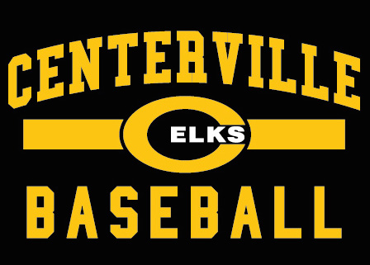

To Whom it May Concern,

The Centerville High School Baseball team has a very strong and proud tradition. We are optimistic about our upcoming season with a lot of new faces for the 2026 Spring Season.
Our program, to the greatest extent, is self-funded. We rely on the hard work, sacrifice and monetary donations of our players and their families. Unfortunately, this is not enough to support our program and so we have several fundraisers held throughout the year. Our team has a lot of activities planned and we need your support.
For the banner sale this year we are asking for a $300.00 donation. In exchange, you will have a professionally made banner that is 4’ x 8’ and will hang at Booster Park on our outfield fence that will be up throughout the year. The banners are hung on the outer fence so all traffic through the high school can view including all extracurricular events.
We will also put a business card size advertisement in our Centerville Baseball program and include it on our web page as a valued sponsor. We ask for your support and appreciate your consideration. If you are interested in donating, please mail your banner donation no later than January 31st , 2026. If you are willing to sponsor a banner, please email or call the contact below as we look forward to you supporting the Elks Baseball team for 2026

Thank you for considering supporting our young men so that they can continue the privilege of playing baseball!

Sincerely,
Mark Weckesser

CHS Dugout Club Banner Chairperson -
Mark Weckesser Cell: 937.823.2477 : weckesserm@gmail.com

