WCFL Pro All Stars stop PBC Youth All Stars, claim Orange Bowl football title
By Jodie Wagner
The WCFL Pro All Stars defeated the Palm Beach County Youth Football All Stars 14-12 to win the Orange Bowl Youth Football Alliance 140-pound championship Dec. 11 at FIU Stadium in Miami.
After a scoreless first quarter, the WCFL trailed 6-0. But following Jake Michelle’s 10-yard scramble, Stephen Acquaviva scored on a 12-yard scamper to tie the game. Acquaviva led all rushers with 17 carries for 119 yards.
Robert Lamelas kicked the extra point to give the WCFL an 8-6 lead.
Palm Beach County Youth Football answered by taking the kickoff to the WCFL 30-yard-line. With 1:20 left in the half, PBCYFL scored on a quarterback keeper. Kyle Cabra broke up the extra-point pass attempt, making the score 12-8 at the half.
“They played more physical than we did in the first half, and we did a poor job of covering kick/punts, and that hurt,” coach Gus Pasquale said. “For most of our kids, this is the last youth game they will play. We challenged them to get after it in the second half. It had to start with a stop in the very first PBCYFL procession of the second half.”
The WCFL stopped the first two PBCYFL possessions of the second half. Acquaviva recovered a fumble, and Jake Moschella checked into a quarterback sneak, darting 15 yards into the end zone for the winning score. Moschella rushed for 47 yards on seven carries to add to a team total 168 yards rushing.
Anchoring the WCFL’s offensive line were Hunter Richards, Sean Swisher, Kyle Maschi, Caleb Taub and Josh Upshaw.
Acquaviva played well defensively, recovering a fumble and recording a sack and several tackles for losses. Other standouts were Keenan Duggan, Justin Simmonds, Keith Berry, Jacob Maybee, Cabra and Weston Demino.
“Robert Lamelas making the two-point kick, Kyle Cabra breaking up an extra point and a swarming second half defense brought us victory,” Pasquale said. “We have some kids on the team that will be very good high school football players over the next few years, and we are thrilled to send them off with this experience.
“As a league, we made history sending a team from each division to the championship. We ended the day bringing home three of the four back to Wellington. Kudos to the community of volunteers, coaches, parents and The Village of Wellington for supporting the program. This was a shining moment for all.”

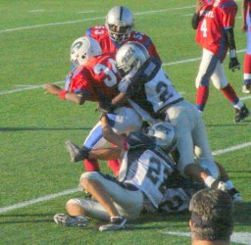
Keenan Duggan, Stephen Acquaviva and Mikey John make a defensive stop.
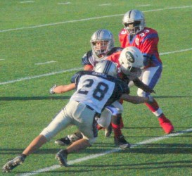
Kyle Cabra and Stephen Acquaviva tackle a PBCYFL ball carrier.

