Why Hitters MUST Drop Their Back Shoulder

By: Cindy Bristow

"Don't drop your back shoulder" is no doubt the #1 thing I hear coaches tell hitters but you might be surprised to learn that all hitters must drop their back shoulder. Don't believe me, read on to discover 5 reasons why all hitters actually do drop their back shoulders.

Every day I either work with a hitter that thinks they shouldn't drop their back shoulder, or else I hear a coach tell me that hitters shouldn't drop their back shoulder. Not only is this wrong, it makes hitting a certain pitch impossible. Make sure you know what is right and why.
The 2 biggest misconceptions when it comes to hitting have to be:
- Don't Drop Your Back Shoulder!
- Swing Level
I believe it's our responsibility as coaches to do our best to understand what is accurate in regards to the skills we teach, and what is just coaching hearsay - those things passed down from coach to coach without anyone ever stopping to give them any thought.
Both of these hitting myths definitely fall into the coaching hearsay category and both of them are wrong as well. But don't just take my word for it, I'll be showing you - with pictures - why hitter's must drop their back shoulder when hitting so we can all ensure our players are as technically correct as possible. Not because we get style points in softball for being correct but because we want our hitters to be able to hit as many pitches in as many locations as possible. (I will explore the Level Swing concept in a future article).
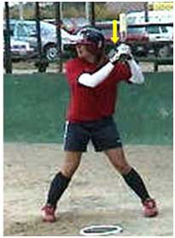
Before we delve deeper let's first define a hitter's back shoulder. The back shoulder is the hitter's shoulder that starts closest to the catcher when she's in her batting stance. If you look at the picture of Jessica Mendoza in her stance you'll see that her back shoulder is her left shoulder (the one with the yellow arrow over it) since she's a lefty hitter. If you hit right handed then your back shoulder is your right shoulder.
Taking a closer look at the back shoulder's position in the batting stance you can see that it starts out pretty much level with the front shoulder. But, where it starts has no bearing on where it ends up at contact so don't fall into that trap.
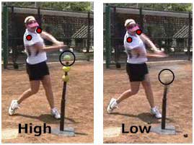
Now let's look at a hitter contacting 2 different locations of pitches; one that's mid-to-high, and one that's low. Notice the 2 red circles over the hitter's two shoulders. In both cases the back shoulder (which is now the one closest to the ball) is lower than the front shoulder, not by much on the higher pitch but still, the shoulders are in no way level at contact.
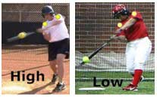
From the front view the shoulder angle is much easier to see - and to see how it definitely corresponds with the height of the pitch. In looking at the High Pitch (from the front view) the yellow dots show the hitter's back shoulder is slightly lower at contact than her front shoulder.
The pitch where "don't drop your back shoulder" simply makes no sense at all is the Low pitch. Look at the hitter to the right that's hitting the Low pitch and notice how drastically she must drop her back shoulder in order to hit this pitch (the back shoulder is now the shoulder closest to the ball). There is absolutely NO way a hitter could reach this pitch with her bat without dropping her back shoulder! No Way! Also notice how the shoulder angle on both hitters is pretty much in line with the ball and pitch location. Pretty cool, huh?!
Let's look at 5 Tips for Understanding a Hitter's Back Shoulder:
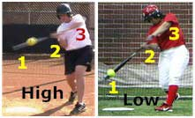
- Know the Order - In looking at hitter's from the front angle again we can see the order we must keep our joints in when hitting no matter where the pitch is that we hit. That order is:
  - The Barrel of the Bat (1) is Below our Hands (2)
  - Our Hands (2) are Below our Elbows (3)
  - Our Elbows (3) are Below our Shoulders
- Dip at Contact - all hitter's dip, or drop their back shoulders at contact. This drop happens more on the lower pitches than the middle to high pitches but it does happen. And I'm talking baseball or softball, it doesn't matter.
- Focus on the Barrel, Not the Shoulder - While I've spent this whole article talking about a hitter's back shoulder that's because we've been analyzing the swing from a technical point of view. But when you start teaching this concept to your hitters you want their focus to be on the barrel of the bat driving into the ball and not on making sure their back shoulder has lowered. Be sure to keep your player's focus on whatever is the priority in regards to outcome success. In this case we're talking about hitting - that is, the bat hitting the ball - so keep their focus on the barrel of the bat going to the ball, wherever the ball is in the zone.
- Hit the Middle of the Ball - One simple reason coaches tell their players to "not drop their back shoulder" is because their hitters are popping up. This is mainly due to the fact that the hitter is hitting the Bottom of the ball instead of the Middle or Back. Work on your hitters hitting the Back or the Middle of the ball instead of the bottom or the top or even the side and your hitters will have far more success.
- The Drop is Going Forward - While we've established that hitters do in fact drop their back shoulders when hitting, make sure you know this happens as the player's hands are moving forward toward the ball and contact zone and not behind them. Many young hitters will keep their hands behind them for most of their swing causing all kinds of problems, the least of which is hitting the bottom of the ball. Take her hands forward to the ball no matter where the pitch is!

