Attention: All Teams & Umpires

It has come to my attention that certain umpires are not letting teams use the Orange Crush and are questioning the Freak 98. Please keep this letter in your scorebook to show an umpire who attempts to throw a legal bat out of the game.

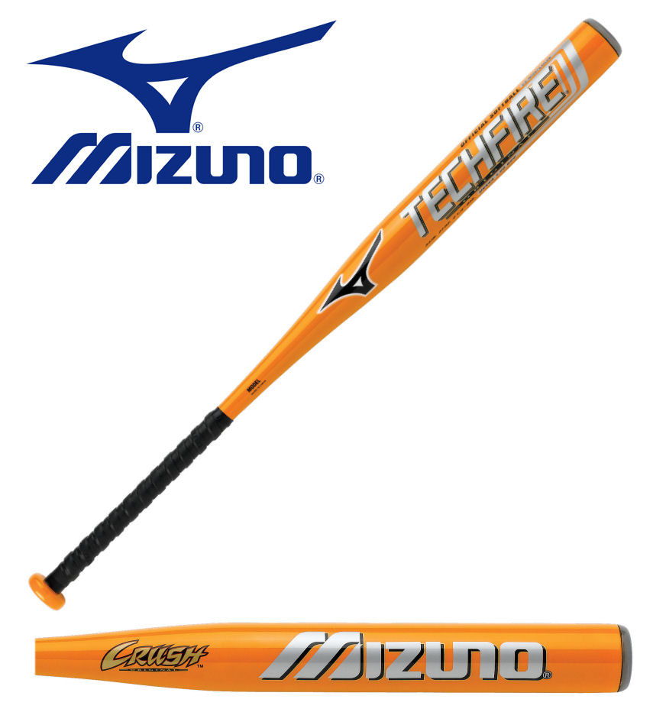Illegal – Has the “bird logo” on it and says The Original on it. Does not have an ASA 2000 (Circle Logo) or an ASA 2004 (Plate Logo) stamp on it.

Legal – Doesn’t have “bird logo” and does not say The Original on it. Has the ASA 2000 (Circle Logo) or ASA 2004 (Plate Logo) stamp on it.

The Freak 98 is legal but the Freak is illegal.

Illegal Legal

The difference is the legal one has Freak 98 on the barrel and the illegal one just has Freak on it.

If an umpire still tries to throw out a legal bat a team has the right to protest the game.

For all other bats please use the Non Approved bat list that I provided to all teams.

Mike Lakovic
ESSL Commisioner/Webmaster

