Forman’s at bats without going to right field climbing once again
Since this is Steve Forman’s final season in the NMCSL, News and Notes wanted to bring the fans up to date on Forman’s lack of hitting the ball to right field. The total is now 116,166,456 at bats without a ball hit to the right side of second base.
A tote board, similar to the Jerry Lewis Telethon, was built years (actually centuries) ago outside DUMC Park to record every at bat in which Forman has not hit the ball to the right side of the field.
Fans who don’t have a ticket to a DUMC game will camp out underneath the sign and play a drinking game called, “Pull, Steve, Pull.” After each at bat, if Steve hits the ball to the left side, everyone underneath the sign does a shot. Needless to say, DUMC has, per capita, one of the drunkest fan bases after every game.
Forman told N&N, “Well, I don’t have a problem with it. You have to be drunk to want to come to our games anyway…”
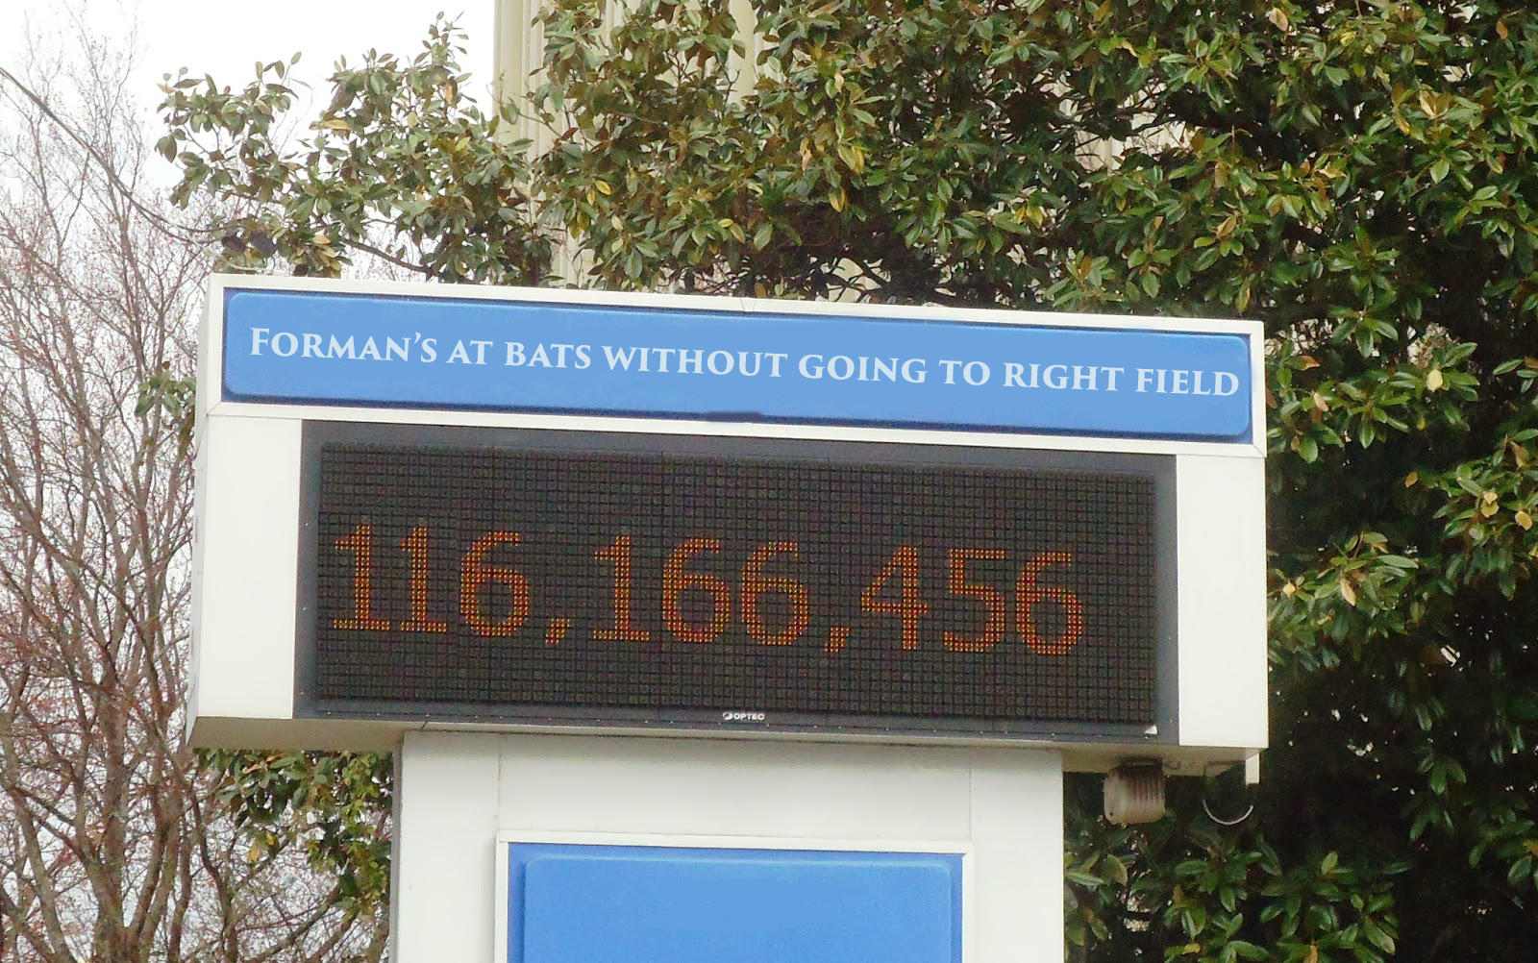
The Steve Forman Tote Board is shown here outside DUMC Park after Saturday’s game. The number of at bats without a ball going to the right of second base, is a League record which, we are pretty sure, will never be broken.

MVP 31 – DUMC 2
“Our best performance of the year,” MVP Manager Charlie Gray told News and Notes during his weekly press conference.
“Our hitters knocked the cover off the ball, we played good defense and “Texas” Terry Doyle finally went a full game without getting the red ass about something. This is what we need before heading into the playoffs next month.”
Steve Forman was inconsolable after the game. “Our shortstop had a tough day, and it got worse when he broke his finger on a hot ground ball and had to leave the game.”
“I was thinking, ‘Wow, he’s lucky. Can I break my finger so I can go home too???’”

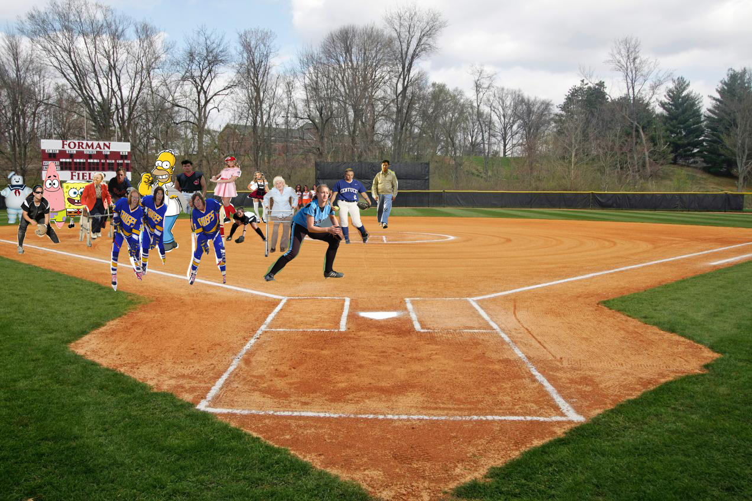
The Forman Shift is shown here during Forman’s press conference at his backyard softball practice field. Note the scoreboard in left field with the Forman Field sign. If you hit the sign, you get a free bowl of soup. Among the stars demonstrating the shift are: The Hanson Brothers from Slapshot, Rainman, The Stay Puft Marshmallow Man, Homer Simpson, two old ladies with walkers, Sponge Bob and Patrick, Ricky Vaughn from the California Penal League and Dottie Hanson from the Rockford Peaches.

PPC 17 – MVP 2
“Well, the case of the red ass came back real quick after the first inning,” Manager Charlie Gray said as he was leaving the locker room Saturday after PPC was able to get the victory over MVP.
Gray added, “After the game, ’Texas’ Terry was more pissed off than a midget with a yo-yo.”


Good to see Scott Sergent got his first hit in about a millieneum last Saturday. In fact, the last time he got a hit, Cain and Able were in elementary school…..

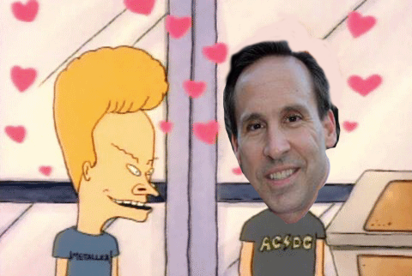
Scott Sergent is shown here with his good friend Beavis, who congratulated him on getting his first hit in a very long time…
RLC 16 – PPC 15
In one of the most exciting games in recent memory, RLC came from a 13-4 defect in the fifth inning to slip past PPC and inch closer to first place.
The usual stars showed up for Rivercliff as “Atomic” Adam Meekof and “The Funkmeister” Kevin Futo led a huge comeback.
However, the player of the game was pitcher Jay “Old Metal” Hanselman, who made several great plays from the pitching position, which saved a bunch of scoring opportunities.
When asked about the game, Hanselman, obviously beaming with pride, told ESPN, “After today, every kid in America will wish he were me…”
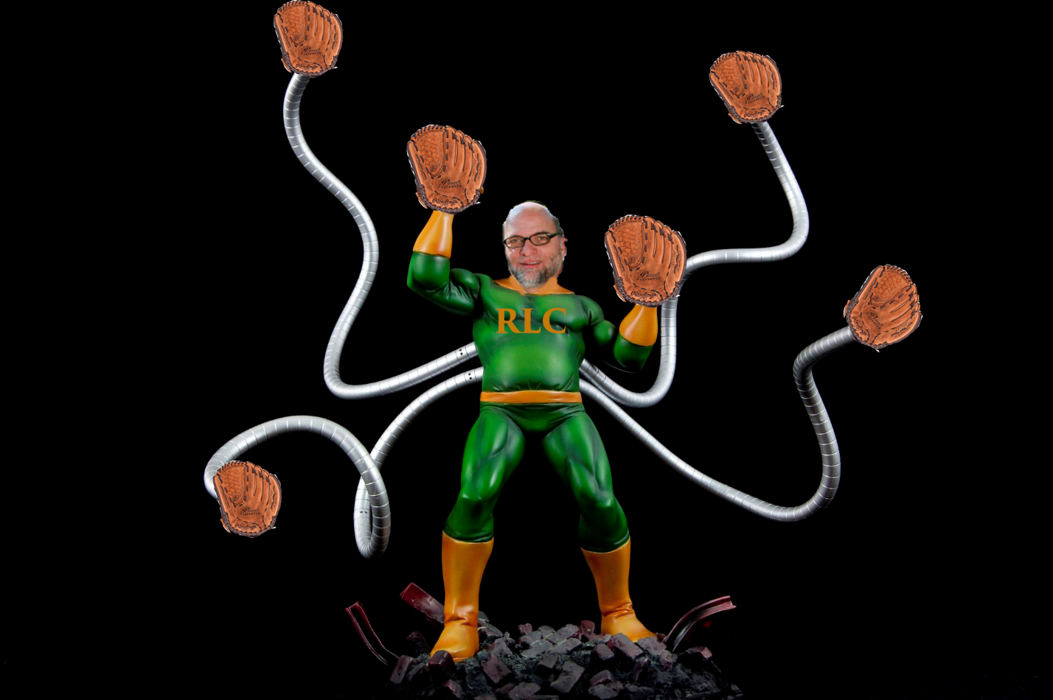
RLC Pitcher Jay “Old Metal” Hanselman is shown here thwarting PPC batters during their comeback victory on Saturday.

MVP 14 – SJC 9
In another improbable victory, MVP made it two straight over SJC as “Texas” Terry got the win.
In an interesting twist, Doyle’s contract states that if he ever beats SJC in consecutive starts, he would be given a free car. MVP Officials never thought that would happen in a million years, but lightning struck, so they drove the car out on the field and parked it in front of the dugout during the post-game ceremonies.
“I am grateful to the MVP Owner and GM for this car,” Doyle told the crowd after the game. “And they even gave it a paint job that is totally me!”
Doyle then grabbed the keys, and still in full uniform, cut about 62 million doughnuts on the infield dirt and sped off the field, leaving tire marks and divots that the MVP ground crew would have to fix before the games on May 30th.
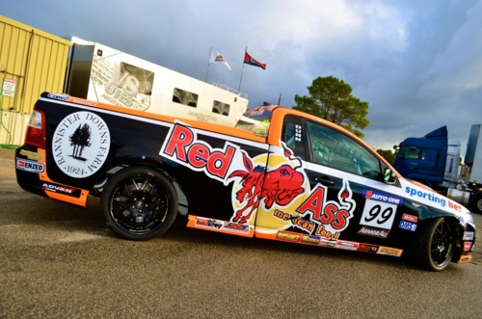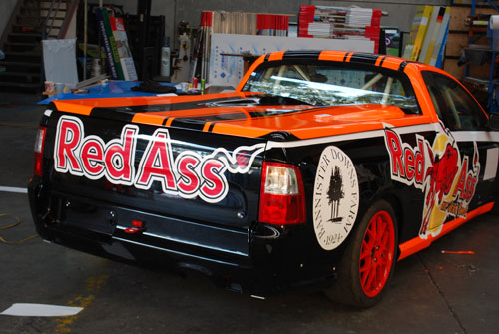
“Texas” Terry’s new car was given to him after two masterful pitching performances over St. Jude. “This car could not be more perfect for me,” he said as he drove out of the Stadium.

RLC 16 – SJC 15
In what was a huge doubleheader sweep, RLC moved even closer to first place as they were able to get another late inning victory as they shaded SJC 16-15 with a run in the bottom of the seventh inning.
After the game, “The Atomic One,” told the media he needed some time away before the huge doubleheader on May 30th against PPC, so he was going into semi-seclusion on his private yacht to get his head ready for the titanic games.
However, N&N was able to track him down and it looks as if the only thing he is worried about is if his ship runs out of margarita mix.
An interesting development was reported after the initial interview as N&N learned later that the All-Star First Baseman fell overboard and had to be rescued. No injuries were reported and all the margarita mix was returned safely to the galley.
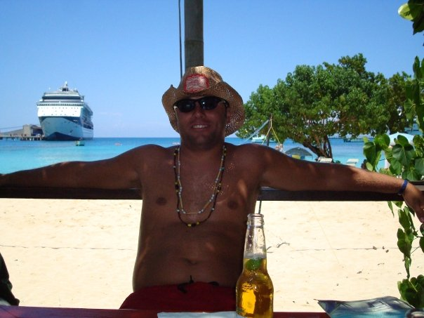
“Atomic” Adam is shown here “clearing his head” as well as whatever his crew put in the cooler after RLC won their two games on Saturday to set up a huge doubleheader with PPC on May 30th.
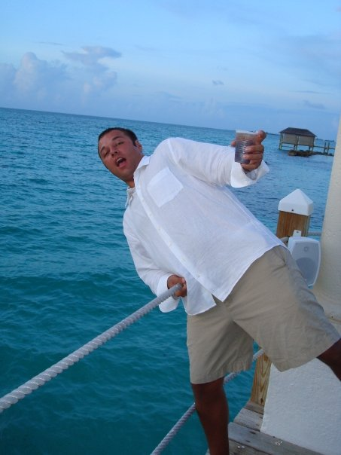
Rescue crews were called to the scene as “The Atomic One” fell overboard and had to be pulled back to the boat. “Once again, those Gilligan’s I call a boat crew forgot to tell me they swabbed the deck so that’s how I slipped off,” he told the press after the incident.

