PPC 15 - MVP 10
PPC managed to get past a pesky Mt. Vernon squad on Saturday as Zack Radermarcher outdueled MVP’s “Texas” Terry Doyle.
In a marketing strategy for the League, Doyle has been named the Most Interesting Man in the NMCSL and the ads can be seen between innings on NMCSL TV broadcasts and all Jumbotrons around the League.
The ads show Doyle lounging in his king’s throne dugout chair telling the camera, “I don’t always get hit with a line drive when I pitch, but when I do, I make sure to get the red ass. Stay low my friends…”

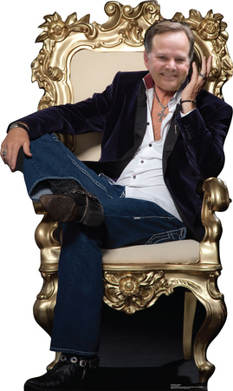
MVP’s “Texas” Terry Doyle is shown here in a promotional poster for the League’s new ad campaign, “The Most Interesting Man in the NMCSL.”

MVP 13 - DUMC 12
News and Notes uncovered this signage (below) from the bowels of DUMC Stadium last week. Apparently, it was used as a banner that hung outside DUMC Stadium to congratulate “Dangerous” Doug Horst on being named the 1905 NMCSL Rookie of the Year. 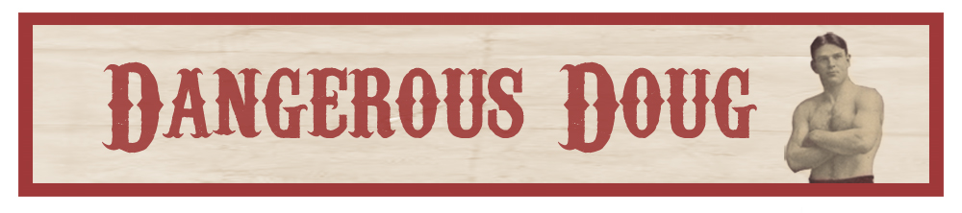
In another close loss, “Stunning” Steve Forman kept up his hot hitting, but also sustained another injury as he now has a neck contusion after watching a long home run from the MVP 3rd baseman off of “Long” John Ritchie.
“Yeah, my head snapped back quicker than when the ladies see ‘The East Roswell Park Heartthrob’ Jonathan Cochran walking past them into the ball park.”
Forman added, “Anything that goes that far ought to have a stewardess on it…”
Here is a picture of the ball leaving the park, which turned out to be the game winner in a close ball game.


SJC 11, DUMC 10
In keeping with post-game concerts over the last few weeks, a pair of old friends reunited after SJC shaded DUMC by a run.
Before Daryl Hall and John Oates were burning up the charts, the super duo of Daryl Hall and Steve Forman were the power brokers in the music world.
Unfortunately, the duo broke up because Forman wanted to focus on his softball career, so an unknown named John Oates answered a vocalist/bassist ad in Spin Magazine, and the rest, as they say, is history.
Hall told News and Notes, “One of the biggest reasons why I chose John Oates is he looks so much like my old friend, Steve Forman.”

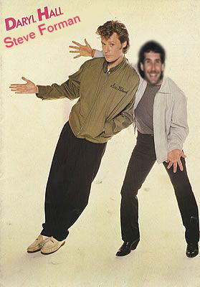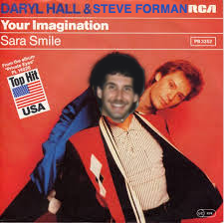

SJC 8, MVP 7
In another close game, SJC made it two straight as they edged MVP 8-7.
However, there was controversy as SJC claims that Manager Charlie Gray and MVP intentionally deflated the softballs prior to the game. This would negate the powerful SJC bats and also help MVP defenders get a better grip on the ball to throw out the SJC base runners.
The NMCSL office is mulling over the discipline and it is rumored Gray could be suspended four games and the team forfeit its draft picks in next year’s NMCSL Draft.
Gray has already voluntarily missed one game last Saturday, so he is hoping that will count towards a possible four game suspension.
The story made national headlines as Robin Meade and the crack team of Morning Express reporters were the first to rip the lid of this blockbuster story.
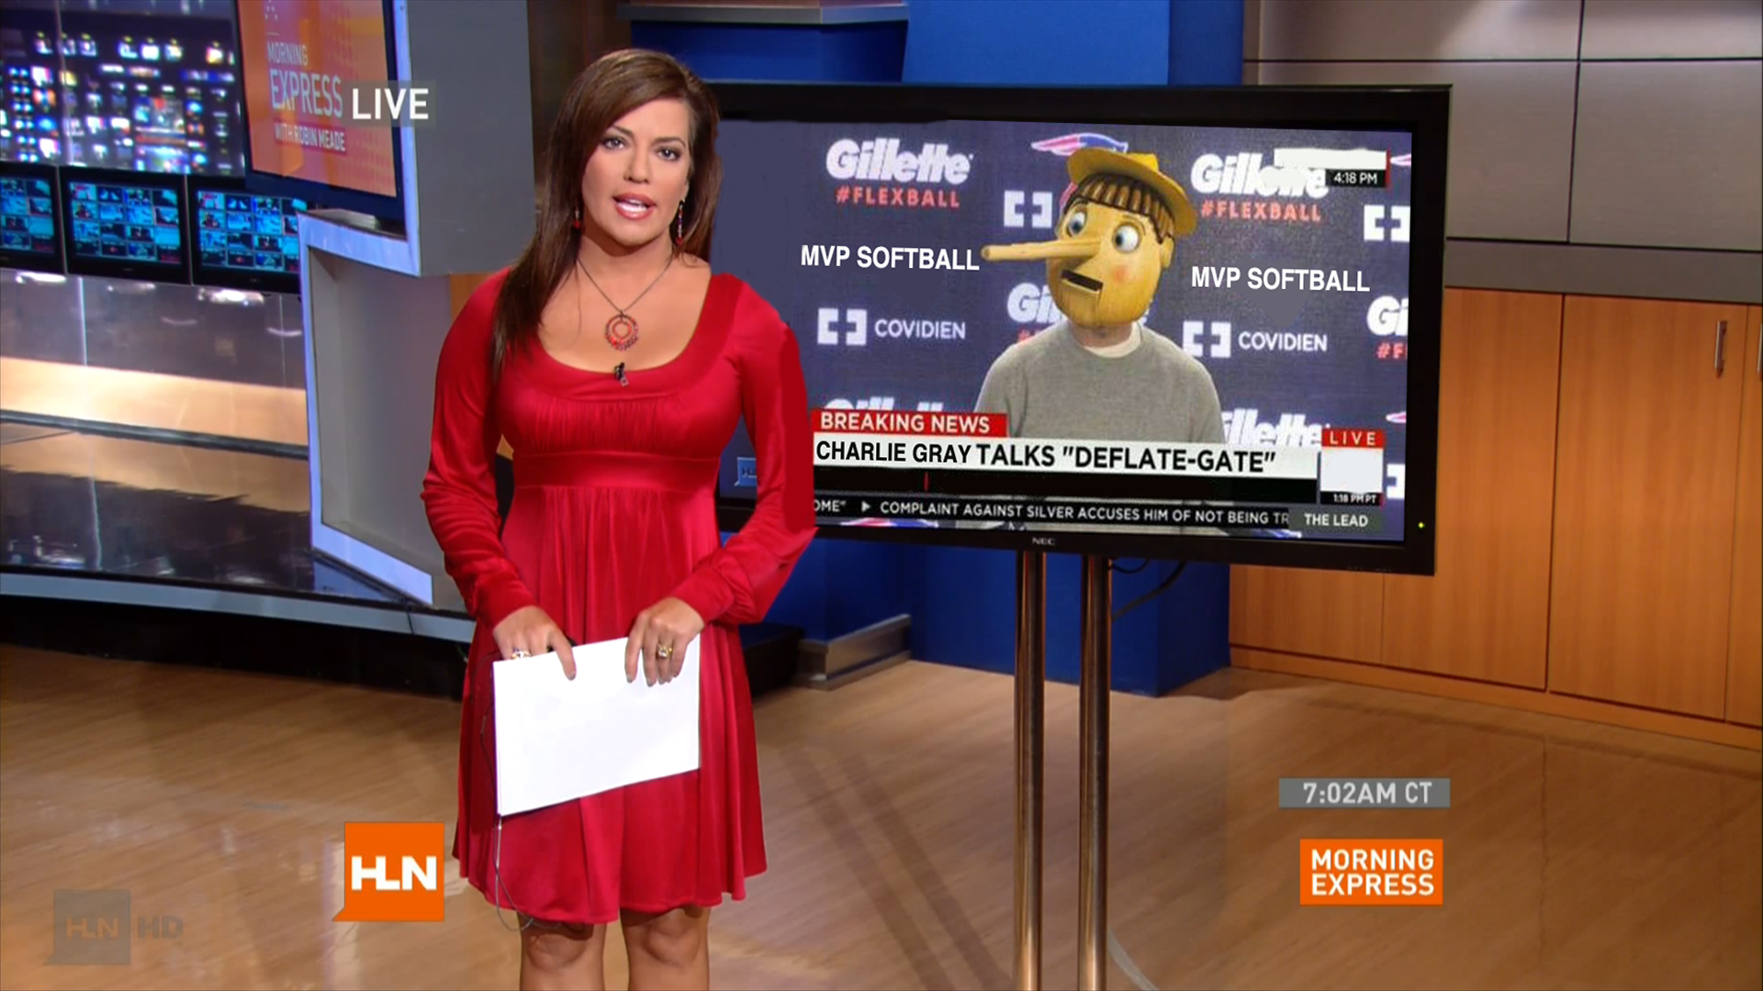
Robin Meade breaks the “Deflate-Gate” story as Manager Gray denys accusations of deflating softballs in this press conference video shown on HLN’s Morning Express last week. (Note his nose appearing to grow with every denial).

SJC 25, RLC 8
The controversial “Hit Pitcher Rule” has resurfaced as RLC has voiced concerns over the rule.
RLC Manager “Atomic” Adam Meekof spoke about the incident during his weekly press conference.
“Our pitcher got hit in the arm, lost a gallon of blood, but because he made what was deemed an athletic, softball move (And if you know my pitcher, athletic and move usually don’t follow each other in the same sentence) the runner was not declared out,”
He added, “I didn’t know Ronnie Milsapp was an umpire in our League.”
“Because we lost our pitcher last week, we called our AA affiliate in the Camelot league and brought up the Black Knight to pitch. We figured he would be protected from line drives with all that armor, but apparently we were wrong. No matter because the Black Knight always triumphs!”
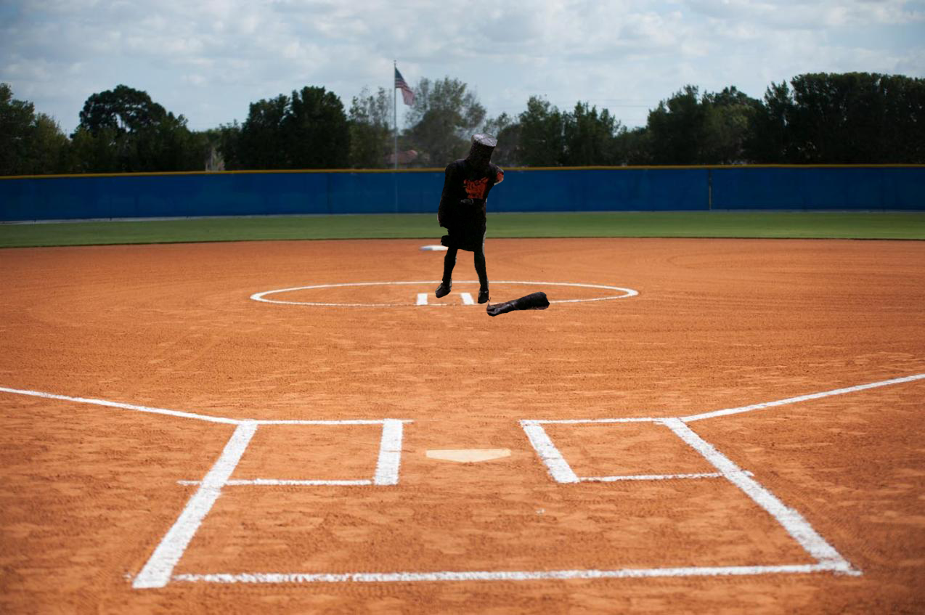
RLC pitcher, The Black Knight, is shown here after getting struck by a line drive during a game last Saturday and losing an arm, which was later called a flesh wound.
Meekof added, “If the Knight can’t go on Saturday, we hired a guy from the local Krispy Kreme Doughnut shop to pitch for us. And he is not shy about challenging anyone who dares to come back up the middle on him.” (Pictured below)
