PPC 9 – DUMC 2
After the victory, PPC had a birthday party for their oldest member (And if it not for “Stunning” Steve Forman, the league’s oldest) “Ravishing” Rick Radermacher.
In case you are wondering why there are only four candles on the cake (pictured below), if they put the correct number of candles on his cake, the Fire Marshall would have had to clear the building since it would have been a serious fire hazard.
So PPC teammates decided to put one candle on the cake for every triple Rick has hit in his career, which has spanned over 15,000 games…
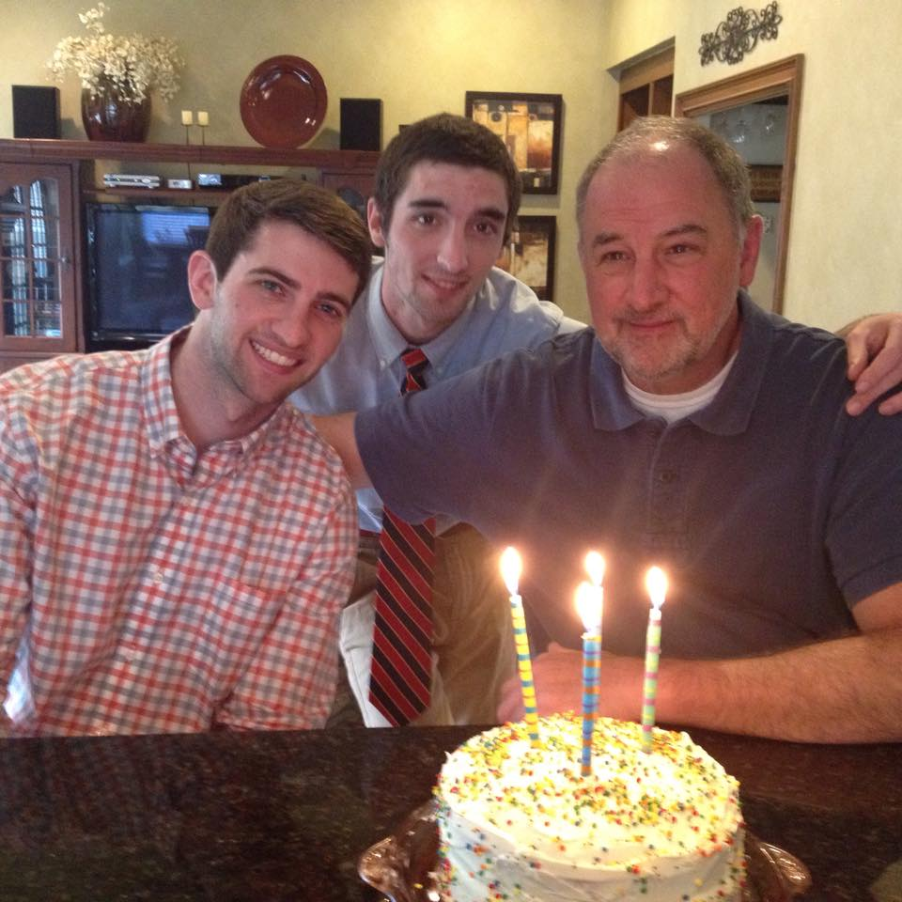
Here is “The Ravishing One” getting ready to blow out the candles on his cake. One for every triple he has ever hit in over 15,000 games.

MVP 9- RLC 5
MVP sprung another upset this week as they knocked off powerhouse RLC 9-5.
It looked like RLC had not played in about a year (actually it was a month, but as bad as the bats were, “Atomic” Adam told the press his team was as rusty as Old McDonald’s farm equipment).
MVP wasn’t exactly blowing any sunshine up anyone’s skirt in the offensive department either, although their bats were offensive to some. However, they managed to hold on to a slight 4-1 lead, thanks to the stellar pitching of Terry “Oil Can” Doyle, who held the heavy hitting RLC team to just a run into the late innings.
RLC’s “Atomic” Adam gave RLC a brief lead as his three run shot made it 5-4.
“Yeah, I tried to pump a fastball by him and he hit a ball that hasn’t landed yet,” Doyle told ESPN's Church League Softball Tonight after the game.

The mushroom cloud from “Atomic “Adam’s 550 foot home run can be seen rising in deep center field.

MVP would score five runs to take a 9-5 lead into the final inning after 3rd baseman “Jackhammer” Jonathon Breeling hit a grand slam.
In the final inning, MVP got the first two outs, then “Oil Can” told manager, Charlie “ChaCha” Gray he wanted a little drama to end the game, so he intentionally walked the next three batters to face RLC’s best hitter.
The batter drove “Oil Can’s” first pitch to the deepest part of East Roswell Park, 495 feet from home plate where it was caught at the base of the wall to end the game.
After seeing the final out caught only a few feet from what would have been a game tying grand slam, Doyle then walked himself…over to the bathroom so he could change his softball pants.

RLC 15 – SJC 9
After coming down with a serve case of the red ass that matched their jerseys, RLC turned things around in an impressive performance as they beat SJC 15-9.
Every starter had at least two hits and “Atomic” Adam added to his league leading home run total with two blasts. He has like 26 bazillion home runs so far this season.
“I am proud of this team for the way they fought back in the second game. I also want to give a special shout out to our player of the game, who was Jay “Old Metal” Hanselman, who is the father of NMCSL players Josh “Heavy Metal” Hanselman and Joel “Light Metal” Hanselman
After going through successful Tommy John surgery and spending last season rehabbing, Hanselman made his first start and was lights out. He even made the play of the game as he snared a rocket one hopper back to him then threw the batter out.
Umpire Jesse told him he was going to call the batter out, citing the always controversial Ross Milke rule, but Hanselman told him, “I left my skirt at home today, so you take care of the balls and strikes, leave the rough stuff to me Daddy…”
Not only was Hanselman the Player of the Game, but he also played the National Anthem before the game on his horn. This guy does everything!
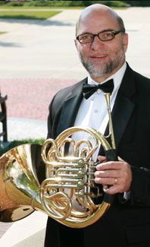

The closest time another player ever played music at a game was the post-game concert after the 2010 season opener when “Luscious” Ed Lambert and the TGI Friday Singers all placed their hands underneath their armpits and did fart noises.


DUMC 13 – MVP 12
In the game against MVP, “Stunning” Steve had the game of his life (which is good news since as old as he is, who knows how many more games he has left) with a bases loaded double to give DUMC an early lead.
Rookie LCF Chris “I will hit it out of the” Parks, hit a towering 3-run HR that landed at least 30 feet past the fence in left center.
DUMC had a precarious 13-9 lead going into the bottom of the 7th when “Dangerous” Doug lost his control. Good thing the restrooms were unlocked.
He walked everyone in Roswell, and even some senior citizens located over in Alpharetta, but got the next batter to groundout for their first win of the year.
Before the game, the Victoria’s Secret Angles gave “Stunning” Steve a key to the city of Roswell (Then they hurried back to town so they could change all the locks) in celebration of his retirement tour.
Here are some of the pictures from the event (below).

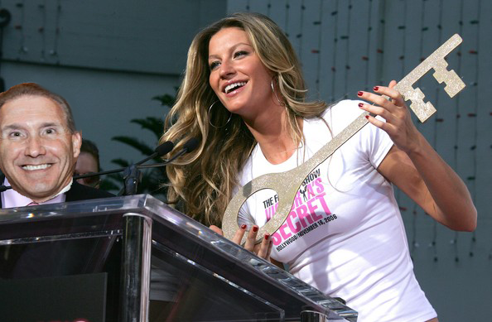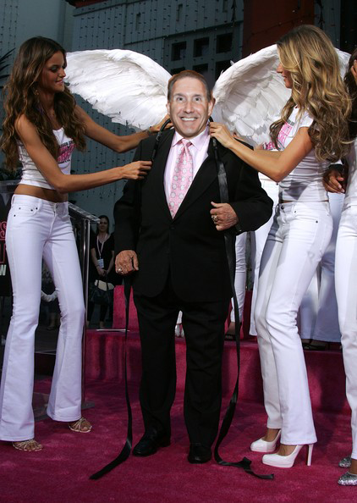

SJC 24 – DUMC 12
The third game of the day for DUMC looked like it as DUMC was worn out by the time they played SJC. St. Jude hit well from start to finish to get the victory.
Despite losing two of three games, “Stunning” Steve Forman went 9-10, which is the best game he has had since the 80’s. Actually it was the 1880’s, but still that is a tremendous day whenever it happened. 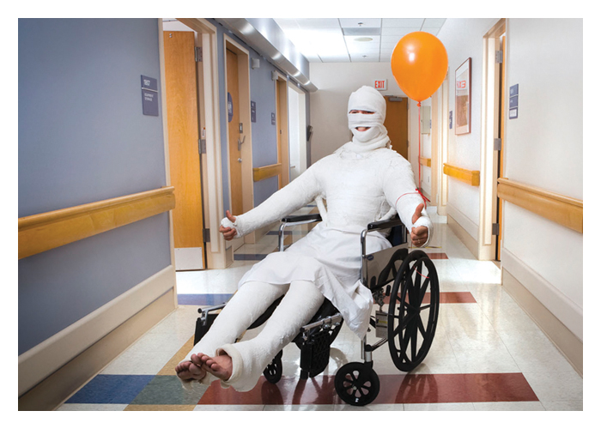
An injured “Stunning” Steve Forman is shown here on Saturday night after his big day when he batted .900 despite playing the three games with every bone in his body broken. After speaking with Manager “Dangerous” Doug Horst, the report is Forman should be ready for Saturday’s games, especially if they can get someone to wheel him down to first base after he hits the ball.

Forman is listed on the DL this week, but is due to come off on Friday, so N&N will monitor his progress to see if he will be ready for Saturday.
We suggest he stretch a little bit more before the game.

Maybe before the next game, “Stunning” Steve can stretch a little bit so he doesn’t hurt his quad again…

PPC Run Shaving Investigation
BREAKING NEWS – Allegations of run shaving by Peachtree Presbyterian have surfaced after last Saturday’s game against Dunwoody Methodist.
In the 9-2 victory, starting shortstop and leadoff batter Chris Davis left the game with an apparent hand injury. Davis was not available at the post-game press conference for further update so his status is still unknown.
Inserted into his place was the “apparently” retired “Ravishing” Rick Radermacher who was officially listed as the leadoff batter.
News and Notes looked into this “strategy”, especially when there could have been a double switch completed, with serious doubts.
In all of the 15,678 career games Radermacher has played, he has never been listed as a leadoff batter. He has been listed as the last batter in 15,677 games, with the one game he wasn’t quickly corrected when the umpire fell over laughing and had a heart attack.
A special senate subcommittee investigating alleged run shaving in church league softball around the country, held a special session last week with Radermacher, suspended PPC Manager “Luscious” Ed Lambert, and other NMCSL officials being summoned to Washington to answer questions about this matter.
More news as it coms available…
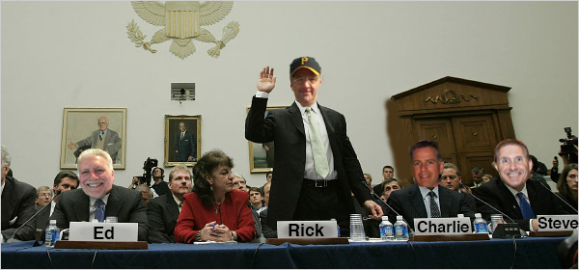
Last Tuesday, PPC Manager “Luscious” Ed Lambert, “Ravishing” Rick Radermacher, MVP Manager Charlie “Cha Cha” Gray and DUMC’s “Stunning” Steve Forman were called to testify regarding last Saturday’s “suspicious” strategy used by PPC in their victory over DUMC.

