PPC 7 – MVP 0
Protestors picketed outside of NMCSL Offices this week when it was revealed that MVP All-Star and two time Ross Milke Award Winner, “Texas” Terry Doyle, was suspended by League officials this week.
In protest, MVP refused to take the field for their 8:50 game last week, and fans of the team picketed outside the NMCSL offices in what they felt was an unfair abuse of power on one of the most beloved and respected stars of the League.
The suspension was announced after Doyle refused to sell his shares of his restaurant/night club, “The Red Ass Café” when it was discovered the establishment was selling unlicensed autographed pictures of the NMCSL Star, which is forbidden according to League Bi-Laws.
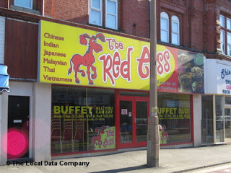
Similar to the iconic Joe Namath/Bachelor’s III ruling in 1969, “Texas” Terry Doyle was ordered to sell shares of his restaurant or face suspension. Doyle has refused to sell and his status for the regular season finale and playoffs is in doubt. 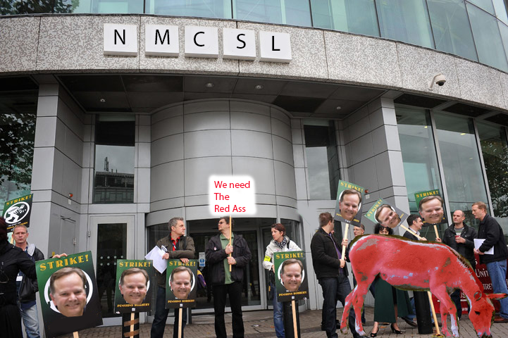
Protestors and team mascot, Senior Red Ass, are seen here picketing the NMCSL Offices after it was announced “Texas” Terry Doyle’s suspension.
SJC 4 – PPC 1
In a game that set softball back to the Stone Age, St. Jude kept their hopes alive for a home field playoff series as they were able to defeat PPC 4-1. Yes, that’s correct, 4-1. Seriously, no typos, it was really 4-1.
The offensive stars of the game were….well…offensive, since there was no offense. And as far as defense goes, nobody really stood out since all they had to do was stand up and they would have the ball hit right at them.
SJC Manager Craig Ambrosio was quoted as saying, “That was a baseball game score. At the 5-6 year old level…”

In a game that took softball back to the Stone Age, PPC’s “Ravishing” Rick Radermacher and Scott Sergent discuss strategy in the PPC dugout during the 4-1 loss to SJC.

SJC 29 – DUMC 5
Mark it down, June 6, 2015, 3rd inning, 11:37 am, against SJC....Steve Forman drills a hot grounder eight feet to the RIGHT of 2nd base for a base hit, his 1st hit to the opposite field in his long and storied NMCSL career.
And with that, the longest streak of any kind in any sport…well come to think of it, in anything ever in the history of the world, has ended.
When reports of this global phenomenon came across the news wire, News and Notes called up hell to check the temperature. And as expected, it was colder than a well diggers bum.
Despite losing the game be 24 runs, Forman was in a giddy mood after the game. Why was he acting like a giggling school girl? “Well, in addition to breaking the streak, we scored more runs against SJC than PPC did…”
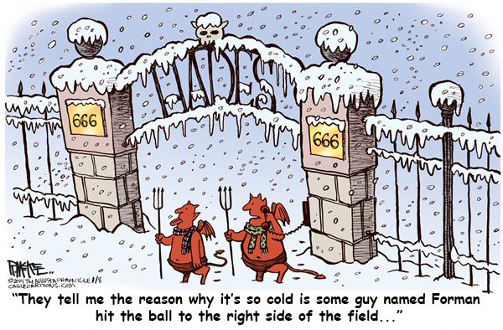
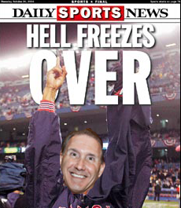
RLC 9 – DUMC 8
Another one run loss, their fourth of the year, brought a fairy tale ending to what was a promising day for DUMC. The 9-8 loss was a bitter pill to swallow, but for RLC, it kept them in second place, and still in contention for a home playoff series with SJC.
DUMC took an 8-6 lead into the bottom of the final inning, but two runs tied it, then a throw to the plate, which beat the runner there by a week, was dropped as the winning run scored.
Forman, giddy just minutes earlier, threw his glove in disgust, and walked off the field. He had to put the disappointing loss behind him as he was taken by the DUMC company jet to a Burger Chef in Americus where he made an appearance at the grand opening, as well as signed autographs for over three hours. As a retirement present, Burger Chef Inc., decided to name a sandwich after the NMCSL star, which is now known as The Forman Fillet.
“That’s quite an honor,” Forman said afterward, “But, to be honest, I really hate fish…”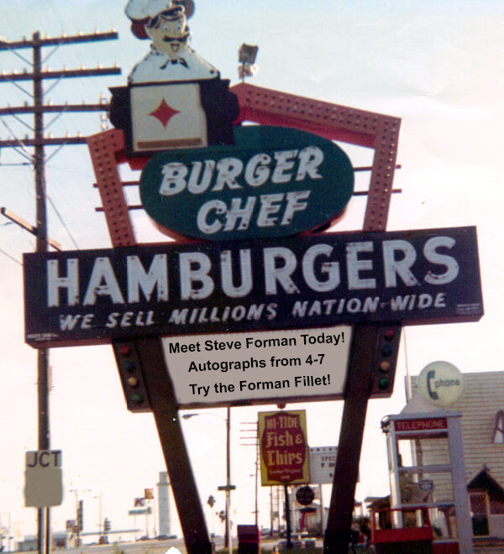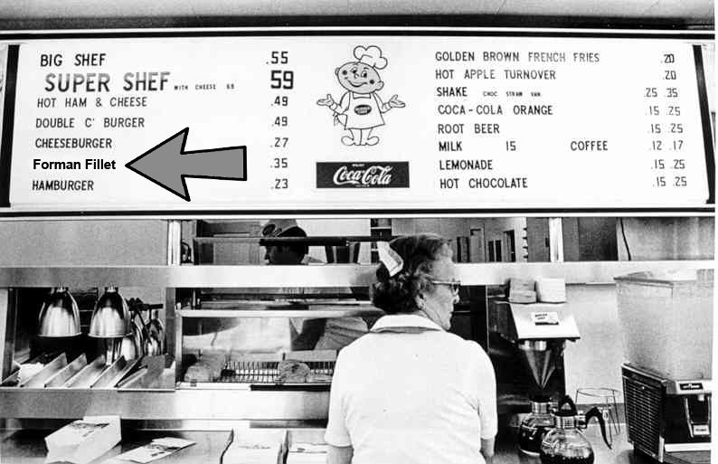
Despite the doubleheader loss, DUMC’s “Stunning” Steve Forman was all smiles as he was the star attraction at the opening at the Americus Burger Chef. He spent three hours signing autographs, and was honored by the company as they decided to name a fish fillet sandwich after him.

