SJC 14 – MVP 13
A late Mt. Vernon comeback was thwarted as St. Jude stayed in contention for the #2 seed with a narrow victory over My. Vernon.
The Mt. Vernon team came into the game with a long list of injuries, but they played on despite a torn ACL/MCL and meniscus to “Diablo” Don Paul, a concussion to an outfielder and food poisoning to Manager Charlie “Cha Cha” Gray.
“We were pulling people out of the crowd, out of the hospitals, and even out of the bars just to get enough players to fill out a team,’ Gray said. “As you can see, we really were desperate for players. It’s a good thing “Texas” Terry was able to get out there and pitch since he was the only one of us who could stand up.”
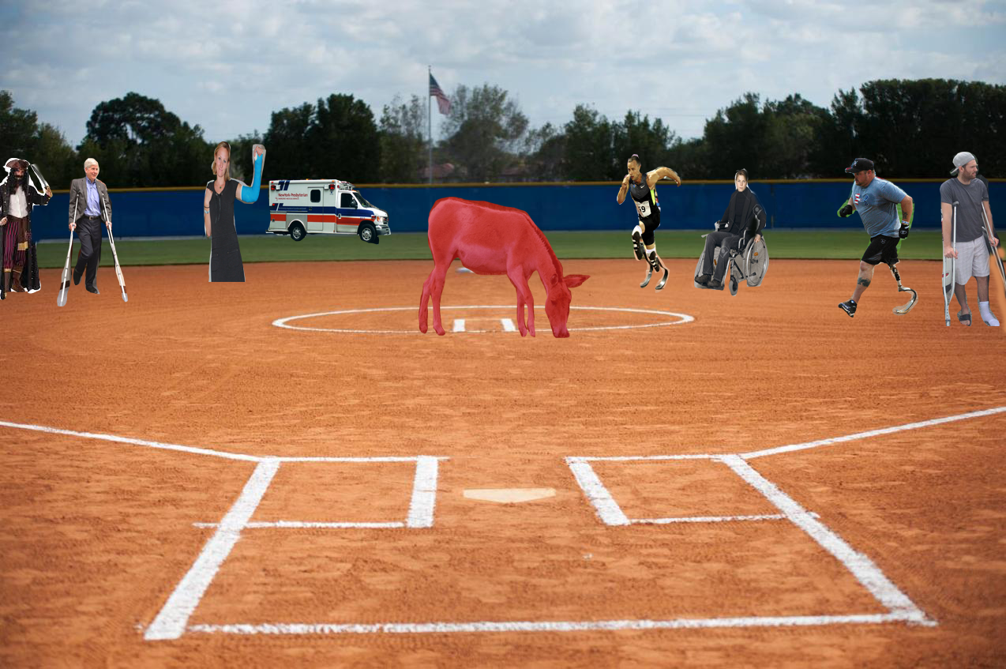
Mt. Vernon’s defense is shown here going up against St. Jude. Despite injuries to everyone, except for pitcher “Texas” Terry Doyle, they almost came back for the victory. Note the ambulance arriving in the outfield to assist with all the injuries.

RLC 12 – MVP 10
In another close game, Rivercliff kept their hopes for a regular season championship by beating Mt. Vernon in extra innings.
Once again, the contract of “Texas” Terry Doyle came into play as his attorney cited a clause that stated if Doyle ever got his jersey dirty making a play, he would be compensated a new airplane for his personal travel.
Well it happened for the first time in his 81 year NMCSL career and true to his word, Manager Charlie Gray delivered on contract.
When Doyle saw the airplane, his eyes filled with tears as he was overcome with the emotion of the moment.
“This is the greatest moment of my career,” Doyle said, then couldn’t talk any more as he was too choked up with emotion.
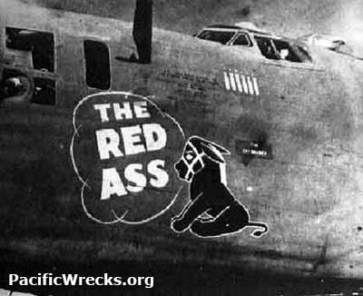
Here are a few pictures of “Texas” Terry Doyle’s new airplane that he was given for getting his jersey dirty during last week’s game against Rivercliff.

PPC 8 RLC 4
After winning his appeal of a season long suspension, PPC Manager “Luscious” Ed Lambert made his triumphant return to the NMCSL.
“I would like to thank my attorney Sam “Small Print” Lieman for proving beyond a shadow of a doubt that I was innocent of all charges against me.”
“And to the shift manager at the TGI Friday’s were I was working, you know what you can do with your broom since I won’t be sweeping up the parking lot anymore!”

Good to see PPC Manager “Luscious” Ed Lambert back in action. Lambert is shown here with his wife during a five minute break where he was working at TGI Fridays until his suspension appeal could be heard.

PPC 17 RLC 2
PPC clinched the regular season championship with a victory over Rivercliff.
“Luscious” Ed Lambert was happy to get the victory, but not impressed with the play of his team.
I leave for a few months and these clowns turn into the Bad News Bears. Well, I am going to pull a Buttermaker on some of these Mensa candidates to try to get them ready for the playoffs.”
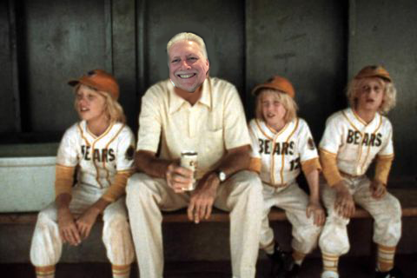
PPC Manager “Luscious” Ed Lambert is shown on the bench with his players during the Rivercliff game. “We won’t beat the North Valley League White Sox the way we played today. And if Tanner calls me ‘Buttercrud’ one more time, I am trading his butt to Dunwoody Methodist!”

PPC 23 – DUMC 10
In a surprising close game for much of the contest, PPC was able to pull away late to win the game 23-10.
The final score was an afterthought as this was Steve Forman’s final regular season game against PPC.
“It was an emotional day for me,” Forman said. “I can call ‘Luscious’ Ed, ‘Dangerous’ Doug and ‘Ravishing’ Rick my good friends. I guess that gives you an idea of how hard a time I have in making friends….”
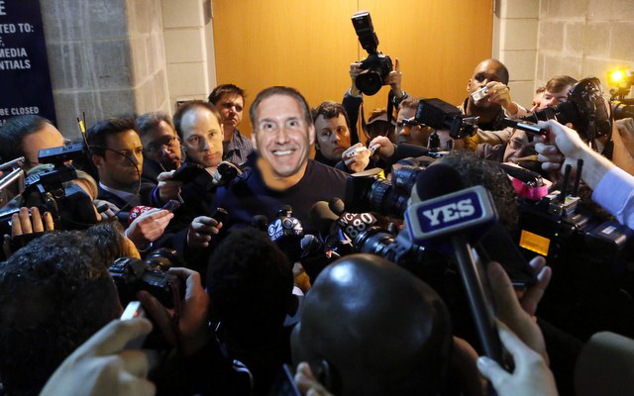
Steve Forman is shown here mobbed by reporters outside the DUMC locker room after his final regular season game against PPC. “I cancelled a proctologist appointment to be here today. I am pretty sure that was a bad choice…”

