Week 4 News and Notes
The NMCSL continued its celebration of Steve Forman’s career by hosting the Steve Forman Celebrity Roast. All present and previous NMCSL stars took their seats at the Dias to roast and ultimately honor one of the icons of the League who has been at the top of his game for over 75 years.

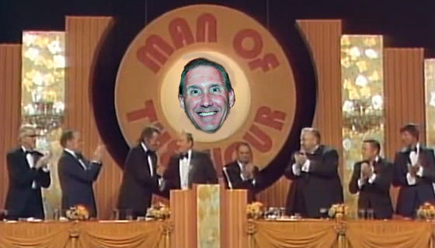
Celebrities lined up to roast and tribute NMCSL Legend, Steve Forman.

Among the guests tributes were:
Doug Horst, Manager, DUMC: “Whenever I have a team that makes a bunch of errors, I can always count on Steve to run right over, and blend in…”
Ed Lambert, Steve’s former Manager at PPC: I’m happy to have an opportunity to talk about how much Steve was the driving force behind our championship years. Unfortunately, I can’t…”
Charlie Gray, Manager MVP: Steve has set records that will never be broken in this league. If you count his 3,457 games played, the 2,509 hits he has accumulated, and throw in the 5,995 errors he has committed, that’s a pretty good career in my book.
When it was announced the League had run out of Steve Forman Farewell Tour Keychains (You can’t buy them in stores) the crowd started booing. Ed Lambert took them microphone and said, “There’s no booing! There’s no booing! If there is another outburst, we’ll let Scott Sergent get up here and tell his jokes…”

8:50 Game
Rivercliff 26 – DUMC 6
With the temperature a balmy 34 degrees and the wind blowing at about 15 mph resulting in a wind chill of 24 degrees, DUMC’s Eskimos took the field against RLC and proceeded to give up 11 runs in the first inning.
“It got so bad,” DUMC’s Steve Forman told the press afterward, “When I had to go to the little second baseman’s room, I had to do my business quickly since we kept going three and out quicker than Dave Ouderkirk changes jobs.”
DUMC Manager, “Dangerous” Doug Horst, after hearing the comment told the press, “I know it's Steve’s last year, but I can still trade him.”
Forman smiled and said, “Promise?”

Rivercliff fans are shown here cheering on their team during the cold morning game against DUMC. Good to see a member of “Diablo” Don Paul’s fan club, The Diabloetts, (second from left) was there to help cheer with her friends from Rivercliff.

10:00 Game
Peachtree Presbyterian 17 – Rivercliff 12
In a hard fought game between two undefeated teams, PPC had just enough to barley shade Rivercliff.
PPC got off to an early lead, then had to hold on late as Riverclif’s “Murderer’s Row” came storming back and barely fell short of stealing the victory.
Now selling at all NCMSL Gift Shops is the new hit single on “Atomic” Adam Meefkof’s label, Atomic Records, “I can’t get to first base with you,” was #5 on the charts last week.
When asked who came up with the name for the band, Meekhof told the press at the release party, “We were going to call the A Notes something else, but the Church objected…”
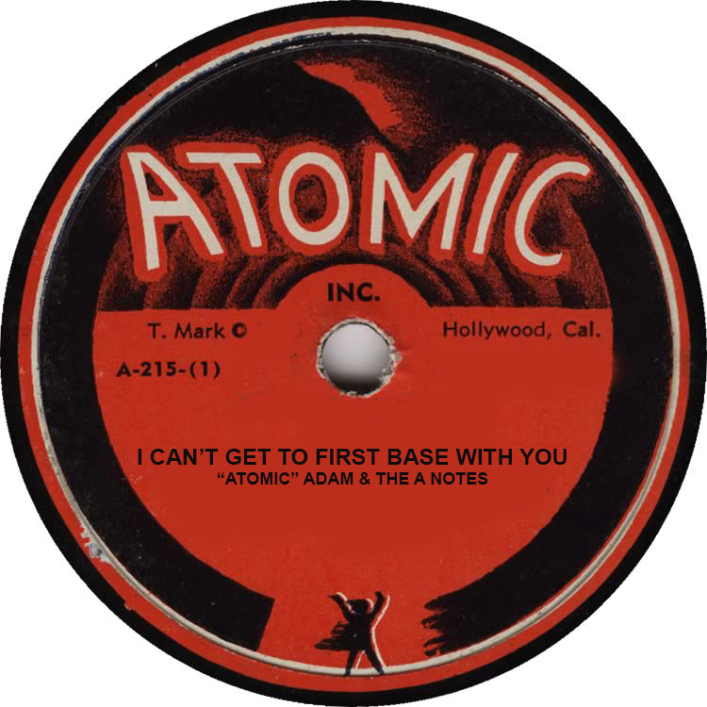

11:10 Game
Peachtree Presbyterian 32 – St. Jude 9
Serving a season long suspension after being found to have perfomance enhancing Geritol in his system, PPC Manager “Luscious” Ed Lambert looks to be enjoying his time away from the stadium.
On a weekly Leaue conference call, Lambter wished everyone a Happy Easter and also sent a picture of himself during his Easter Party to let everyone know how we was doing.

“Happy Easter!” says PPC Manager, Ed Lambert.

12:20 Game
Mt. Vernon 16 – St. Jude 15
A lot of the Mt. Vernon faithful dread seeing St. Jude on their schedule, especially since they have not beaten the Saints since “Diablo” Don Paul was a little bandito.
In fact, the last victory came in 1924, which was Manager Charlie Gray’s rookie season. However, the Mt. Vernon faithful were finally rewarded for their loyalty as the Vernons finally beat their longtime nemesis 16-15 in what is being called “Miracle at the Ros.”
Fast forward to the climatic seventh inning with the score tied 9-9. As usual, St. Jude looked to have salted the game away as they tallied six runs in the top of the inning to go up 15 -9.
However, Mt. Vernon’s "Oil Can" Doyle who is a career 0-368 as a starting pitcher against St. Jude, came up with the bases loaded nobody out. He pulled a Babe Ruth by pointing his bat towards center field and then blasting the next pitch to the spot to score four runs and cap an improbably comeback.
When asked about it after the game Doyle remarked, "Actually, I was pointing to the concession stand to get a couple of chili dogs and a Fresca ready since I was pretty sure I was going to hit into a triple play to end the game.”
Team manager Cha Cha Gray was quoted as saying, "Thank goodness I wasn't needed!"
Gray did score one of the runs in the magical 7th inning while employing the ever controversial "Substitute Runner" rule. It was noted by SJC's manager, Craig Ambrosio, there was an unfair advantage when Gray inserted himself in the game during the last half inning of the game.
Umpire Jesse told the press, “I agree it was an unfair advantage. For MVP, since Gray is so slow, by the time he gets to the base, his clothes have gone out of style.”
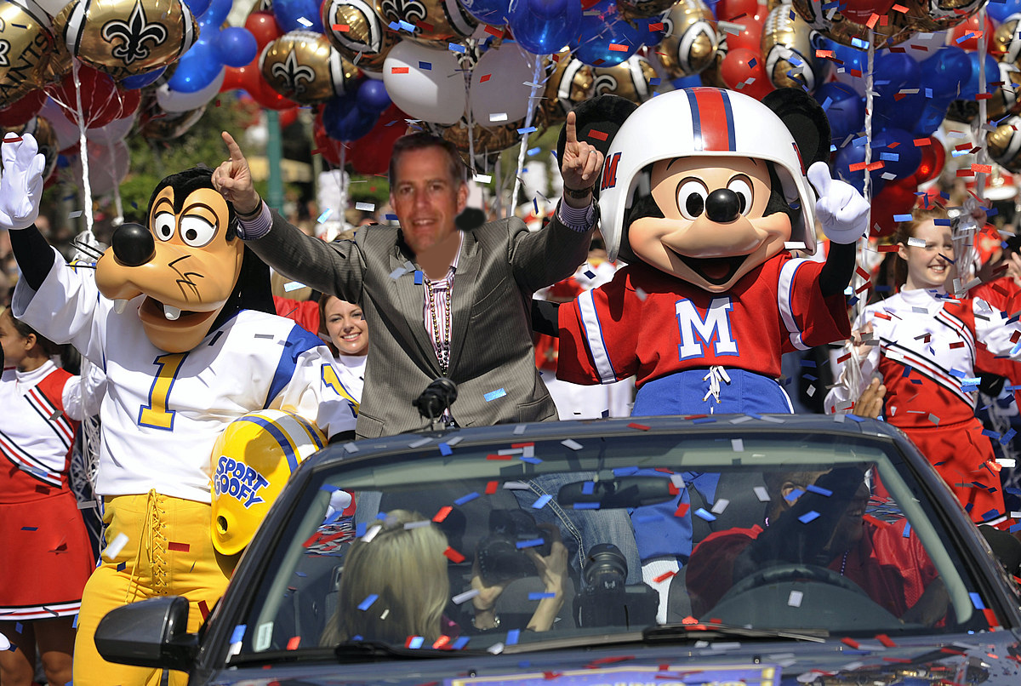
Mt. Vernon threw a victory parade for their players after their first win over St. Jude since the 20’s. At the center of the parade is their manager, Charlie Gray, who got a victory ride with Mickey and Minnie.

