Week 3 News and Notes
The Steve Forman Farewell Tour has reached Week 3 of the Season with
“The Stunning One” spending a little quality time making a personal appearance in Las Vegas before Saturday’s game against PPC.
“When you get to be my age you need some quality time away, and as you can see, this was quality…”
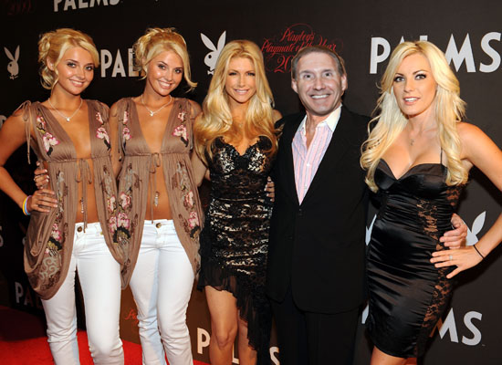
“Stunning” Steve poses with a few of his many fans, who stood in line for hours to get their picture taken with him at a special autograph session Friday night.

8:50 Game - RLC 24 – MVP 12
Facing a pitching dilemma going into the Mt. Vernon game, new manager “Atomic” Adam Meekof tapped former Rookie of the Year “Precious” Paul Anderson to take the rubber, and Anderson responded by striking out three.
Kevin “The Funkmeister” Futo was 3-4, Mike “Mr. T” Turner, who is sporting a Mohawk just like his name sake, was an incredible 5-5 and the before mentioned “Atomic One” was 3-4 with a three run homer that hit the Ross Milke Doughnut Shop sign in centerfield. Meekof now gets free doughnuts for the rest of the year.
The game was a back and forth contest until the top of the 6th when RLC put up ten runs to stretch the lead to 12 and seal the victory.
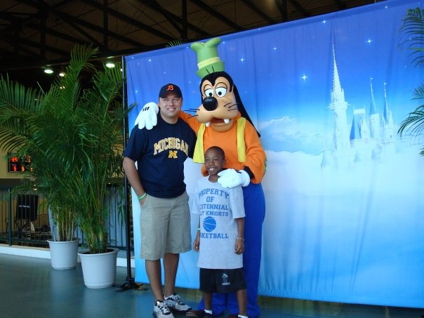
If this hitting tear continues, we could see a repeat of “The Atomic One” being named NMCSL MVP. Here he is after winning the award in 2010 at Disney World and was the Grand Marshall of the daily parade. Here he is posing for pictures with Goofy and a young fan.

10:00 Game - RLC 13 – DUMC 8
Well, he didn’t get the name “Atomic” Adam for nothing as the Rivercliff slugger went deep in the second game to lead Rivercliff to a 3-0 record in a close 13-8 victory over DUMC.
The $100 outfield of Mike “Mr. T” Turner, Kevin “The Funkmeister” Futo, “Demolition” David Oster and Warren “Sweet P” Phillips made sure the lead stood up as DUMC score five times in the top of the 6th, but could get no closer.
Once again, “Precious” Paul Anderson baffled the hitters with a pair of strikeouts, and now leads the league in strikeouts and hit batsmen. He even threw at his own kid in a father and son game.
Mike “The Rifleman” Rhielman went 3-4 as well.
“Stunning” Steve Forman, still a little red eyed from his weekend visit to Vegas, responded with a 500 foot blast to deep left field, but the fences at East Roswell are 501 feet, so it was a long fly out.
Chris “The Punisher” Parks did hit a ball 502 feet for his first home run of the year, and Robbie “Pretty Boy” Floyd, also had a clutch hit to close the gap early, but RLC held on late.

During the RLC game, fans behind the dugout were competing in the Steve Forman look-a-like contest, to promote his Farewell Tour. The winner received a free dinner at the Golden Corral with the DUMC legend. The second place winner received two free dinners with him.

11:10 Game - PPC 21 – DUMC 3
PPC got three touchdowns from “Devastating” Dave Ouderkirk, and new pitcher Zach “Little Ravishing” Radermacher held the vaunted DUMC offense to one field goal in a 21-3 victory.

Desperate for some offense, DUMC manager, “Dangerous” Doug Horst, has reached out to a former feared slugger to see if he could help their team.
“Babe Ruth and I were great friends and we gave him a tryout years ago, but because of roster limits, and players with guaranteed contracts, we had to cut him,” said “The Dangerous One.”
When asked how Ruth, who has been dead for about a bazillion years, could help the team, Horst joked, “This guy plays dead a lot better than some of our guys play alive.”
Only “The Dangerous One” can come up with a sensational ploy such as this, and have it make sense.
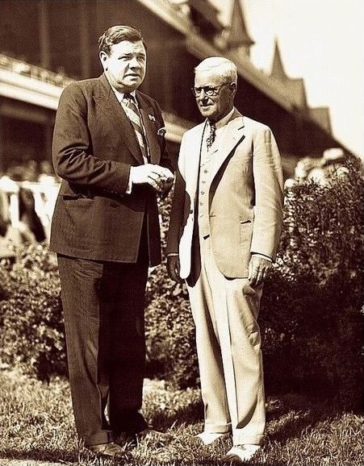
“Dangerous” Doug is once again pulling the strings that could blow the lid off the NMCSL as he is considering bring back Babe Ruth to play for DUMC. Doug looks as if he has not aged one day since this photo was taken.

12:20 Game - PPC 25 – SJC 14
In what has been referred to the best rivalry in all of sports (Well, in all of East Roswell Park anyway) PPC renewed its long-standing rivalry with St. Jude in their first of four matchups in 2015.
In a game that had more swings than a playground, SJC got out to a first inning 11-0 lead as everyone in the lineup had about 50 hits. After the first inning was over, Umpire Jessie had to replace the balls due to them being dented and lopsided from the SJC bats.
PPC began to chip away at the lead and when it was over, they had outscored SJC 25-3, to win the game to do to 4-0 with dangerous Rivercliff on the schedule next.
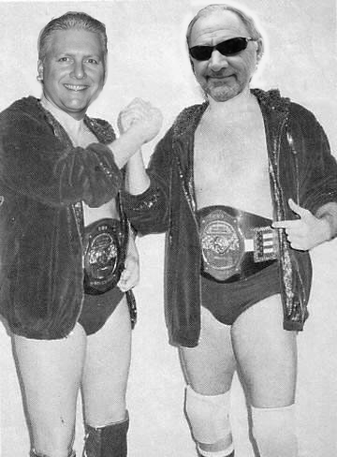
To stay in shape during the Lockout, “Luscious” Ed and “Ravishing” Rick joined Georgia Championship Wrestling and became the tag team champions, which they held until they left the promotion to begin he 2015 season.

