Week 1 News and Notes

The NMCSL was back after a year long lock out by management as the players demands for Rick Radermarcher to finally retire and the right to have a two joke minimum when Jessie goes over the rules during the pregame prayer was granted.

In other news, it was announced during the off-season in a tearful press conference that Steve “I have ties older than some of the players in this League” Forman would be playing in his final season in the NMCSL.

As it turned out, the tears were of joy as Forman told the media, “Just think what that means as far as the gifts each team will give me as I make my farewell tour. Am I a genius or what?”

DUMC Manager, “Dangerous” Doug Horst added, “I’ll be the first to send Steve a gift. And that is a swift kick in his backside because when he leaves I get the title of oldest player in the League. Thanks a lot, Steve…”

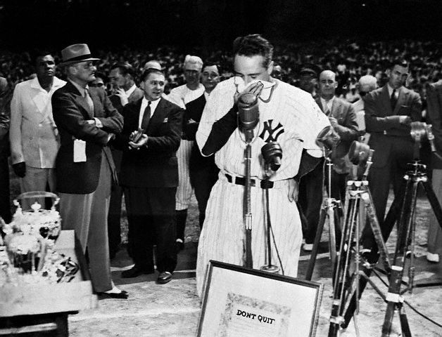
Steve Forman, shown here giving his retirement speech, covers his nose after it was revealed “Gorgeous” Glenn Bell visited the Los Rancheros on his way to the press conference.

8:50 Game DUMC vs. St. Jude
St. Jude and DUMC kicked off the 2015 NMCSL season in very frigid conditions Saturday. Both teams struggled to maintain any offensive consistency in the early innings.

Trailing 7-0 in the top of the 7th, DUMC rallied for their first runs of the season, and when all the dust, or snow as the case may be, settled and the runners had stopped, they put up an 8-spot to actually go ahead.

The lead was the first time DUMC has led SJC in any part of a game since the 1924 season (Forman’s rookie year by the way).

SJC came back to score two runs in the bottom of the 7th for the final score of 9-8.

Part of the reason this was such a low scoring game was the fact the white softballs kept getting lost in the snow.


Conditions for the 2015 NMCSL season opener were a bit on the frigid side, but all teams gutted through the cold to get Week 1 in the books.

10:00 – PPC vs. DUMC
Even though PPC got the 17-0 victory, the game was closer than the
final score might indicate, at least in the eyes of PPC since they were weary of another potential great DUMC come-back, as in Game 1.

With Manager “Luscious” Ed Lambert serving a season long suspension for testing positive for performance enhancing Geritol, Assistant Manger (Emphasis on the first three letters) “Ravishing” Rick Radermacher took the helm and got his first victory as PPC Manager.
When asked about PPC’s outfield, which had two rookies and a second year player, Nate Morrow, playing alongside veteran Scott Sergent, Radermacher was asked how important it is to have a veteran like Sergent helping the younger players out.
“I could go on for days about his leadership, hitting for both power and average, and his tremendous speed, but it seems silly to be talking about how great Nate Morrow is when you asked me about that old fart Sergent…”
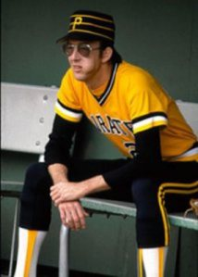
PPC’s Assistant Manager, “Ravishing” Rick Radermacher looked a little tense before he took the helm as PPC’s skipper for the season opener.
11:10 MVP vs. PPC
MVP got off to a great start in this one as they took an early lead, but arm troubles for MVP’s “Texas” Terry Doyle led to a tough loss in the third game of the day.
When asked if he was going to be examined by world-renowned orthopedic specialist, Dr. James Andrews in Birmingham, MVP Manager Charlie “Cha Cha” Gray responded, “We passed the hat around in the dugout and ended up with enough dough to get Terry to the doctor.”
“It wasn’t James Andrews, but we had enough to get a….um…doctor.” (pictured below)

MVP will bring in Dr. Frankenstein to look at “Texas” Terry’s ailing shoulder and hopefully have him ready for next week’s games.

12:20 Rivercliff vs. Mt. Vernon
“Rivercliff won 20-11. The whole team played great and our infield play was strong as well. I don't really have a name to call out for you.”
And thank you to “Atomic” Adam Mekoff for that detailed recap of the game. He’s not the best reporter in the NMCSL for nothing…
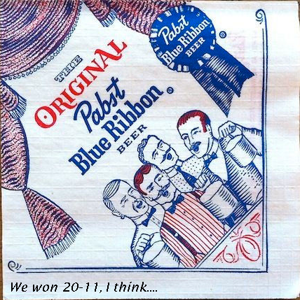
Updates from “Atomic” Adam can come into the NMCSL offices in a variety of ways…

Umpiring in the NMCSL
There was talk of a shaky umpire in Week 1’s games and there were a few calls that were questioned by some.

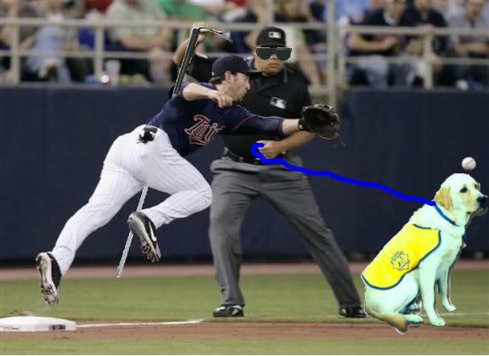
Action from the St. Jude – DUMC game where the umpiring came into question.

Wanting to capitalize on the controversy, NMCSL League Officials have begun printing T-Shirts to be sold at all NMCSL Stadiums and local NMCSL Retail Outlets around Atlanta to raise money to cure Umpire blindness so this terrible epidemic can be a thing past. 
LATE BREAKING NEWS!!!!!
As of press time on Monday, an interesting development has been reported into the NMCSL League Offices regarding the umpiring controversy.
“The East Roswell Heartthrob” Jonathan Cochran has once again stepped up to help the League.
In response to this latest League crisis, “The Heartthrob” has offered the services of some of his “Acquaintances” to replace umpires who consistently make bad calls.
“It is the least I can do for the League to help out with what I understand is a terrible situation that we should not have to deal with.”
“In fact, Daphne here would be happy to start calling the games this Saturday, if we need her,” he chuckled as he walked to his limo after the press conference.

Strike One as the “The East Roswell Park Heartthrob” has saved the day. The NMCSL would like to personally welcome Daphne to the League and know she will be a welcomed addition to the umpiring crew.

