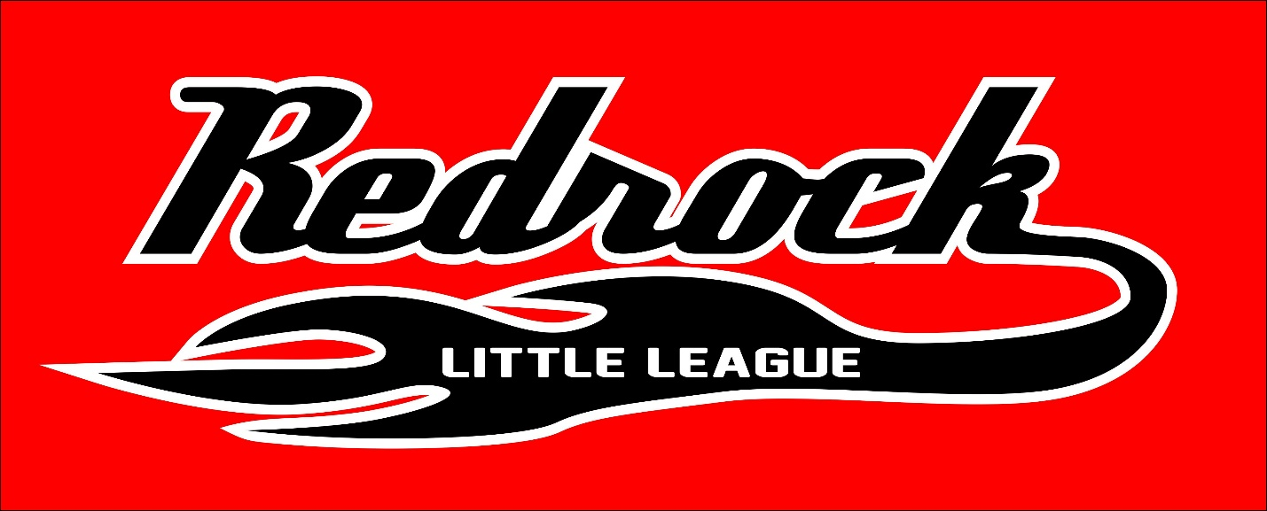
www.redrockbaseball.com
redrocklittleleague@gmail.com

Dear Friend,

The purpose of this letter is to request your tax-deductible financial support for the upcoming season. We are a 501 C3 non-profit organization providing children from ages 4 to 16 the opportunity to play the Great American Past time, baseball. Our program benefits hundreds of boys and girls each year and we are now beginning our sponsorship program for the upcoming season. As a nonprofit organization, we are dependent on business support to provide equipment, uniforms and fields for the children. The registration fees, snack bar venue and other fundraisers do not cover the leagues operating expenses.

Redrock Little League is part of Nevada District 4 and we have been part of the Little League Organization since 1990. We have won many all-star titles over the past 15 years including District & States Champions over multiple divisions we believe we teach our children much more then just baseball. We are especially proud of the development of our player’s personal self-esteem, teamwork, camaraderie, confidence and sportsmanship!

To properly recognize donors, we have established six levels of sponsorship. Please see the Sponsorship form enclosed with this letter. Please do not hesitate to contact any of our directors for additional information.

Sincerely,

Redrock Little League Board of Directors

Redrock Little League
P. O. Box 82156
Las Vegas, NV 89180
(702) 380-7888
Fax: (702) 248-0254
www.redrockbaseball.com
redrocklittleleague@hotmail.com

We ask your help in sponsoring Redrock Little League by choosing one of the following levels. 100% of your money goes directly into helping the league, etc. In return for your sponsorship Redrock Little League will provide the following benefits.

___All-Star Sponsor $2,000
You will receive:
- Your company name/logo will be screen printed to the right sleeve of all of the player’s uniforms of all of the teams in one of our divisions.
- We will also have a color banner with you company’s logo placed on the outfield fence of two of our fields at Rainbow Family Park complex.
- A photograph of the division players on a plaque thanking you for.
- During opening day, you will be able to have a table setup to meet the players and parents.
- Your name will be recognized on our website.

___Grand Slam Sponsor $1,000
You will receive:
- Your company name/logo will be screen printed to the back of 1 team’s uniforms in one of our divisions.
- We will also have a color banner with you company’s logo placed on the outfield fence of two of our fields at Rainbow Family Park complex.
- A photograph of the team on a plaque thanking you for.
- During opening day, you will be able to have a table setup to meet the players and parents.
- Your name will be recognized on our website.

___Home Run Sponsor $500
You will receive:
- Your company name/logo will be screen printed to the back of 1 team’s uniforms in one of our divisions.
- We will also have a color banner with you company’s logo placed on the outfield fence of one of our fields at Rainbow Family Park complex.
- A photograph of the team on a plaque thanking you for.
- Your name will be recognized on our website.

___ RBI Sponsor $250
You will receive:
- We will have a color banner with you company’s logo placed on the outfield fence of one of our fields at Rainbow Family Park complex. (You may purchase multiple banners)
- Your name will be recognized on our website.

___ Pinch Hit Sponsor $150
You will receive:
- Your sponsorship will be go toward supporting one Little League Player that otherwise might not get the opportunity to play.

Upon request, sponsors will receive a team schedule and a list of the players. Please make checks payable to Redrock Little League. This is a tax-deductible contribution (FED TAX ID # 88-0265229).

WE THANK YOU FOR YOUR SUPPORT
________________________________ _______________________________
COMPANY NAME DATE COMPANY WEB ADDRESS
________________________________ _______________________________
COMPANY ADDRESS DIVISION/TEAM
________________________________ _______________________________
CITY/STATE/ZIP MANAGER’S NAME
________________________________ _______________________________
CONTACT PERSON PHONE NUMBER NAME OF PLAYER (IF APPLICABLE)

____________________________________________________________________
NAME TO APPEAR ON BANNER
PLEASE PROVIDE YOUR LOGO BY ATTACHING IT TO THIS PAGE, BY E-MAIL OR ON A DISK.

I AGREE TO SPONSOR REDROCK LITTLE LEAUGE IN THE AMOUNT OF $_________
________________________________ _______________________________
SPONSOR SIGNATURE DATE LEAGUE REPRESENTATIVE

REMARKS: __________________________________________________________________________________________________________________________________________________________________________________________
I AM UNABLE TO SPONSOR A TEAM AT THIS TIME. HOWEVER, I WOULD LIKE TO MAKE A CONTRIBUTION.

