Cousin, Uncle, Brother
Written, animated, produced by Academy Award winning Director Adam Elliot (“Harvie Krumpet”).

Cousin
(4 minutes)

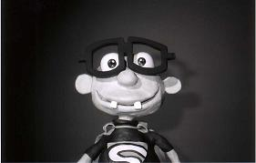

‘Cousin’ is the childhood remembrance of a little boy born with cerebral palsy.
Being of the same age, the narrator tells of their antics together as children: their
Attempts to fly off the chickenshed roof, out of control shopping trolley rides and games of violent cricket in the backyard. We meet his newest pets and visit the graveyard of the old ones, aswell as glancing his many assorted collections of tee shirts, pet rocks and toenails. We observe how he copes with his disability using safety pins and finger breaking and follow him to the depths of the ocean where he contemplates his world.

Uncle
(6 minutes)

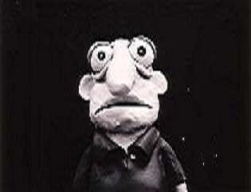

‘Uncle’ is the biography of a humble man, retold and narrated by an anonymous nephew who strings together a collection of his uncle’s passions, failings and beliefs. With their first meeting in the uncle’s hardware shop, a lifelong bond is established with the gift of a spider bent together with pipe cleaners. Over time the nephew acquaints himself with his uncle’s eccentricities, gory bedtime stories, chats with religious salesmen, fertilizing the lemon tree, burning fetishes, snail crushing and odd culinary pursuits.

Uncle’s two closest companions, his wife and Chihuahua, Reg, are briefly mentioned before encountering horrible deaths. As uncle ages we gain an understanding of his struggle with life and its meaning to him. We observe an unfortunate pyjama incident that signals his retreat into senility to the Ashburn Gentlemen’s Hospice. There he spends his final days surrounded by his saddened bedfellows and beefy urinal smells, drinking cups of tea and nibbling on burnt crumpets.

Brother
(8 minutes)

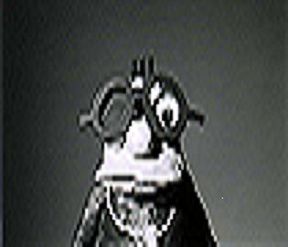

‘Brother’ is the childhood memory of a little boy afflicted with asthma. Through the narrator, we observe the antics of the two brothers from swinging on the clothesline, to chasing the chickens, from combusting ants, to pooing in the bath.

We learn about ‘getting the blame’, how to smoke a teabag and that getting head lice can turn you into a leper. We discover the delights of leaving other peoples names in cement and that if the devil doesn’t get you then ‘karma’ will. Above all we watch as a little boy deals with a horrible disease that defers his dream of becoming an acrobatic clown.

