Populations and communities

Checkups and follow-ups
EST
Questions 1–19 and A–C
ChaptEr 9
Checkup
1 STUDYING populations (pp. 292–302)
1. What do the living organisms that form a population have in common?
2. Give two examples of a plant population and two examples of an animal population.
3. How can knowing the size of a wolf population be useful?
4. For each of the following examples, name the factor that makes the population size vary (births, deaths, immigration or emigration) and specify its effect.
a) Every spring, Canada geese return to the shores of Lac Tranquille.
b) During a logging operation, the noise from the forestry vehicles scared away the white-tailed deer in the vicinity.
c) In the spring, a female bear nurses her three cubs in her den.
d) Fish farmers stock a river with salmon fry.
e) Cottage owners can eliminate voles by installing traps in the roof.
Write your answers in the table below.
Example | Factor | Effect on population size
a)
b)
c)
d)
e)
5. What happens to a population when death and emigration rates are higher than birth and immigration rates?
6. The photos below show a slug (A), an American robin (B) and a bison (C). What would be the most appropriate method for measuring the size of a population of each of these species?
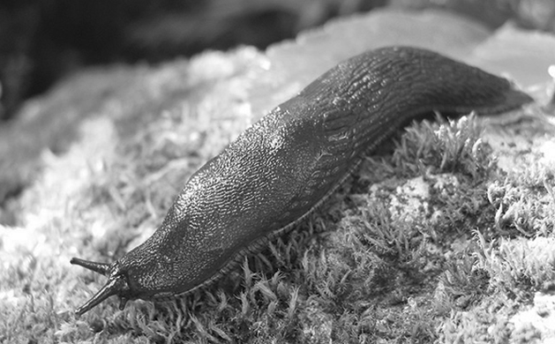
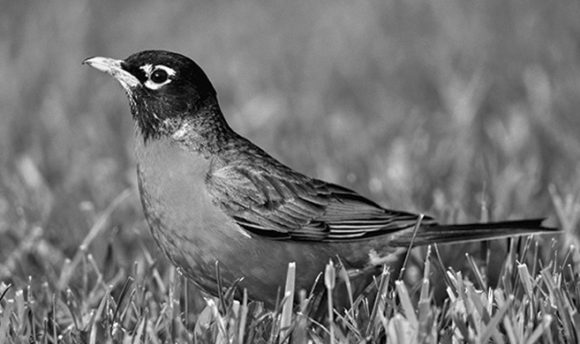
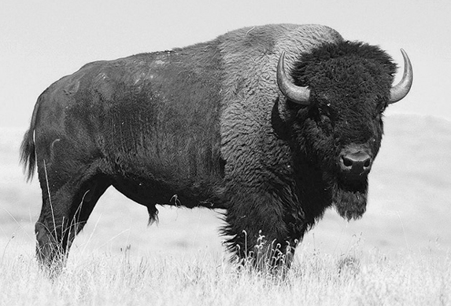
7. Scientists want to determine the size of a population of brook trout in a lake. First, they catch 50 trout, tag them and release them. A few days later, they catch 55 trout, including 11 tagged fish.
a) Which method for measuring population size did the scientists use?
b) What is the estimated population of brook trout in this lake? Show your calculations.
8. The twelve-spotted lady beetle feeds on the eggs of the Colorado potato beetle (a pest that attacks potato plants).
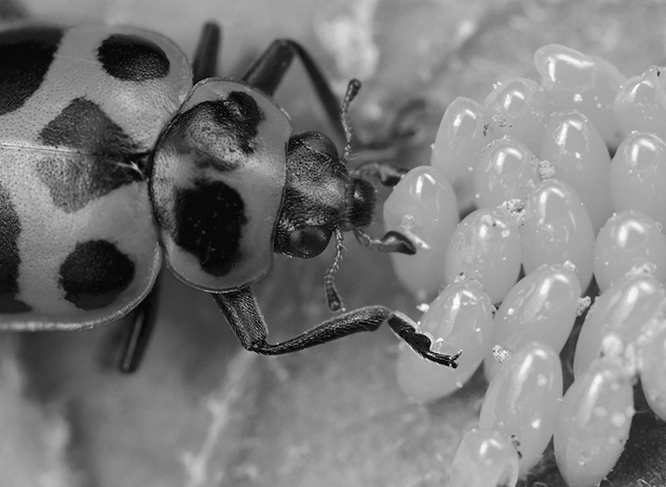
Biologists wanted to study the population of this type of lady beetle in a potato field of 10 000 m², so they counted the number of individuals in one-square-metre quadrats. The table on the following page presents the results of this sampling.

Quadrat number | Number of twelve-spotted lady beetles | Quadrat number | Number of twelve-spotted lady beetles
1 | 2 | 6 | 0
2 | 1 | 7 | 0
3 | 0 | 8 | 1
4 | 1 | 9 | 1
5 | 0 | 10 | 0
a) What is the size of the population of twelve-spotted lady beetles in the field under study? Show your calculations.
b) What is the population density of twelve-spotted lady beetles in the field under study? Show your calculations.
c) If the population of twelve-spotted lady beetles were higher than the Colorado potato beetle population, what would happen?
9. The table below contains statistics on the human population and the area of Canadian provinces and territories (according to Statistics Canada, April 1, 2007).
Province or territory | Population | Total area  (km²)
Nfld. | 506 548 | 405 212
P.E.I. | 138 800 | 5 660
N.S. | 932 966 | 55 284
N.B. | 748 878 | 72 908
Québec | 7 687 068 | 1 542 056
Ontario | 12 753 702 | 1 076 395
Manitoba | 1 182 921 | 647 797
Saskatchewan | 990 212 | 651 036
Alberta | 3 455 062 | 661 848
B.C. | 4 352 798 | 944 735
Yukon | 30 883 | 482 443
N.W.T. | 41 795 | 1 346 106
Nunavut | 31 216 | 2 093 190
a) In which province or territory is the population density the lowest?
b) In which province or territory is the population density the highest?
c) How does Québec rank in population density compared to the other provinces and territories?
10. a) What is the main factor affecting the density of any population?
b) Name two other factors that have an impact on population density.
11. Given that most of the Canadian population lives in cities, what is the pattern of population distribution in our country?
12. Which pattern of distribution is illustrated by each of the following situations?
a) In a forest, the fir trees are scattered about at random.
b) Fungi grow in colonies on the trunks of dead trees.
c) Several clouds of mayflies hover over a lake.
d) The hummingbirds in a valley aggressively defend their respective territories; they tend
to build their nests at equal distances from one another.
at equal distances from one another.

13. Do the studies described below relate to a biotic or an abiotic factor?
a) An ecologist studies the effect of hares’ browsing on a
population of fir trees.
b) Chemists test the acidity of a soil sample.
c) A water specialist assesses the amount of sunlight at
different depths in a lake.
d) Ecologists test a river for amounts of phosphorus from
agricultural fertilizers.
14. Is the amount of oxygen in a lake a limiting factor for a population of fish (bass or trout, for example)? Explain your answer.
15. Why does the size of the hare population in Québec decrease when the size of the lynx population increases?
2 STUDYING communITIEs (pp. 303–309)
16. The Earth is home to many communities.
a) What do the living organisms that form a community have in common?
b) What is a community composed of?
17. The Amazon Rainforest, in South America, is considered the most diverse forest habitat on Earth. What criteria do scientists use to establish the degree of biodiversity in a community?

18. Look at the photo opposite and answer the following questions.
a) What is the interaction between the bee and the flower called?
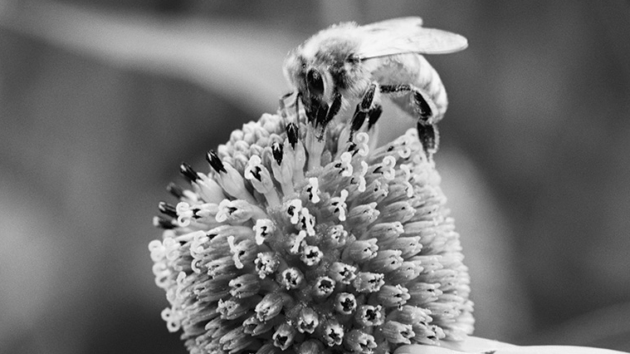
b) If a bumblebee flies up to the flower to feed on its
nectar, how will the first bee and the bumblebee interact?
c) If a bird eats the bee, what type of interaction would that be?
d) If aphids attack the flower and damage its leaves, what would be the interaction between the aphids and the flower?
e) If a spider spins a web, attaching one of its threads to the flower stem, what would be the interaction between the spider and the flower?
19. True or false? Explain your answers.
a) The biodiversity of a community can be qualified as high when one species in the community is much more abundant than other species.
b) In a relationship of parasitism, one of the living organisms is a parasite, and the other is its prey.
c) When populations in a community interact through mutualism, this interaction tends to increase their population densities.
d) Competition has a positive impact on population density.
e) Parasitism and predation refer to exactly the same phenomenon.

REVIEW QUESTIONS
A. The mark-recapture method was used to estimate the size of the groundhog population in a field. According to this estimate, the population was 50.
a) Subsequent studies of groundhog behaviour revealed that these animals can recognize a trap more easily if they have already been captured. In light of this new information, is the estimate of the size of the groundhog population too high or too low? Explain your answer.
b) Recapturing took place in May, when it was observed that many females were about to give birth. In light of this information, is the groundhog population more likely to grow or decrease?
c) Explain why quadrat sampling would not have been appropriate for estimating the size of the groundhog population.
B. During a study on a population of red fox, many of these animals are discovered to live near the groundhog population of the previous question.
a) Since foxes may feed on groundhogs, what type of interaction connects these two populations?
b) Do the fox and groundhog populations form a community? Explain your answer.
c) How does the presence of foxes affect the density of the groundhog population?
d) Explain why the size of the fox population could not be calculated using aerial photography and suggest an appropriate method for estimating the population size.
C. Prepare your own summary of Chapter 9 by building a concept map.
Follow-up
1. Do you think that the methods used to save peregrine falcons could be applied to all other endangered species?
2. Peregrine falcons feed on other birds, especially pigeons. These birds of prey are now introduced into airports. Explain how they can be useful in such places.

