The biosphere

Checkups and follow-ups
EST
Questions 1–22 and A–C
ChaptEr 8
Checkup
1 WHAT IS THE biosphEre? (p. 254)
1. Can the water in a lake be considered part of the biosphere? If so, explain your answer.
2 biogEochEMICAL cycles (pp. 255–261)
2. List the processes of the carbon cycle that are illustrated in the photos below.
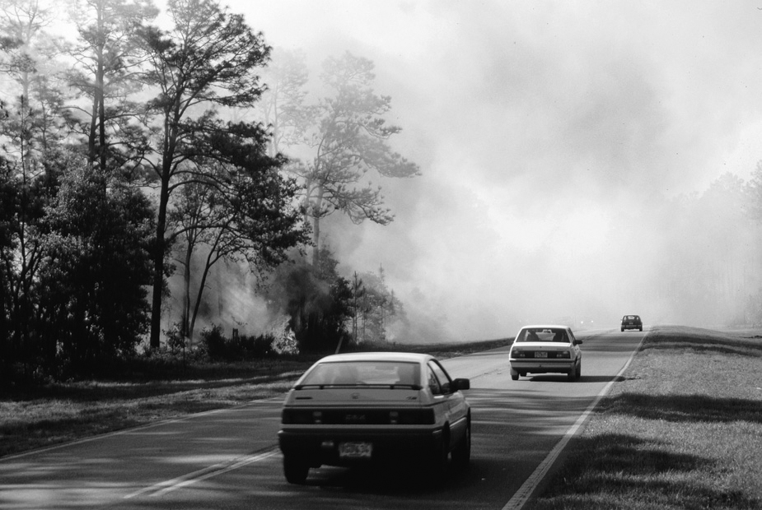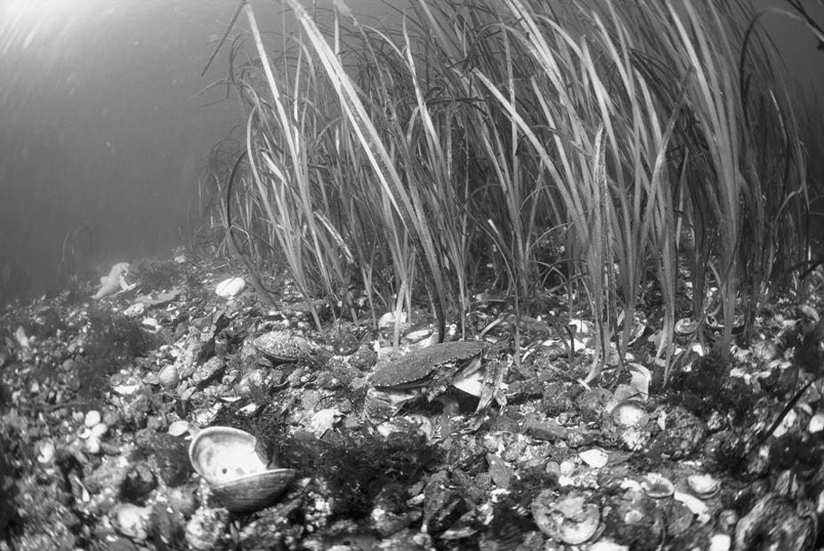
3. Carbon dioxide (CO₂) is an important source of carbon for living organisms.
a) Through which two processes does carbon enter the biosphere?
b) The carbon absorbed by human beings usually ends up returning to the atmosphere as CO₂. Briefly describe the two processes involved in this transfer.
4. What process matches each of the following descriptions?
a) the process by which bacteria take atmospheric nitrogen and change it into ammonia
b) the process by which bacteria change ammonium into nitrites
c) the process by which bacteria change nitrates into nitrogen
5. Without plants, herbivores would be unable to manufacture the DNA molecules they need to store their genetic information. Explain your answer.
6. The nitrogen cycle is disrupted by human activity.
a) Which farming practice is the main source of this imbalance?
b) What are the consequences of this practice?
7. Look closely at the photo opposite.
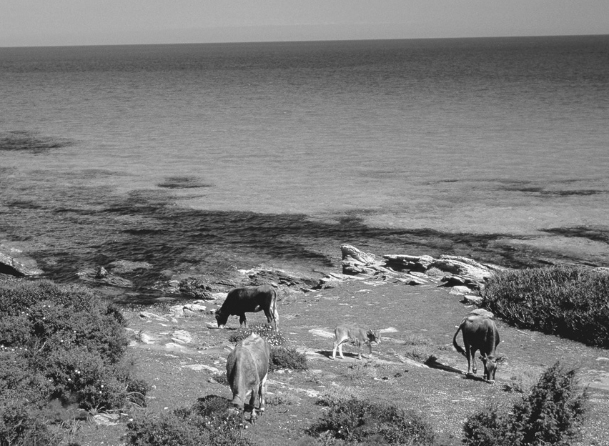
a) In this scene, where is phosphorus mainly
to be found?
b) Name three sources of phosphorus that are
accessible to humans.
c) The phosphorus absorbed by plants and
humans eventually returns to its original state
as rock. Explain how.
8. The natural phosphorus cycle is disrupted by human activity.
a) Which human activities have the greatest impact?
b) How do these activities affect lakes, rivers and other bodies of water?
c) What steps can we take in our everyday lives to reduce these effects?
9. Which biogeochemical cycle is related to each of the following phenomena?
a) Ammonia reacts with hydrogen to form ammonium.
b) Rocks erode, worn away by rain and wind.
c) Through photosynthesis, plants manufacture the
glucose they need for energy.
d) Calcium carbonate enters into the composition of the shells and skeletons of certain marine organisms.
e) Decomposing waste produces methane.
f) Decomposing waste produces ammonia.
3 biomes (pp. 262–279)
10. Answer the following questions on the factors that determine biome distribution.
a) How does latitude affect the distribution of terrestrial biomes?
b) What factors do you think could determine whether trees grow in a particular environment?
c) What is the principal factor that differentiates aquatic biomes?
11. Answer the following questions, referring to the photo
opposite.
a) What type of forest is it?
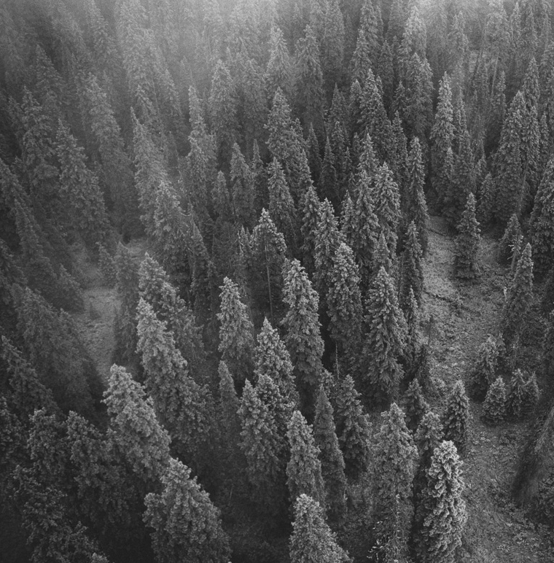y
b) What are the main differences between tropical
forests, boreal forests and temperate forests?
12. The tropical forest is the terrestrial biome with the richest biodiversity, but it is threatened by certain human activities. What are these activities?
13. In Québec and Ontario, a large part of the temperate forest has been cut down. Explain your answer.
14. Which type of grasslands matches each of the following descriptions?
a) They are found mainly in Africa and South America, in regions where it is hot all year
round.
b) They cover a large part of Alberta, Saskatchewan and Manitoba, in regions where farming plays an important role.
c) They are found in certain regions of Asia and North America, where the summers are hot and the winters are cold.
15. Which zone of an alpine biome matches each of the following descriptions?
a) Only bushes and grasses grow there.
b) A mixture of conifers and deciduous trees can be
found there.
c) Grain crops and deciduous forests dominate the landscape.
d) The snow there never melts.
e) It is the highest zone in which trees can still grow.
16. Look at the two photos below.
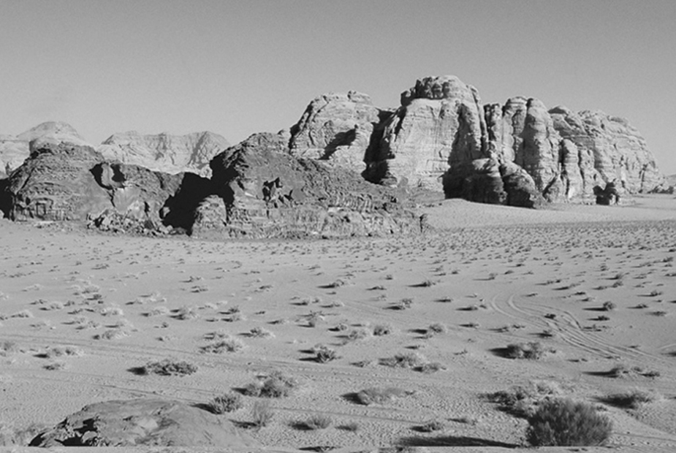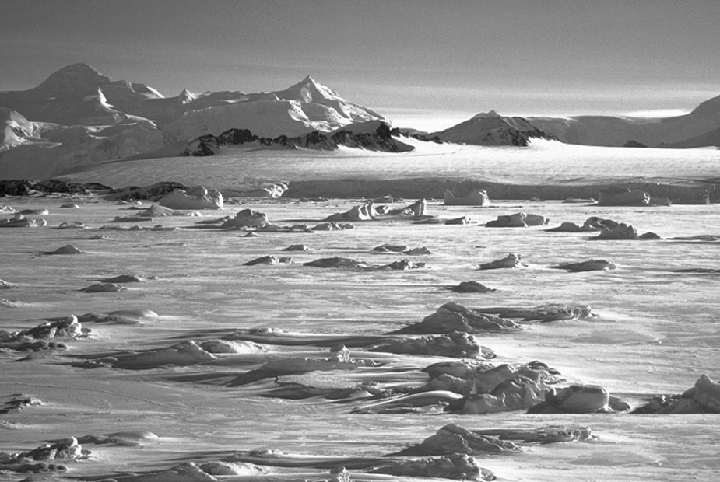
a) Which biome is pictured?
b) What characteristics are common to these two environments and to all the environments that make up this biome?
17. Is it true that it is hot night and day in sandy deserts? Explain your answer.
18. Name three factors that affect aquatic biomes.
19. Which type of aquatic biome is illustrated in the
photo opposite? Explain your answer.
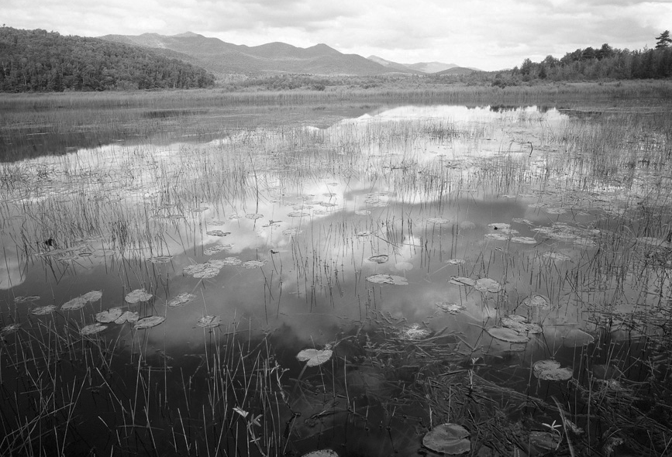
20. Wetlands help reduce the risks of flooding.
Explain how.
21. Which type of aquatic biome matches each of the following descriptions?
a) They are home to more than 500 000 animal and plant species.
b) They are the places where rivers and oceans meet.
c) They are bodies of fresh water surrounded by land.
d) They contain the greatest part of the water on Earth.
22. Look at the photo opposite.
a) Which biome is illustrated in this photo?
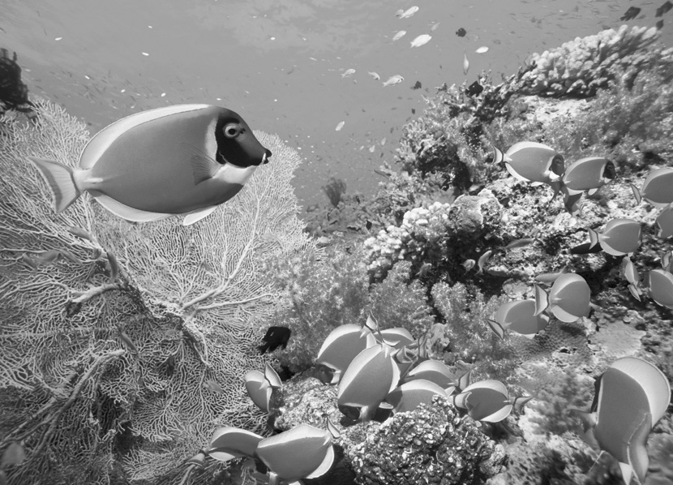
b) Why is this biome at risk?
c) Why is it important to protect it?
REVIEW QUESTIONS
A. The photo opposite shows a black bear,
the most common bear in North America.
Black bears usually live in forests and
mountains, where they can find food and
shelter and easily climb trees when they
wish to escape danger. They are omnivores
although their diet consists primarily of
plants; they sometimes feed on insects,
rodents and fawns. Black bears are good
swimmers and can catch fish in rivers to
supplement their diet.
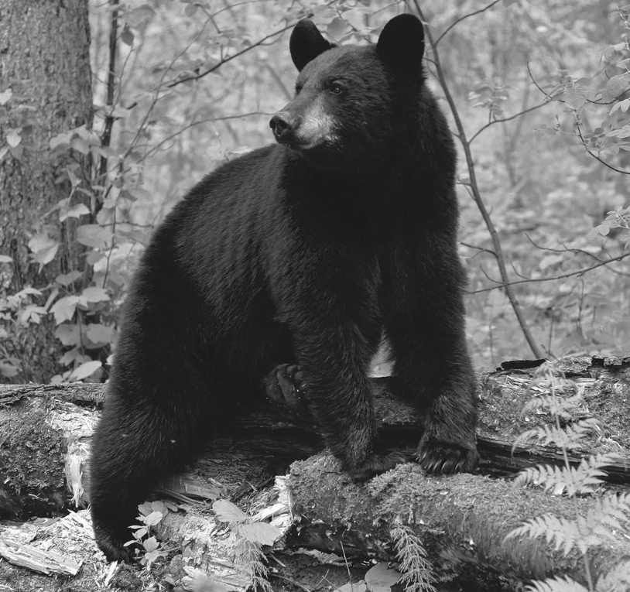
a) The forest where this black bear lives contains a mixture of coniferous and deciduous trees.
What type of forest is it?
b) How do plants obtain the carbon and nitrogen they need?
c) What are the black bear’s sources of nitrogen?
d) The leaves and dead trees on the forest floor will be decomposed by earthworms and microorganisms. Name some products that will be released into the environment as a result of this decomposition.
B. Match each of the species described below with the appropriate biome.
a) The arctic fox lives in an environment with minimal vegetation: a few scrubby bushes, mosses and lichen. To hide from predators, the fox has adapted to its surroundings in a particular way: its fur turns white in winter to help it blend into the snowy landscape.
b) The Fraser fir puts down its roots in acidic soil. It lives in an environment consisting of mosses and lichen.
c) The minnow is a small fish, 10 cm long, which thrives in
rapid currents and well-oxygenated water.
d) The Mojave yucca (illustrated opposite) receives an
annual average of 13 cm of rain.
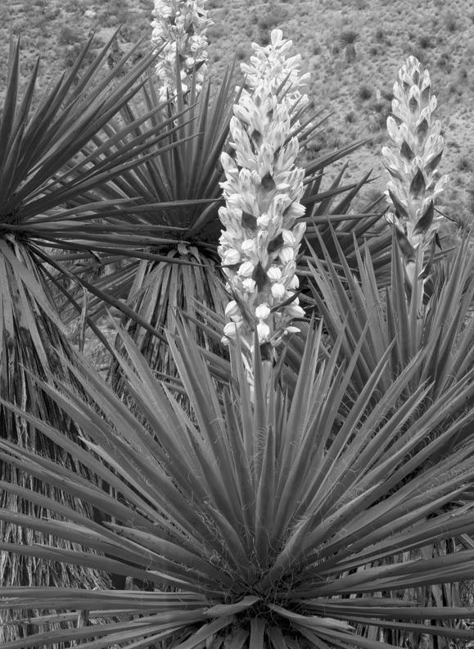
e) Alligators live in slow-moving, shallow waters that are
rich in vegetation.
C. Prepare your own summary of Chapter 8 by building a
concept map.
Follow-up
1. What would be the negative consequences of the disappearance of peat bogs?
2. Why is it so difficult to restore a peat bog once it has been destroyed?

