The atmosphere and space

Checkups and follow-ups
AST
Questions 1–9, 12–14, 21–32, A, C and D
ChaptEr 7
Checkup
1 THE atmosphere (pp. 222–239)
1. True or false? Explain your answers.
a) The atmosphere is the 30-km-thick layer of air surrounding the Earth.
b) The atmosphere is composed mainly of oxygen.
c) The atmosphere protects us from the sun’s harmful rays.
2. Which layer of the atmosphere matches each of the following descriptions?
a) It is the coldest layer of the atmosphere.
b) Meteorological phenomena occur in this layer.
c) It contains the ozone layer.
d) It is the warmest layer of the atmosphere.
e) Most satellites travel in this layer.
3. On October 23, 2007, the space shuttle Discovery blasted off from the Kennedy Space Center, in Florida, to deliver equipment to the International Space Station. Name, in order, the layers of the atmosphere the shuttle passed through.
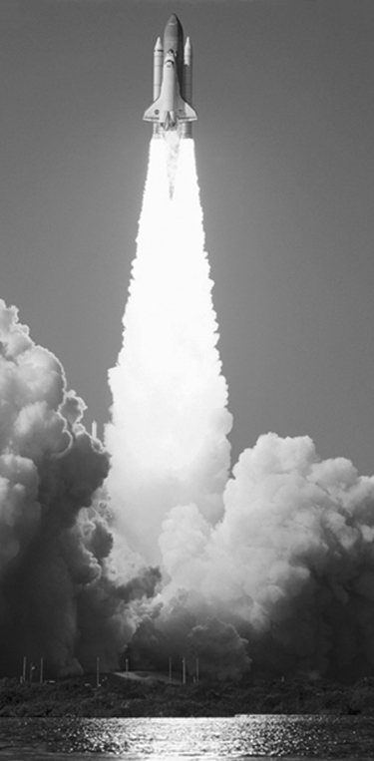
4. Name three characteristics of air that are important to meteorology.

5. To measure atmospheric conditions at high altitude, meteorologists use weather balloons that can rise up to 30 km in the air. These balloons are equipped with measuring instruments and radars that send the data back down to Earth. As they rise, the air-filled balloons expand. Explain your answer.
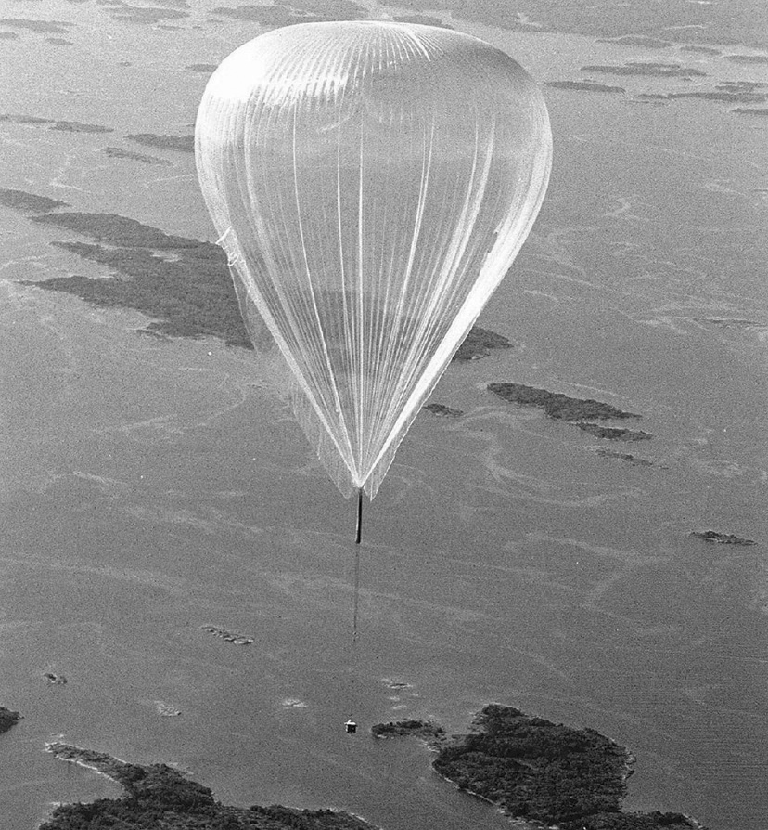
6. Do air particles exert more or less pressure as the
temperature rises? Explain your answer.
7. What causes winds to blow?
8. A highly trained cyclist leaves Montréal for Québec. At the same time, another cyclist, of equal ability, makes the trip in the opposite direction. If a high-pressure system is hanging over Montréal, and a low-pressure system, over Québec, which cyclist will be the first to arrive at destination? Explain your answer.
9. How is heat from the sun distributed between the equator and the poles?

⇒ Questions 10 and 11 are not intended for students in the AST program.
12. What does each of the following definitions describe?
a) a large expanse of the atmosphere where temperature and humidity are relatively uniform
b) the leading edge of a cold air mass where it meets a warm air mass, causing puffy clouds, or cumulus, to form
c) the leading edge of a warm air mass where it meets a cold air mass, causing long layered clouds to form
13. Look closely at the photo opposite.
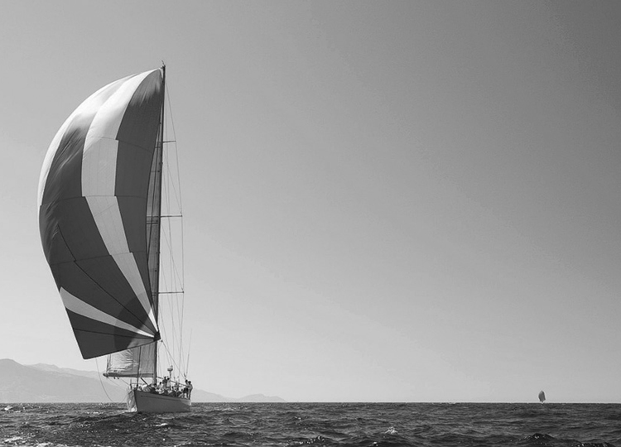
a) Was the photo taken in an area of high or low
atmospheric pressure?
b) What is such an area called?
c) If this area is in the Northern Hemisphere, in which
direction do the winds turn?
d) What is the opposite phenomenon called?
14. Do winds generally blow in a straight line from a high-pressure area to a low-pressure area?
Explain your answer.

⇒ Questions 15 to 20 are not intended for students in the AST program.

21. Name two advantages and two disadvantages of wind power.

2 THE EFFECT OF THE SUN AND THE MOON ON THE EARTH (pp. 239–245)
22. What kind of reactions transform hydrogen into helium in the Sun’s core?
23. In what form does solar energy reach the Earth?
24. Which electromagnetic waves from the Sun reach the Earth’s surface?
25. Explain the meaning of the following statement: The curvature of the Earth is at the origin of many atmospheric phenomena.
26. What does each of the following definitions describe?
a) a large glass panel that captures the sun’s heat and transfers it to a liquid running beneath the panel surface
b) a device that converts sunlight into electric current
27. Describe two elements of a passive heating system.
28. Name two advantages and two disadvantages of solar power.

29. At 11 a.m., Jennifer left her towel and book on the beach to go for a walk. When she came back an hour later, her belongings had been swept away by the tide. She was surprised; the day before, the tide had been high around midnight. Why is it already high again?
30. True or false? Explain your answers.
a) Tides are caused by the gravitational force of the Moon only.
b) At any one time, there are two high tides and two low tides on Earth.
c) The Moon’s gravitational force is due to its rotation.
31. The following are stages in tidal power generation. Place them in the correct order.
A. The tide goes out. | D. A gate is opened.
B. The tide comes in. | E. The water is held in a basin.
C. The water is released, setting a turbine in motion.
32. Name two advantages and two disadvantages of tidal power.

REVIEW QUESTIONS
⇒ Question B is not intended for students in the AST program.
A. Out of concern for the environment, Sophie has chosen to leave her car at home two days a week and walk to the office instead of driving. Before leaving home, she listens to the radio. According to the weather report, a high-pressure area has appeared over the city where she lives.
a) What is the name of the weather system affecting the city?
b) Should Sophie think about taking an umbrella to work? Explain your answer.
C. The Smith and Schwartz families each built a hunting cabin in an isolated region of northern Québec. The province’s power grid does not reach their cabins. The Smiths decided to install a small wind turbine to meet their electrical needs. The Schwartzes installed solar collectors and photovoltaic panels.
a) In terms of greenhouse gas emissions, which family is the more environmentally friendly? Explain your answer.
b) What problem will each family have to deal with in its choice of power supply?
c) The two families are thinking of combining their generating systems to create a small supply network for the two cabins. What do you think? Is this the answer to their problems?
D. Prepare your own summary of Chapter 7 by building a concept map.
Follow-up
1. In Québec, smog levels have increased by 15 percent on average since the early 1990s, primarily in the south of the province. Explain your answer.
2. Québec cannot act alone to solve the problem of smog over its territory. It must collaborate with neighbouring provinces and states. Explain your answer.

