The lithosphere and the hydrosphere

Checkups and follow-ups
EST
Questions 1–36 and A–D
ChaptEr 6
Checkup
1 THE lithosphEre (pp. 184–200)
1. Look at the illustration opposite.
ChaptEr 6
a) Name the different layers of the Earth’s
structure.
1
2
3
4
5
b) Which layers form the lithosphere?
2. What distinguishes a mineral from a rock?
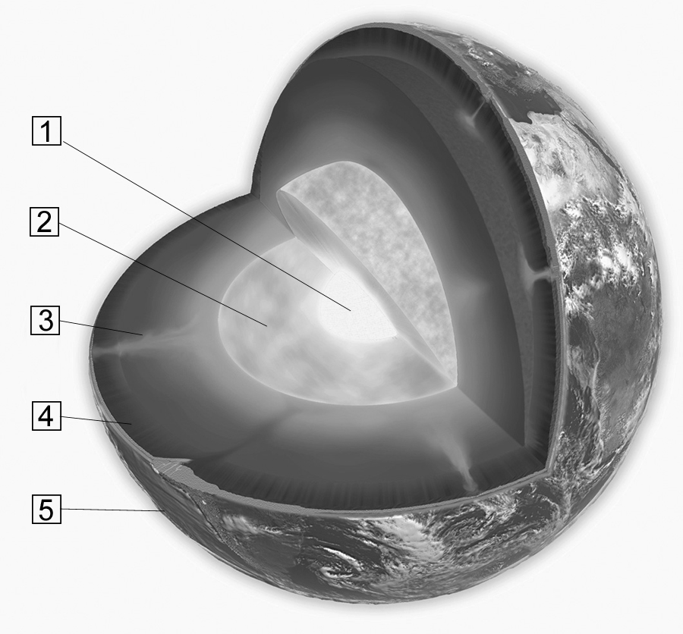
3. What am I? A rock, a mineral or both?
a) I am crystalline in nature.
b) I am neither animal nor vegetable in origin.
c) I am a solid substance.
d) I am a mixture.
e) I am found in the lithosphere.
f) I always have the same chemical composition.
g) I am a product of cooled lava.

4. True or false? Explain your answer.
a) Light passes straight through crystal. It is a translucent mineral.
b) Gold is always yellow. It is an idiochromatic mineral.
c) Amethyst has a hardness of seven on the Mohs scale. It is harder than topaz.
5. At first glance, pyrite looks very much like gold. What tests could you conduct to try and distinguish one mineral from the other?
6. What can be compared using the Mohs scale?
7. A teacher takes an enormous rock from her garden and shatters it into small pieces. She gives each of her students a piece, and they must analyze its hardness, colour and streak. Will all the students obtain different results? Explain your answer.
8. Which type of rock is it (igneous, sedimentary or metamorphic)?
a) Sandstone is formed by the accumulation and compaction of layers of sand.
b) Slate is formed from sedimentary rock subjected to heavy pressure.
c) Granite results from the cooling of magma.
9. The Raglan Mine in northern Québec produces nickel. What can this mineral be used for?
10. A building contractor wants to build a high-rise apartment building with a five-level underground parking lot. Before beginning construction, he must remove the layers of soil covering the rock. Name the layers of soil (in order) that the contractor must remove.
11. Matthew buys a hydrangea at the nursery. He also wants to buy a bag of soil so he can plant the shrub in his garden. Knowing that Matthew lives near a highway and that rain in his region is more acidic than average, what type of soil would you recommend?
12. In the Canadian Arctic, houses are sinking into the ground, and runways are cracking. Explain your answer.
13. Is there any vegetation in the Far North of Québec? Explain your answer.
14. Vicky, who lives in the village of Kuujjuaq in northern Québec, wants to build a house on
piles.
a) Given that the active layer in her region is 1.5 m thick, how long should the piles be? Explain your answer.
b) Can Vicky be sure of the long-term stability of her house?
15. Name three fuels that come directly from the lithosphere.

16. Name the form of energy described in each statement.
a) It is produced by atomic fission.
b) It is the result of the decomposition of prehistoric plants and animals.
c) It is derived from the internal heat of the Earth.
d) It emits more greenhouse gases than any other form of energy.
e) It leaves behind radioactive waste.
f) It is in danger of running out within the next few decades.
17. Name three farming practices that lead to soil depletion.
18. Name one advantage and one disadvantage
of using heavy machinery on farmland.
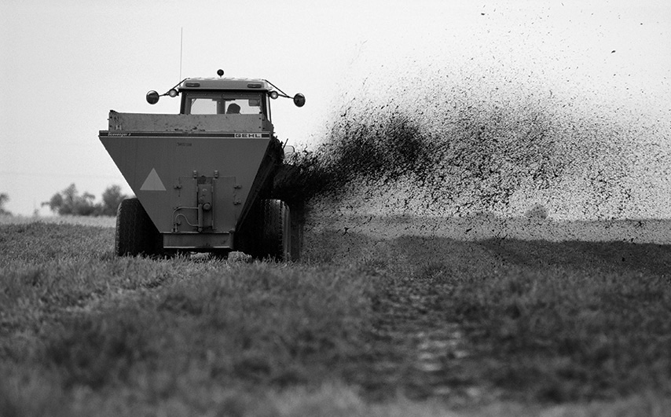
19. Nitrogen oxides (NO_{x}) and sulphur dioxide (SO₂) are emitted by car engines and industrial
processes.
a) What happens when they come into contact with rainwater?
b) How does this rain affect the soil?
2 THE hydrosphEre (pp. 200–213)
20. What am I? I represent 2.5 percent of the hydrosphere, and 79 percent of my total volume is
contained in glaciers.
21. Name five forms of water in the hydrosphere.
22. Environmental experts divide inland waters among watersheds. How do they define the
boundaries of watersheds?
23. Name four factors that affect the flow of water within a watershed.
24. The differences in seasonal temperatures are not as great in the ocean as on land.
a) Explain your answer.
b) Name three factors that affect the temperature of ocean waters.
25. Is seawater more saline at the poles or in the tropics? Explain your answer.

26. What am I?
a) I am a wind-driven ocean current.
b) I am an ocean current caused by differences in water density.
c) I form a huge “conveyor belt” that transports ocean waters around the world.
27. Name three factors that affect ocean circulation.
28. Which water is denser?
a) water with three-percent salinity or water with four-percent salinity?
b) water at 12°C or water at 18°C?
29. What is the cryosphere?
30. The two photos opposite were taken during a trip to the Arctic.
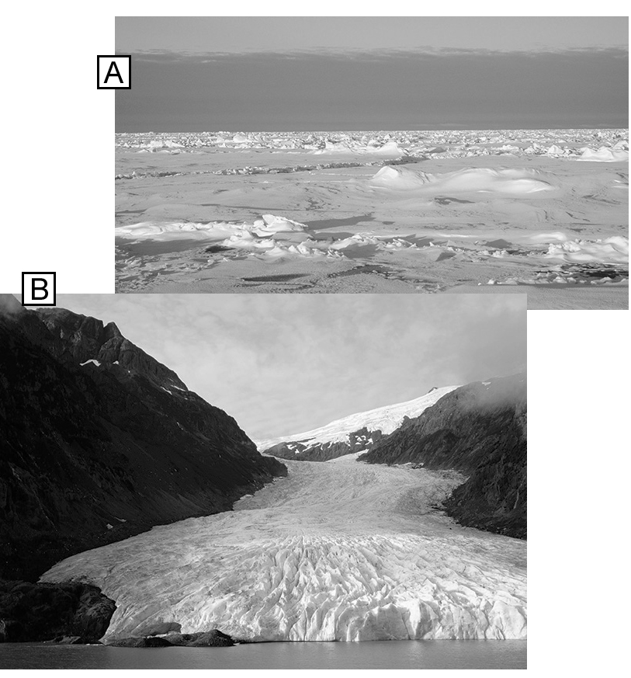
a) Which photo features pack ice?
b) What distinguishes the glacier from the pack ice?
31. What impact can melting pack ice have on the
environment?
32. Name two consequences of melting ice in the Greenland and Antarctic ice sheets.
33. Name one advantage of hydroelectric power.
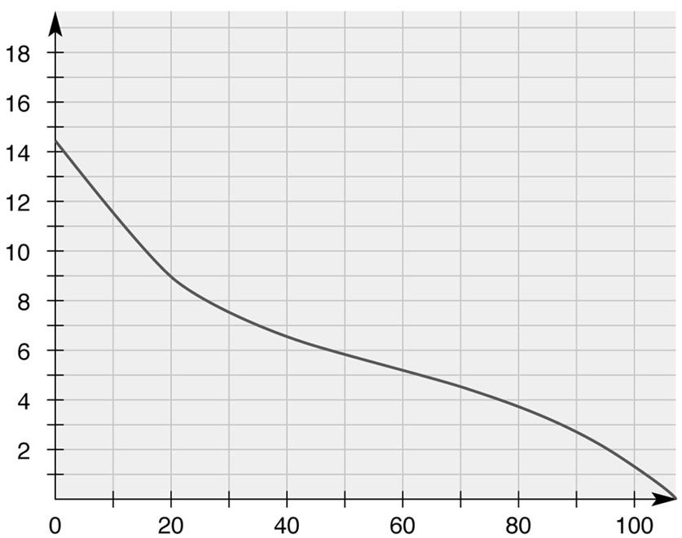
34. Look at the graph opposite. What does it demonstrate?
Oxygen solubility (mg/L)
35. A gold mine on the banks of a river discharges
water that was used to cool the ingots. The
wastewater has a temperature of 22°C, while
the river water is at 14°C. How will the wastewater discharge affect the river?
Water temperature (°C)
- Place the stages of eutrophication in the correct order.
A. drop in the oxygen concentration of the water
B. growth of algae
C. increase in the phosphorus concentration of the water
D. decomposition of algae

REVIEW QUESTIONS
A. A prospecting company has discovered a new gold deposit in Québec, in a belt of volcanic rock. The company must extract the volcanic rock from the ground to recover the gold fragments and shape them into ingots.
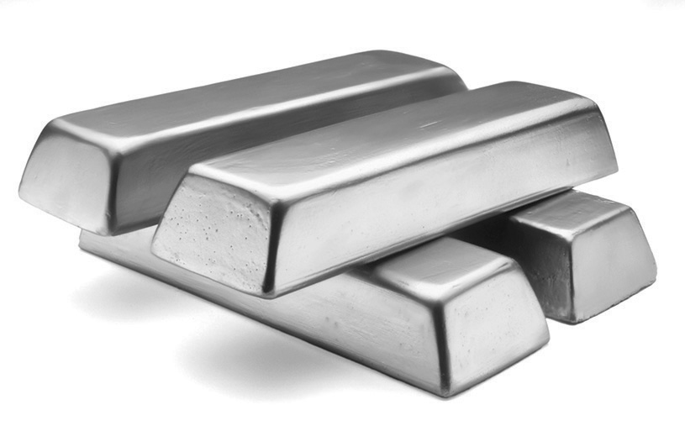
a) What is the rock containing the gold fragments called?
b) This rock is the result of volcanic activity. What type of rock is it?
c) To confirm that the prospectors have really found gold, geologists perform various tests. Name three of them.
d) The gold lies deep underground. What type of mine should be built?
B. To mine the deposit described in question A, the company must set up a camp.
a) The camp is not connected to a power grid, so the geologists install gas-powered generators. Which polluting gases will be emitted by the camp?
b) One of the geologists, who must spend the summer at this remote camp, decides to grow a vegetable garden. Given that the deposit is in the Canadian Shield—known for its low buffering capacity—which environmental problem could affect the geologist’s gardening plans?
C. Cruise ships regularly offer tours along the shores of Greenland. Tourists can observe the spectacular blocks of ice that break off from the coast and fall into the sea.
a) What are these blocks of ice called?
b) A few fragments of ice melt in the seawater. This water does not stay near the coast; it moves about. What factors will affect its movement?

c) Will the meltwater eventually arrive at the equator? Explain your answer.
d) In certain places, the Greenland glaciers are melting at twice their previous rate. Which climatic phenomenon explains this acceleration?
D. Prepare your own summary of Chapter 6 by building a concept map.
Follow-up
1. The Inuit diet consists mainly of food that the people have hunted or fished and food that has been brought in from southern regions. How does climate change interfere with their diet?
2. Although Inuit are responsible for a tiny fraction of global greenhouse gas emissions, they are more profoundly affected by climate change than any other population. How can people living farther south demonstrate solidarity with their northern neighbours?

