The lithosphere and the hydrosphere

Checkups and follow-ups
AST
Questions 1–9, 15–16, 20–23, 33, A and D
ChaptEr 6
Checkup
1 THE lithosphEre (pp. 184–200)
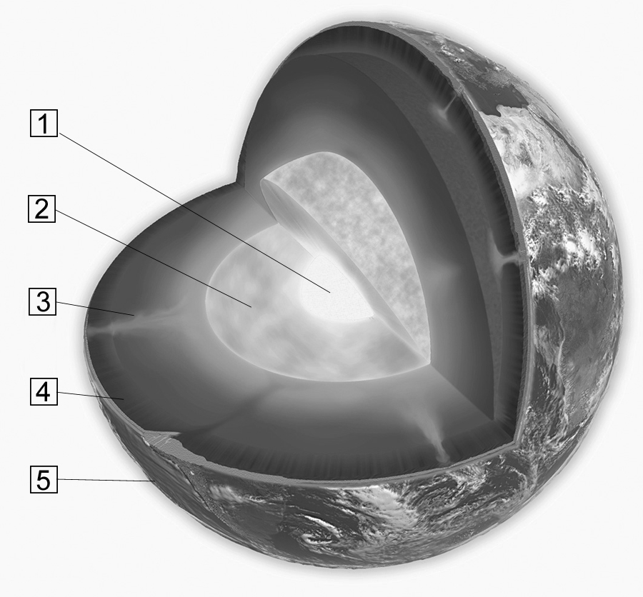
1. Look at the illustration opposite.
a) Name the different layers of the Earth’s
structure.
1
2
3
4
5
b) Which layers form the lithosphere?
2. What distinguishes a mineral from a rock?
3. What am I? A rock, a mineral or both?
a) I am crystalline in nature.
b) I am neither animal nor vegetable in origin.
c) I am a solid substance.
d) I am a mixture.
e) I am found in the lithosphere.
f) I always have the same chemical composition.
g) I am a product of cooled lava.
4. True or false? Explain your answer.
a) Light passes straight through crystal. It is a translucent mineral.
b) Gold is always yellow. It is an idiochromatic mineral.
c) Amethyst has a hardness of seven on the Mohs scale. It is harder than topaz.
5. At first glance, pyrite looks very much like gold. What tests could you conduct to try and distinguish one mineral from the other?
6. What can be compared using the Mohs scale?
7. A teacher takes an enormous rock from her garden and shatters it into small pieces. She gives each of her students a piece, and they must analyze its hardness, colour and streak. Will all the students obtain different results? Explain your answer.
8. Which type of rock is it (igneous, sedimentary or metamorphic)?
a) Sandstone is formed by the accumulation and compaction of layers of sand.
b) Slate is formed from sedimentary rock subjected to heavy pressure.
c) Granite results from the cooling of magma.
9. The Raglan Mine in northern Québec produces nickel. What can this mineral be used for?

⇒ Questions 10 to 14 are not intended for students in the AST program.
15. Name three fuels that come directly from the lithosphere.
16. Name the form of energy described in each statement.
a) It is produced by atomic fission.
b) It is the result of the decomposition of prehistoric plants and animals.
c) It is derived from the internal heat of the Earth.
d) It emits more greenhouse gases than any other form of energy.
e) It leaves behind radioactive waste.
f) It is in danger of running out within the next few decades.

⇒ Questions 17 to 19 are not intended for students in the AST program.
2 THE hydrosphEre (pp. 200–213)
20. What am I? I represent 2.5 percent of the hydrosphere, and 79 percent of my total volume is
contained in glaciers.
21. Name five forms of water in the hydrosphere.
22. Environmental experts divide inland waters among watersheds. How do they define the
boundaries of watersheds?

23. Name four factors that affect the flow of water within a watershed.

⇒ Questions 24 to 32 are not intended for students in the AST program.
33. Name one advantage of hydroelectric power.

⇒ Questions 34 to 36 are not intended for students in the AST program.
REVIEW QUESTIONS
⇒ Questions B and C are not intended for students in the AST program.

A. A prospecting company has discovered a new gold deposit in Québec, in a belt of volcanic rock. The company must extract the volcanic rock from the ground to recover the gold fragments and shape them into ingots.
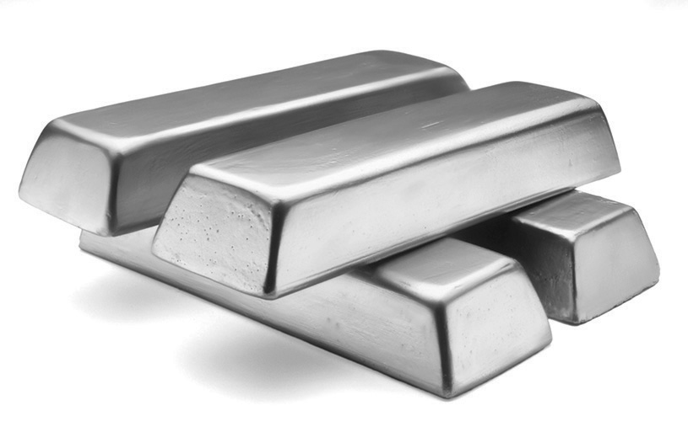
a) What is the rock containing the gold fragments called?
b) This rock is the result of volcanic activity. What type of rock is it?
c) To confirm that the prospectors have really found gold, geologists perform various tests. Name three of them.
d) The gold lies deep underground. What type of mine should be built?
D. Prepare your own summary of Chapter 6 by building a concept map.
Follow-up
1. The Inuit diet consists mainly of food that the people have hunted or fished and food that has been brought in from southern regions. How does climate change interfere with their diet?
2. Although Inuit are responsible for a tiny fraction of global greenhouse gas emissions, they are more profoundly affected by climate change than any other population. How can people living farther south demonstrate solidarity with their northern neighbours?

