Electricity and magnetism

Checkups and follow-ups
EST
Questions 1–25 and A–D
ChaptEr 5
Checkup
1 WHAT IS ELECTRICITY? (pp. 140–144)
1. Vanessa observes that an object is positively charged. Has it gained or lost electrons? Explain your answer.
2. The five spheres opposite, identified A to E, carry
an electrical charge. If sphere A carries a positive charge, what is the sign of the charges on each
of the other spheres? Explain your answer.
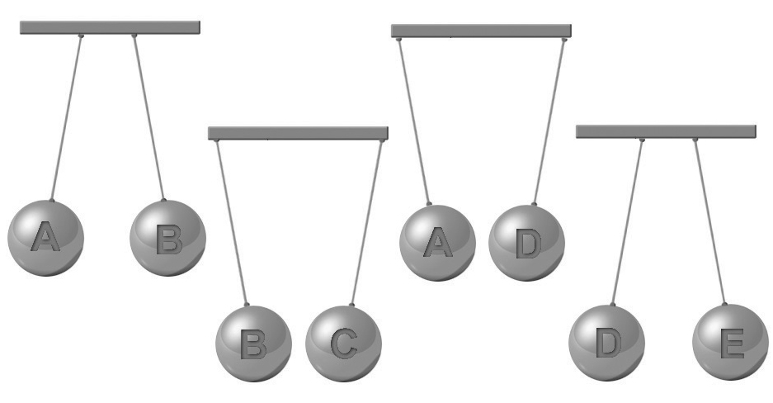
3. During a storm, impressive bolts of lightning form jagged lines across the sky. The lightning is caused by a brief but powerful electrical discharge. If the electrical discharge of a lightning bolt is equal to 20 C, how many electrons were involved in the neutralization process?
4. After charging a piece of fabric, Jonathan calculates that it has lost 2 x 10¹⁵ electrons.
a) What is its charge in coulombs?

b) Is this charge positive or negative? Explain your answer.
5. A copper rod and a plastic rod are electrically charged. In terms of attraction and repulsion, will the charges behave in the same way in the two rods? Explain your answer.
6. Look at the illustration opposite.
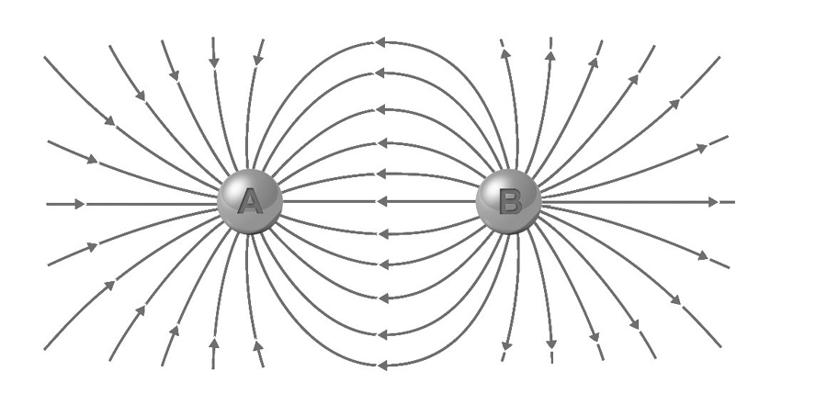
a) What is the charge of particle A?
Explain your answer.
b) What is the charge of particle B? Explain your answer.
c) Is the force exerted by each particle on the other attraction or repulsion? Explain your answer.
2 STATIC ELECTRICITY (pp. 145–149)
7. Are the following objects charged by friction, conduction or induction?
a) Carl brings a charged comb close to his hair without touching it, and his hair stands on end.

b) A certain number of charges are transferred from one body to another, resulting in two bodies carrying like charges.
c) When we walk about, our bodies may accumulate an electrical charge.
8. To clean his copper trophy, Brad rubs it with a woollen cloth. What will be the charge on each of these objects? Explain your answer.
9. Two positively charged particles with respective charges of 0.02 C and 0.05 C are placed 2 cm apart. What is the intensity of the electrical force each particle exerts on the other?
Problem-solving steps | Application

3 DYNAMIC ELECTRICITY (pp. 150–163)
10. Do the following situations describe an example of static electricity or dynamic electricity? Explain your answer.
a) an engine belt charging by friction
b) an MP3 playing your favourite music
11. In which of the circuits below is the ammeter correctly connected? Explain your answer.

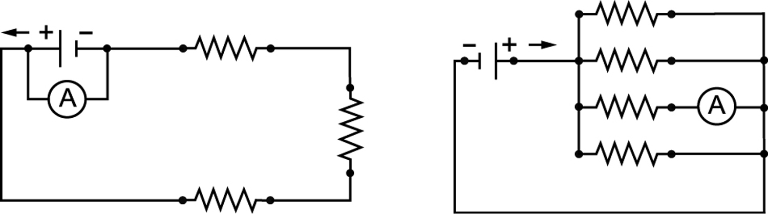
a)
b)
12. A hair dryer runs on an eight-ampere current. After five minutes’ use, what charge will have been transferred to this appliance?
Problem-solving steps | Application
13. A charge of 5400 C flows through a circuit element in one hour. What is the intensity of the electric current?
Problem-solving steps | Application
14. In which of the circuits below is the voltmeter correctly connected? Explain your answer.
c)
d)
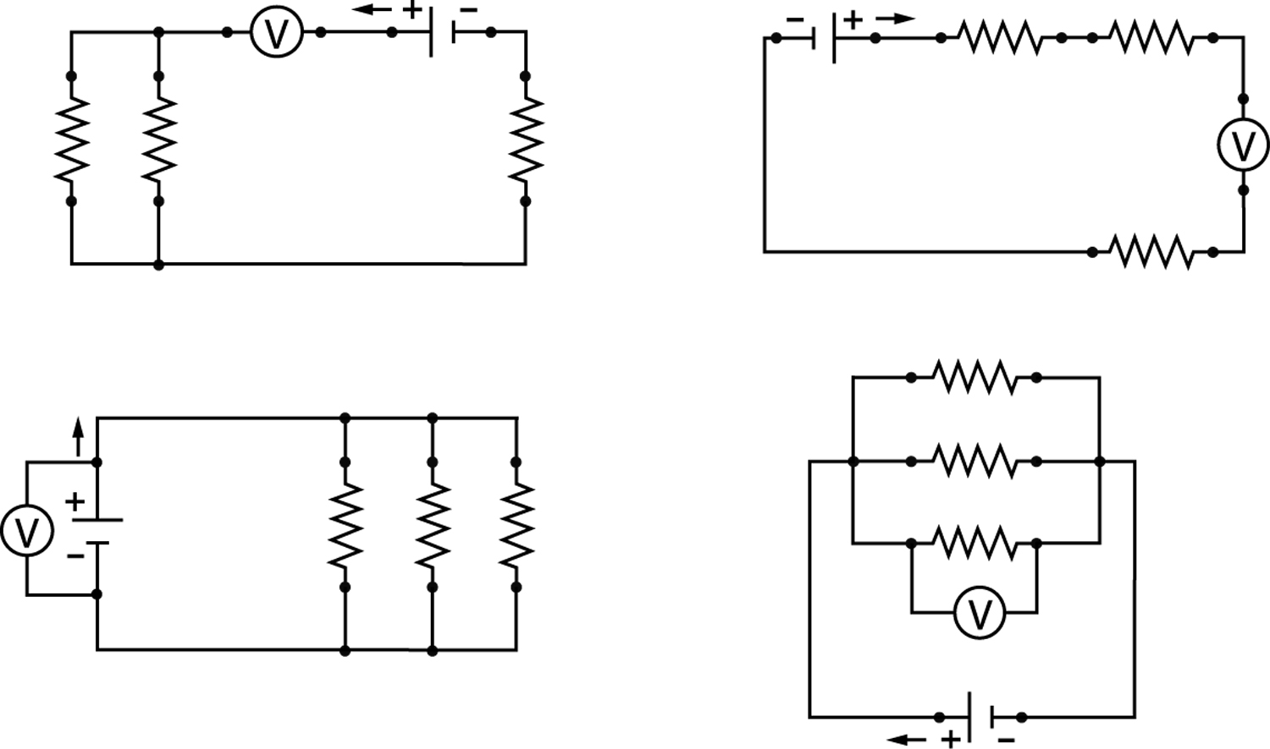
a)
b)

15. A wide variety of batteries are available on the market. What is the energy supplied by
a 1.5-V battery if 200 C of charge flow through an electrical appliance in 20 minutes?
Problem-solving steps | Application
16. To find the resistance of a heating element, Maria conducts an experiment. She discovers that when the current intensity is 3.5 A, the potential difference at the terminals of the element is 10 V. What is the resistance of the heating element?
17. How much energy will an electrical appliance have consumed after 15 minutes’ use if the current flowing through it has an intensity of 15 A and the potential difference is 120 V?
Problem-solving steps | Application

18. Which of the circuits below are connected in series, and which are connected in parallel?
a)  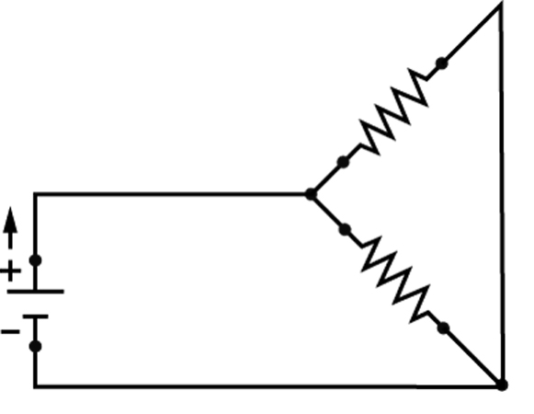 | b)  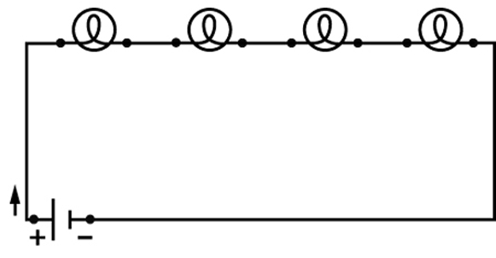
c)  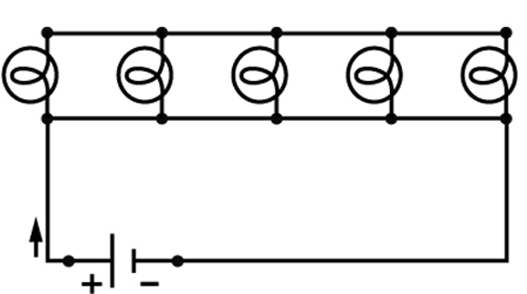 | d)  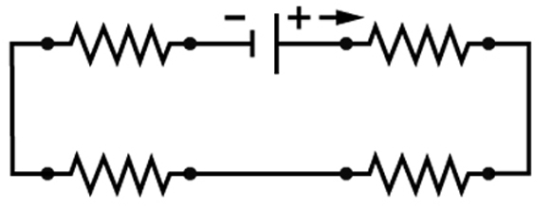
19. In each of the following circuits, calculate the equivalent resistance.
a)
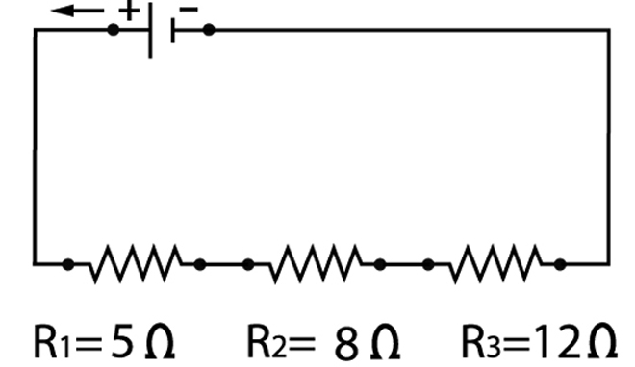

b)
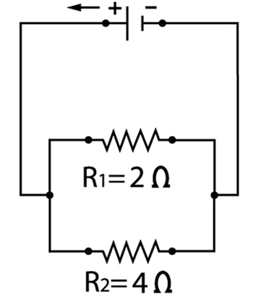

c)
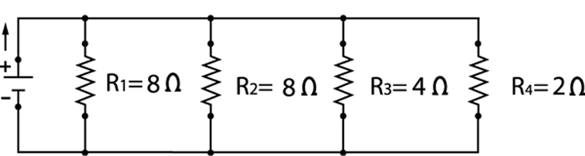
20. Find the missing value in each of the circuits below.
a)
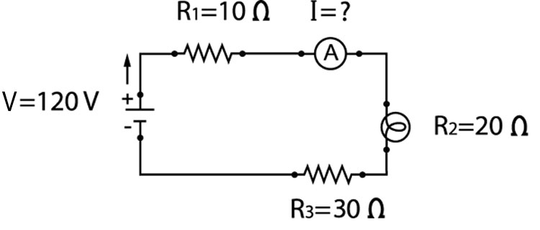
b)
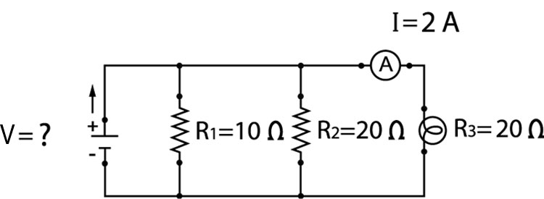
4 WHAT IS MAGNETISM? (pp. 163–167)
21. If the north pole of a magnet is moved toward the south pole of another magnet, will the north pole be subjected to an attractive or a repulsive force? Explain your answer.

22. Which of the illustrations below is an accurate representation of the magnetic field of a bar magnet? Explain your answer.
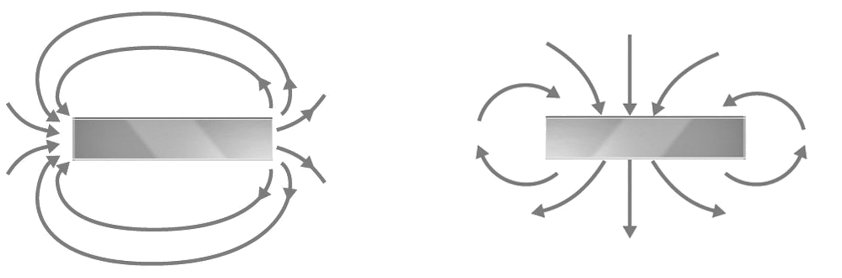
a)
b)
23. Is a ferromagnetic substance necessarily a magnet? Explain your answer.
5 ElectromagnEtism (pp. 167–171)
24. Which of the illustrations below is an accurate representation of the magnetic field of a live wire? Explain your answer.
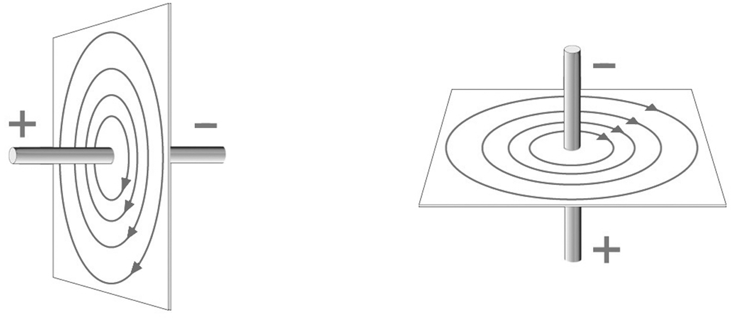
a)
b)

25. Which of the illustrations below is an accurate representation of the magnetic field of a solenoid? Explain your answer.
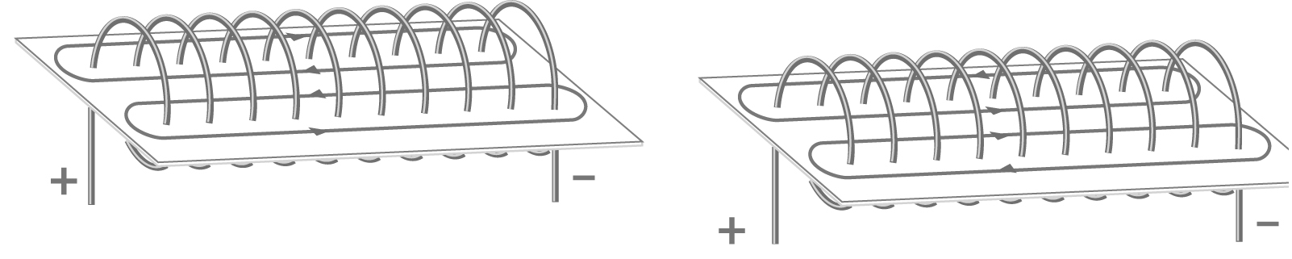
b)
a)

⇒ Question 26 is not intended for students in the EST program.
REVIEW QUESTIONS
A. Valerie charges an ebonite comb by rubbing it on her pants. She thus gives it a charge of 5 × 10^{–8} C. She then tries to lift up small pieces of paper with the charged comb.
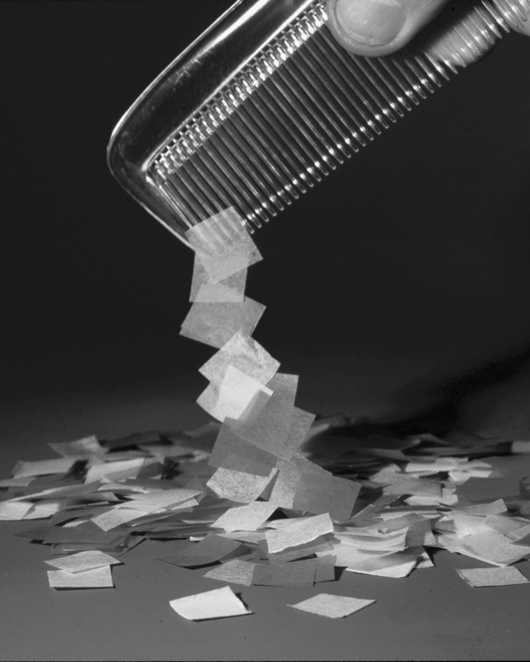
a) If Valerie’s pants are made of wool, will the electrical charge of the comb be positive or negative? Explain your answer.
b) How will the charges on the comb be distributed? Explain your answer.

c) When Valerie moves the comb close to the pieces of paper, they become charged. Will the electrical charges accumulating on the side of the paper closest to the comb be positive or negative? Explain your answer.
d) When she moves the comb close to a metal ruler, Valerie sees a spark. She concludes that the two objects have cancelled each other’s charge. If 5 x 10^{–8} C have been transferred from one object to the other in 0.001 s, what was the intensity of the electrical discharge?
e) Air is an insulator with a resistance of 2 x 10¹⁰ Ω. What is the potential difference of the electrical discharge between the comb and the metal ruler?
B. To lift a piece of paper weighing 0.01 N, how close will Valerie have to move her charged comb, bearing in mind that the piece of paper acquires a charge equivalent to that of the comb?
Problem-solving steps | Application

C. Below are diagrams of two different electrical circuits. If the power supply provides a potential difference of 60 V, and if the resistance of each light bulb is 120 Ω, what current intensity will be measured by each of the ammeters? Show your calculations.
b)
a)
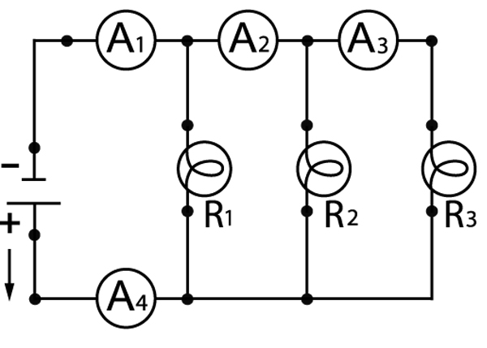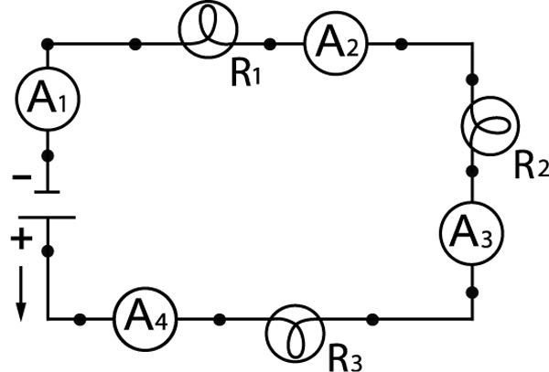
a)

b)
D. Prepare your own summary of Chapter 5 by building a concept map.
Follow-up
1. Briefly explain how a wind turbine can generate electricity using wind energy.
2. Do you think it would be a good idea to build wind turbines in your region? Explain your answer, suggesting at least one advantage and one disadvantage.

