Changes in matter

Checkups and follow-ups
EST
Questions 1–28 and A–E
ChaptEr 4
Checkup
1 WHAT ARE CHANGES IN MATTER? (p. 108)
1. Does each of the following phenomena describe a physical change, a chemical change or a nuclear transformation? Explain your answers.
a) a puddle of water evaporating in the sun
b) propane gas burning in a barbecue
c) a wooden plank being sawn in half
d) lead turning into gold
2 CHEMICAL CHANGES (pp. 109–124)
2. For each of the situations in the following photos, name at least one sign that a chemical change is occurring.
A  B |   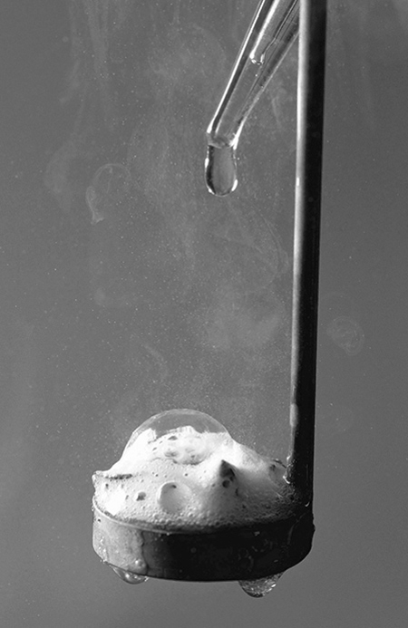

C  D  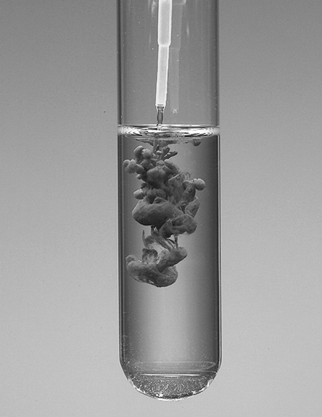 | 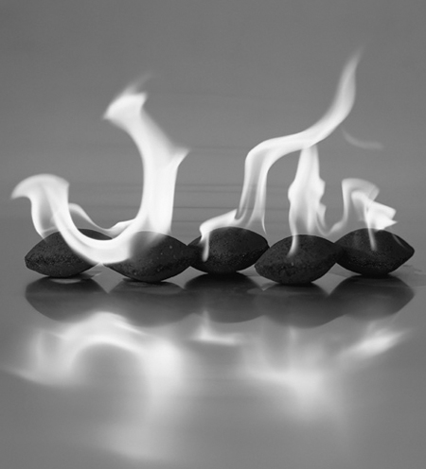
3. Represent each of the following reactions with a chemical equation. Specify the physical state of each substance.
a) A solid zinc atom reacts with two molecules of a solution of hydrochloric acid (HCl), to form one molecule of zinc chloride (ZnCl₂) in solution and one molecule of hydrogen gas.
b) Two atoms of solid sodium react with two molecules of liquid water to form two molecules of sodium hydroxide (NaOH) in solution and one molecule of hydrogen gas.
c) The reaction of one molecule of propane gas (C₃H₈) with five molecules of oxygen gas produces three molecules of carbon dioxide gas and four molecules of water vapour.
d) When two molecules of sodium chloride (NaCl) in solution are mixed with one molecule of barium nitrate (Ba(NO₃)₂) in solution, two molecules of sodium nitrate (NaNO₃) in solution are formed, as well as one molecule of barium chloride (BaCl₂) in the form of a solid precipitate.
4. The equation for the synthesis of water is as follows: 2 H_{2(g)} + O_{2(g)} → 2 H₂O_{(l)}. If 2 g of hydrogen are made to react with 16 g of oxygen, what is the mass of the resulting water? Show your calculations.
5. When magnesium is made to react with hydrochloric acid, hydrogen gas is released. If the reaction occurs in an open beaker, what will happen to the mass of the beaker’s contents? Explain your answer.
6. Is each of the following equations balanced or not? Explain your answers.
a) NA + O₂ → Na₂O₂

Before the chemical reaction |  | After the chemical reaction
Reactants | Numbers of atoms | Product | Numbers of atoms

b) C + O₂ → CO₂

Before the chemical reaction |  | After the chemical reaction
Reactants | Numbers of atoms | Product | Numbers of atoms

c) 2 C₂H₂ + 5 O₂ → 4 CO₂ + 2 H₂O

Before the chemical reaction |  | After the chemical reaction
Reactants | Numbers of atoms | Products | Numbers of atoms

d) CH₄ + 2 CI₂ → CCI₄ + 4 HCI

Before the chemical reaction |  | After the chemical reaction
Reactants | Numbers of atoms | Products | Numbers of atoms
7. Balance each of the following equations.
a) Mg + O₂ → MgO

Mg + O₂ | → | MgO

b) Fe + O₂ → Fe₂O₃

Fe + O₂ | → | Fe₂O₃

c) C₃H₈ + O₂ → CO₂ + H₂O

C₃H₈ + O₂ | → | CO₂ + H₂O

d) KOH + H₂SO₄ → K₂SO₄ + H₂O

KOH + H₂SO₄ | → | K₂SO₄ + H₂O
8. The equation for the formation of copper oxide (CuO) is as follows: 2 Cu + O₂ → 2 CuO. If four moles of copper are made to react with a sufficient amount of oxygen, how many moles of copper oxide will be obtained? Show your calculations.
9. Consider the following reaction: 2 Na + 2 H₂O → 2 NaOH + H₂. How many moles of sodium hydroxide will be produced if 46 g of sodium are made to react completely? Show your calculations.
10. The equation for the synthesis of ammonia is as follows: N₂ + 3 H₂ → 2 NH₃. Write the equation for the decomposition of ammonia.
11. When a solution of hydrochloric acid is mixed with sodium bicarbonate, carbon dioxide is released according to the following equation: HCl_{(aq)} + NaHCO_{3(s)} → NaCl_{(aq)} + H₂O_{(l)} + CO_{2(g)}. Suppose that 200 mL of the hydrochloric acid solution are made to react with sufficient sodium bicarbonate. What should the molar concentration of the solution be to obtain 4.4 g of carbon dioxide? Show your calculations.
12. Iron rusts in the presence of oxygen according to the following equation:
4 Fe_{(s)} + 3 O_{2(g)} → 2 Fe₂O_{3(s)}. To obtain 20 g of rust, what mass of iron must be transformed? Show your calculations.
13. Does each of the following phenomena describe an endothermic reaction or an exothermic reaction?
a) an egg cooking
b) the electrolysis of hydrochloric acid
c) a battery in use
d) 4 Fe_{(s)} + 3 O_{2(g)} → 2 Fe₂O_{3(s)} + energy
e) 6 C_{(s)} + 3 H_{2(g)} + energy → C₆H_{6(l)}
f) wood burning
14. Ammonia synthesis is a reaction that is widely used in industry. Calculate the reaction energy of the process in order to estimate the amount of energy released or absorbed.
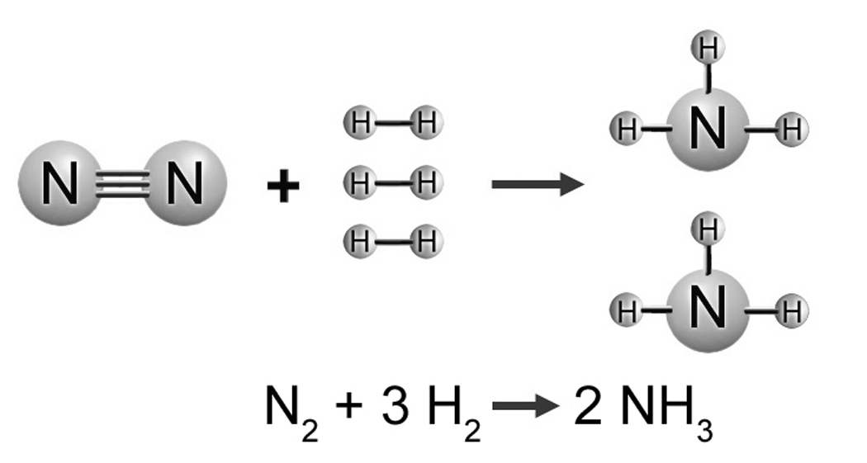
15. The synthesis of nitrogen dioxide is an endothermic phenomenon. What amount of energy would be needed to produce six moles of NO₂? Show your calculations.
N_{2(g)} + 2 O_{2(g)} + 67.6 kJ → 2 NO_{2(g)}
.
16. The complete combustion of one mole of carbon releases 393.5 kJ of energy. To obtain 900 kJ of energy, what mass of carbon would have to be burned? Show your calculations.
C_{(s)} + O_{2(g)} → CO_{2(g)} + 393.5 kJ
17. When solutions of hydrochloric acid (HCl) and potassium hydroxide (KOH) are mixed, the substances react with each other.
a) What type of chemical reaction is involved?
b) Write the chemical equation for this reaction.
18. In an acid-base neutralization reaction, what happens to the pH of the acid solution? Explain your answer.
19. What is oxidation? Give two examples of oxidation.
20. To learn how to control fires, firefighters have to study the three necessary conditions for a fire to start. What are these conditions?

21. What is the difference between an oxidizing agent and a fuel? Give an example of each.
22. Does each of the following statements refer to rapid combustion, spontaneous combustion or slow combustion?
a) A fire starts because of a gasoline-soaked rag.
b) Iron rusts easily in damp environments.
c) A campfire draws people together with its light and warmth.
d) Many varieties of fruit rot quickly when cut and left in the open air.
23. What distinguishes photosynthesis from cellular respiration? Name at least five differences.
Cellular respiration | Photosynthesis
3 nuclEar transformations (pp. 124–131)
24. Which type of ionizing radiation, though very harmful to human health, can be blocked with a simple sheet of paper?
25. Food irradiation is a process that kills harmful microorganisms and prolongs the shelf life of the food. Isotopes like cobalt-60 are used. Since ionizing radiation must travel a certain distance and penetrate the food completely, which type of radiation would be the most appropriate for this application? Explain your answer.
26. Scintigraphy is a method of medical imaging used to visualize certain organs as they are functioning. It involves a radioactive substance, which is injected into the patient. The radioactive substances used usually have a very short half-life. Explain why they are preferred over substances with longer half-lives.
27. Even though radioactivity can be harmful to human health, it nonetheless provides many advantages. Name two industrial applications of radioactivity.
28. Does each of the following nuclear reactions involve fusion or fission? Explain your answers.
235
92
a) U + n → Xe + Sr + 2 n
1
0
140
54
94
38
1
0
b) H + H → He + n
1
0
2
1
2
1
3
2
c) Be + n → He + H
6
3
1
0
4
2
3
1
d) N + He → O + p⁺
14
7
4
2
17
8
1
1
e) Al + He → P + n
27
13
4
2
30
15
1
0

REVIEW QUESTIONS
A. The combustion of one litre of gasoline provides approximately 30 MJ (3.0 x 10⁷ J) of energy, while the reaction of one mole of zinc with oxygen provides approximately 350 kJ (3.5 x 10⁵ J). What mass of zinc would be required to obtain as much energy as from the combustion of 20 L of gasoline?
B. Gasoline is composed mostly of octane (C₈H₁₈). When octane burns in a car engine, it reacts mainly according to the following equation:
C₈H_{18(l)} + O_{2(g)} → CO_{2(g)} + H₂O_{(g)} (unbalanced equation)
a) Balance this equation.
b) If a car consumes, on average, 14 kg of gasoline per week, how many moles of carbon dioxide will it release into the air (on average) per week?
C. Dwindling oil reserves and climate change are spurring scientists to find alternative methods of fuelling cars. One method is to use metal powder. For example, zinc reacts with oxygen gas to produce solid zinc oxide (ZnO), releasing a large amount of energy in the process. Preliminary results for this method look promising.
a) Write a balanced equation for this reaction.
b) What type of chemical change is involved?

c) Normally, when a metal reacts with oxygen, the energy released is barely noticeable. Explain your answer.
d) Researchers believe that using metal powder to fuel cars would be less harmful to the environment than burning gasoline. Explain your answer.
D. Is the combustion of zinc powder an endothermic or exothermic reaction? Explain your answer.
E. Prepare your own summary of Chapter 4 by building a concept map.
Follow-up
1. Why is it difficult to protect people from the radiation given off by radioactive elements? Why is this radiation harmful to human health?
2. Cesium-137 has a half-life of about 30 years. Is it normal that after more than 20 years, levels of radioactivity in the ground near Chernobyl are still very high? Explain your answer.

