Changes in matter

Checkups and follow-ups
ST
Questions 1–7, 17, 18, 20–23, C and E
ChaptEr 4
Checkup
1 WHAT ARE CHANGES IN MATTER? (p. 108)
1. Does each of the following phenomena describe a physical change, a chemical change or a nuclear transformation? Explain your answers.
ChaptEr 4
a) a puddle of water evaporating in the sun
b) propane gas burning in a barbecue
c) a wooden plank being sawn in half
d) lead turning into gold
2 CHEMICAL CHANGES (pp. 109–124)
2. For each of the situations in the following photos, name at least one sign that a chemical change is occurring.
A  B | 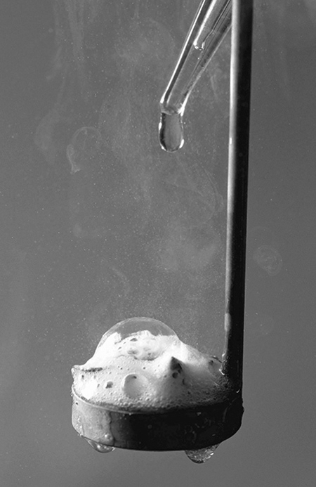  

C  D  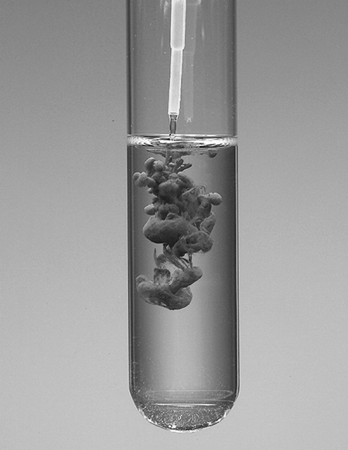 | 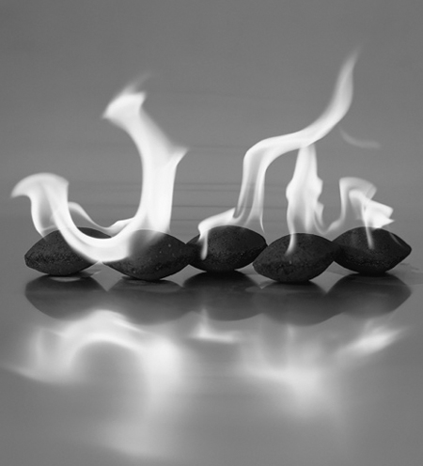
3. Represent each of the following reactions with a chemical equation. Specify the physical state of each substance.
a) A solid zinc atom reacts with two molecules of a solution of hydrochloric acid (HCl), to form one molecule of zinc chloride (ZnCl₂) in solution and one molecule of hydrogen gas.
b) Two atoms of solid sodium react with two molecules of liquid water to form two molecules of sodium hydroxide (NaOH) in solution and one molecule of hydrogen gas.
c) The reaction of one molecule of propane gas (C₃H₈) with five molecules of oxygen gas produces three molecules of carbon dioxide gas and four molecules of water vapour.
d) When two molecules of sodium chloride (NaCl) in solution are mixed with one molecule of barium nitrate (Ba(NO₃)₂) in solution, two molecules of sodium nitrate (NaNO₃) in solution are formed, as well as one molecule of barium chloride (BaCl₂) in the form of a solid precipitate.
4. The equation for the synthesis of water is: 2 H_{2(g)} + O_{2(g)} → 2 H₂O_{(l)}. If 2 g of hydrogen are made to react with 16 g of oxygen, what is the mass of the resulting water? Show your calculations.
5. When magnesium is made to react with hydrochloric acid, hydrogen gas is released. If the reaction occurs in an open beaker, what will happen to the mass of the beaker’s contents? Explain your answer.
6. Is each of the following equations balanced or not? Explain your answers.
a) NA + O₂ → Na₂O₂

Before the chemical reaction |  | After the chemical reaction
Reactants | Numbers of atoms | Product | Numbers of atoms

b) C + O₂ → CO₂

Before the chemical reaction |  | After the chemical reaction
Reactants | Numbers of atoms | Product | Numbers of atoms

c) 2 C₂H₂ + 5 O₂ → 4 CO₂ + 2 H₂O

Before the chemical reaction |  | After the chemical reaction
Reactants | Numbers of atoms | Products | Numbers of atoms

d) CH₄ + 2 CI₂ → CCI₄ + 4 HCI

Before the chemical reaction |  | After the chemical reaction
Reactants | Numbers of atoms | Products | Numbers of atoms
7. Balance each of the following equations.
a) Mg + O₂ → MgO

Mg + O₂ |  | → | MgO
b) Fe + O₂ → Fe₂O₃

Fe + O₂ |  | → | Fe₂O₃
c) C₃H₈ + O₂ → CO₂ + H₂O

C₃H₈ + O₂ | → |  | CO₂ + H₂O
d) KOH + H₂SO₄ → K₂SO₄ + H₂O

KOH + H₂SO₄ | → | K₂SO₄ + H₂O

⇒ Questions 8 to 16 are not intended for students in the ST program.
17. When solutions of hydrochloric acid (HCl) and potassium hydroxide (KOH) are mixed, the substances react with each other.
a) What type of chemical reaction is involved?
b) Write the chemical equation for this reaction.
18. In an acid-base neutralization reaction, what happens to the pH of the acid solution? Explain your answer.

⇒ Question 19 is not intended for students in the ST program.

20. To learn how to control fires, firefighters have to study the three necessary conditions for a fire to start. What are these conditions?
21. What is the difference between an oxidizing agent and a fuel? Give an example of each.
22. Does each of the following statements refer to rapid combustion, spontaneous combustion or slow combustion?
a) A fire starts because of a gasoline-soaked rag.
b) Iron rusts easily in damp environments.

c) A campfire draws people together with its light and warmth.
d) Many varieties of fruit rot quickly when cut and left in the open air.
23. What distinguishes photosynthesis from cellular respiration? Name at least five differences.
Cellular respiration | Photosynthesis
3 nuclEar transformations (pp. 124–131)
⇒ The questions in this section are not intended for students in the ST program.
REVIEW QUESTIONS
⇒ Questions A, B and D are not intended for students in the ST program.
C. Dwindling oil reserves and climate change are spurring scientists to find alternative methods of fuelling cars. One method is to use metal powder. For example, zinc reacts with oxygen gas to produce solid zinc oxide (ZnO), releasing a large amount of energy in the process. Preliminary results for this method look promising.
a) Write a balanced equation for this reaction.

b) What type of chemical change is involved?
c) Normally, when a metal reacts with oxygen, the energy released is barely noticeable. Explain your answer.
d) Researchers believe that using metal powder to fuel cars would be less harmful to the environment than burning gasoline. Explain your answer.
E. Prepare your own summary of Chapter 4 by building a concept map.
Follow-up
1. Why is it difficult to protect people from the radiation given off by radioactive elements? Why is this radiation harmful to human health?
2. Cesium-137 has a half-life of about 30 years. Is it normal that after more than 20 years, levels of radioactivity in the ground near Chernobyl are still very high? Explain your answer.

