Changes in matter

Checkups and follow-ups
AST
Questions 1–3, 19–22 and E
ChaptEr 4
Checkup
1 WHAT ARE CHANGES IN MATTER? (p. 108)
1. Does each of the following phenomena describe a physical change, a chemical change or a nuclear transformation? Explain your answers.
a) a puddle of water evaporating in the sun
b) propane gas burning in a barbecue
c) a wooden plank being sawn in half
d) lead turning into gold
2 CHEMICAL CHANGES (pp. 109–124)
2. For each of the situations in the following photos, name at least one sign that a chemical change is occurring.
A  B | 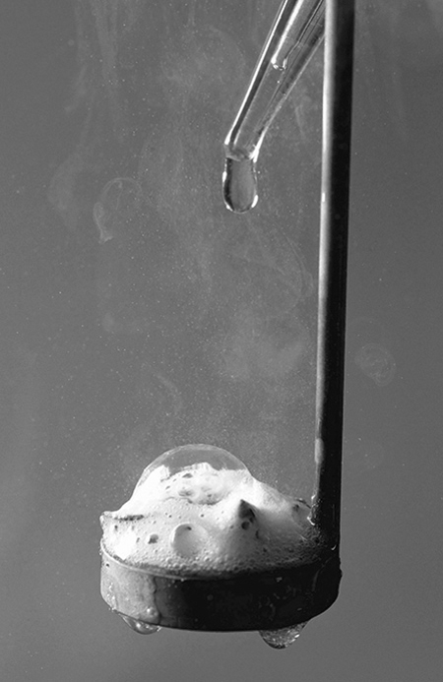  

C  D  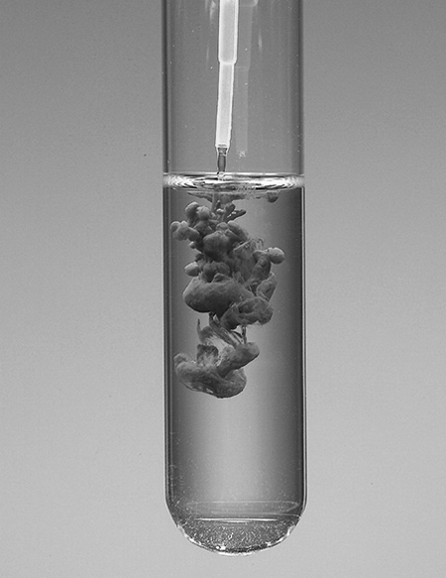 | 
3. Represent each of the following reactions with a chemical equation. Specify the physical state of each substance.
a) A solid zinc atom reacts with two molecules of a solution of hydrochloric acid (HCl), to form one molecule of zinc chloride (ZnCl₂) in solution and one molecule of hydrogen gas.
b) Two atoms of solid sodium react with two molecules of liquid water to form two molecules of sodium hydroxide (NaOH) in solution and one molecule of hydrogen gas.
c) The reaction of one molecule of propane gas (C₃H₈) with five molecules of oxygen gas produces three molecules of carbon dioxide gas and four molecules of water vapour.
d) When two molecules of sodium chloride (NaCl) in solution are mixed with one molecule of barium nitrate (Ba(NO₃)₂) in solution, two molecules of sodium nitrate (NaNO₃) in solution are formed, as well as one molecule of barium chloride (BaCl₂) in the form of a solid precipitate.

⇒ Questions 4 to 18 are not intended for students in the AST program.

19. What is oxidation? Give two examples of oxidation.
20. To learn how to control fires, firefighters have to study the three necessary conditions for a fire to start. What are these conditions?
21. What is the difference between an oxidizing agent and a fuel? Give an example of each.
22. Does each of the following statements refer to rapid combustion, spontaneous combustion or slow combustion?
a) A fire starts because of a gasoline-soaked rag.
b) Iron rusts easily in damp environments.
c) A campfire draws people together with its light and warmth.
d) Many varieties of fruit rot quickly when cut and left in the open air.

⇒ Question 23 is not intended for students in the AST program.

3 nuclEar transformations (pp. 124–131)
⇒ The questions in this section are not intended for students in the AST program.
REVIEW QUESTIONS
⇒ Questions A to D are not intended for students in the AST program.
E. Prepare your own summary of Chapter 4 by building a concept map.
Follow-up
1. Why is it difficult to protect people from the radiation given off by radioactive elements? Why is this radiation harmful to human health?
2. Cesium-137 has a half-life of about 30 years. Is it normal that after more than 20 years, levels of radioactivity in the ground near Chernobyl are still very high? Explain your answer.

