Different forms of energy

Checkups and follow-ups
EST
Questions 1–19, 25–29 and A–E
ChaptEr 3
Checkup
1 WHAT IS ENERGY? (pp. 70–78)
1. Name the form or forms of energy in each of the following energy sources.
A  B  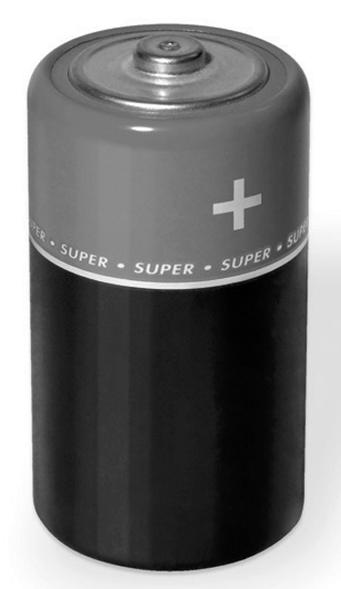 | 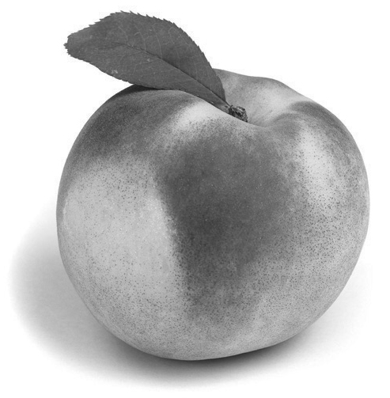
C  D  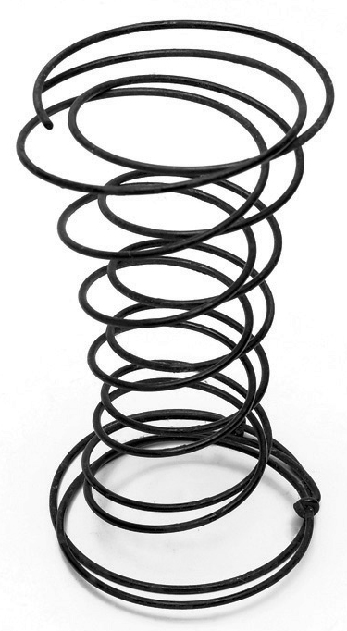 | 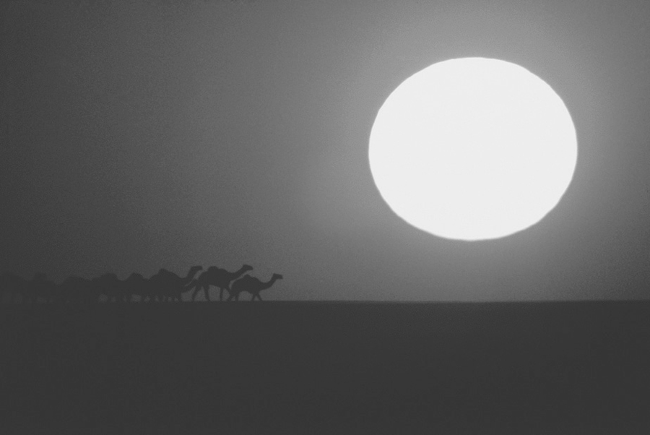
2. In each of the following examples, is energy used to do work or to cause a change?
a) a puddle of water evaporating in the sun
b) a burning log
c) a car moving along the road
d) a person climbing a staircase
3. Why is the amount of energy in the universe said to be constant?
4. Does each of the following situations describe a transfer or a transformation of energy,
or both?
a) Solar energy makes photosynthesis in plants possible.
b) Energy from a heating system warms the air in a home.
c) Power plants generate electricity that is then delivered to our homes.
d) Food provides the energy we need to go about our daily lives.
5. To perform work equal to 2 400 J, a machine consumes 12 000 J. What is the energy
efficiency of this machine?
6. Can a cup of boiling water contain more thermal energy than a bucket of water at 50°C?
Explain your answer.
7. Amanda applies the same amount of heat to four samples of matter:
– a piece of wood
– a piece of silver
– a piece of iron
– a piece of copper
If each sample has the same mass and the same initial temperature, which will experience the greatest temperature variation? Explain your answer.
8. Ravi puts a 100-g block of lead, heated to 155°C, in 100 mL of water at 19°C. The water temperature rises to 24°C. Assuming no energy has been lost to the surroundings, calculate the specific heat capacity of lead.
Problem-solving steps | Application

Problem-solving steps | Application
9. You pour 250 mL of water into a glass just out of the freezer. After a while, you notice that the
temperature of the water has fallen from 18°C to 12°C.
a) How much heat has been transferred between the water and the glass?
Problem-solving steps | Application

b) Did the water give off or absorb energy? Explain your answer.
c) Did the glass give off or absorb energy? Explain your answer.
10. A baseball pitcher throws a ball weighing about 150 g to another player. What is the kinetic energy of the ball if, at the moment it is caught, its velocity is 5 m/s?
Problem-solving steps | Application
11. An elevator carries a person weighing 60 kg from the ground to the eighth floor.
a) If the eighth floor is 56 m above the ground, what is the potential energy acquired by
the person?
Problem-solving steps | Application
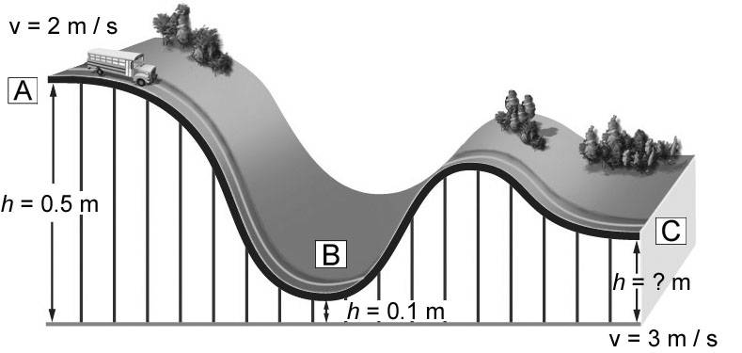
b) Where did the potential energy come from?
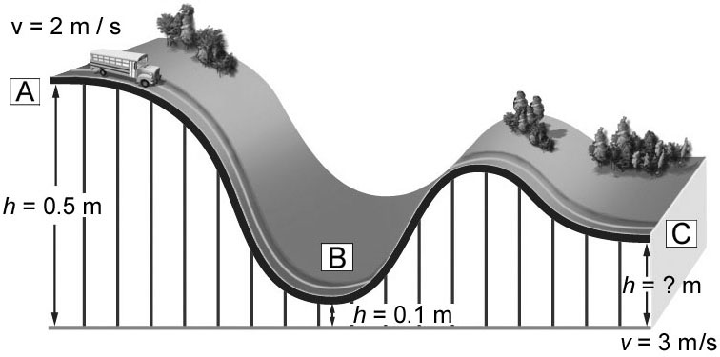
12. Jessica builds a model track for her little brother.
She places a toy bus weighing 0.5 kg at point A
and gives it a velocity of 2 m/s. The bus travels
the entire route with no further addition of energy.
a) Ignoring the effect of friction, calculate the mechanical energy, the potential energy and the kinetic energy of the bus at points A, B and C.
At point A | At point B | At point C
b) Calculate the height of the bus at point C.
2 MOTION AND FORCES (pp. 79–91)
13. In each of the following situations, does the force involve pulling or pushing?
a) the force of a dog on its leash
b) the force of a person inserting a letter in an envelope
c) the force of a magnet on a paper clip
d) the force of a bowstring on an arrow
14. The illustration opposite represents the action of a force.
a) Is the force applied horizontally or vertically?
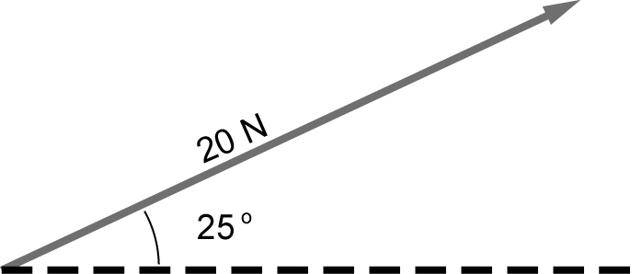
b) Which symbol indicates the direction of the force?
c) What is the magnitude of the force?
15. How does the intensity of the Earth’s gravitational field vary?
16. What distinguishes mass from weight?
17. Plasma or liquid crystal television sets are much lighter in weight than the old models with cathode ray screens. What is the weight of a television set that has a mass of 25 kg at the Earth’s surface?
Problem-solving steps | Application

18. On the surface of which planet of the solar system would you be heaviest? Explain your answer.
19. Look at the illustration opposite.
a) Will the mass of this explorer vehicle be the
same on Earth and Mars? Explain your
answer.
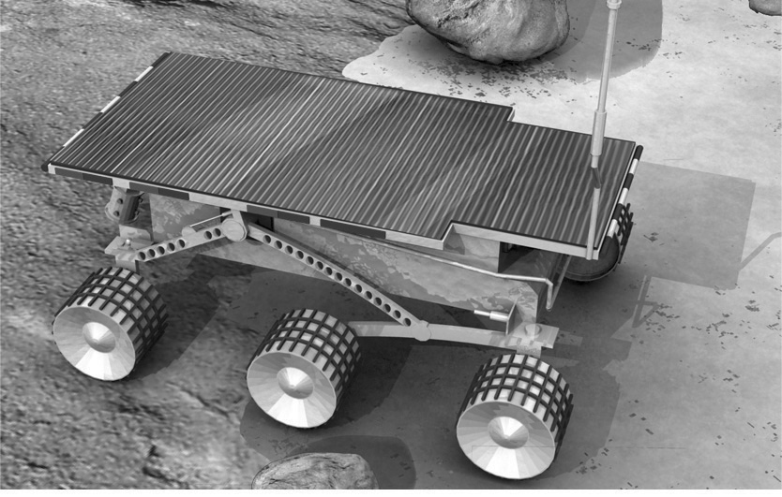
b) Will the weight of the explorer be the same on Earth and Mars? Explain your answer.

⇒ Questions 20 to 24 are not intended for students in the EST program.

25. Find the horizontal and vertical components of each of the following forces.
a)  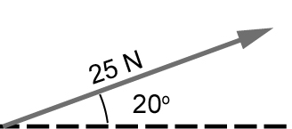 | b)  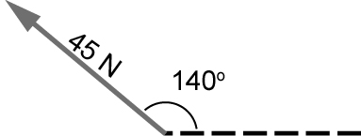

26. What is the effective force in each of the following situations?
a) The box slides down the inclined plane.
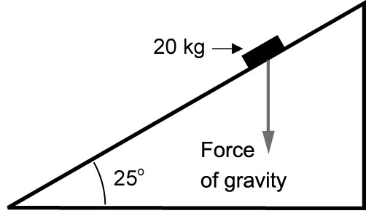
b) The box slides along the ground.
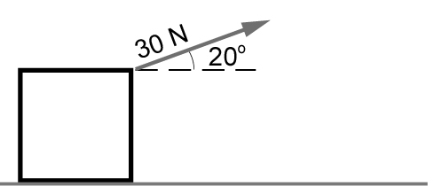
27. A person applies a force of 200 N to the side of a piano. How much work will it take to move the piano 5 m?
Problem-solving steps | Application

28. How much work does the gravitational force acting on this skier represent if the skier travels 4 m?
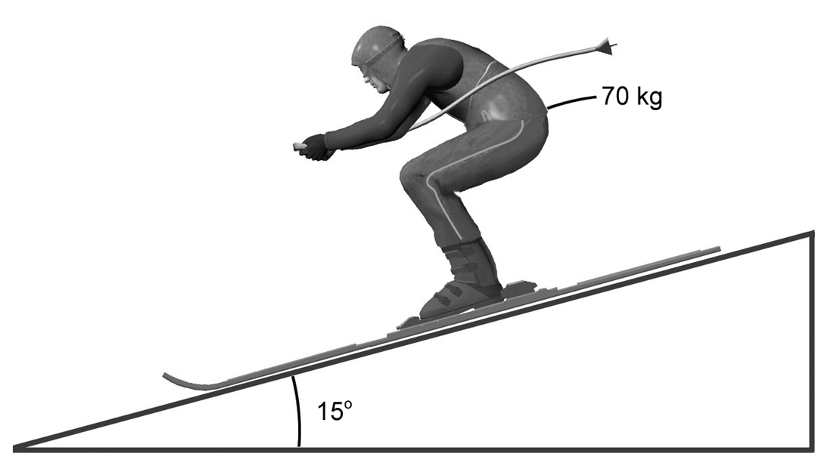
Calculating the effective force

Problem-solving steps | Application
29. When work is done, energy is consumed. What happens to this energy? Explain your answer.

3 forces IN FLUIDS (pp. 92–98)
⇒ The questions in this section are not intended for students in the EST program.
REVIEW QUESTIONS
A. To boil water, Bassima uses a microwave oven.
a) How much energy does it take to boil 250 mL of water with an initial temperature of 20°C?
Problem-solving steps | Application
b) Bassima calculates that to boil the water, her oven used 100 000 J of electrical energy.
What is the energy efficiency of the microwave oven?
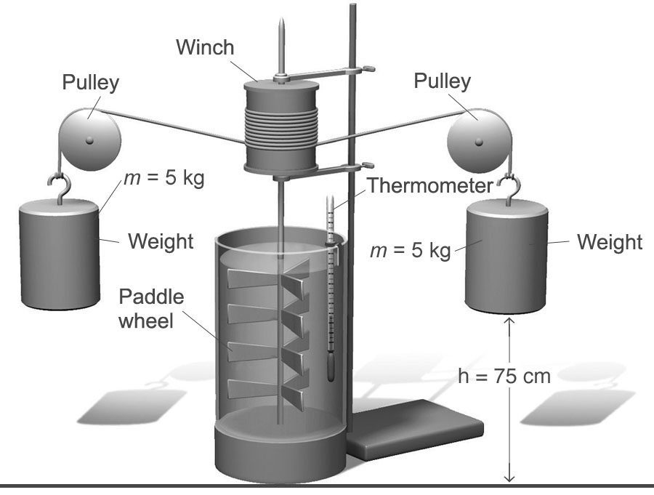
B. James Prescott Joule designed many experiments involving thermal energy. In one
of these experiments, he transformed the mechanical energy of an object into thermal energy, using the apparatus illustrated opposite, known today as Joule’s apparatus.
a) How much mechanical energy do the weights possess?
b) Given an initial quantity of one litre of water at 20°C in the container, what will be the final water temperature if the weights are lowered 20 times? The Joule apparatus is assumed to be 100-percent efficient, and the weights move 75 cm each time they fall.
C. A 10-kg chair is placed on a plane inclined at an angle of 25° to the horizontal. The plane exerts a frictional force of 30 N on the chair. Will the chair move? Explain your answer.
D. Fred lifts a 20-kg box to a height of 1 m.
a) How much work did Fred do to lift the box?
b) What form of energy did the box store?
E. Prepare your own summary of Chapter 3 by building a concept map.
Follow-up
1. Why is it important to reduce energy consumption?
2. Whether we own or rent our homes, we can all take steps to reduce our energy consumption. Give three examples of such steps.

