Different forms of energy

Checkups and follow-ups
ST
Questions 1–6 and E
ChaptEr 3
Checkup
1 WHAT IS ENERGY? (pp. 70–78)
1. Name the form or forms of energy in each of the following energy sources.
A  B  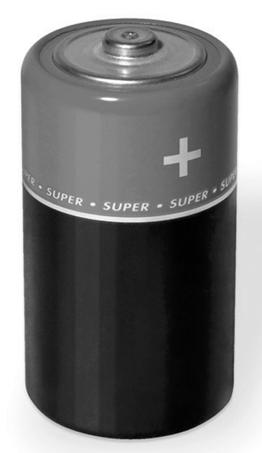 | 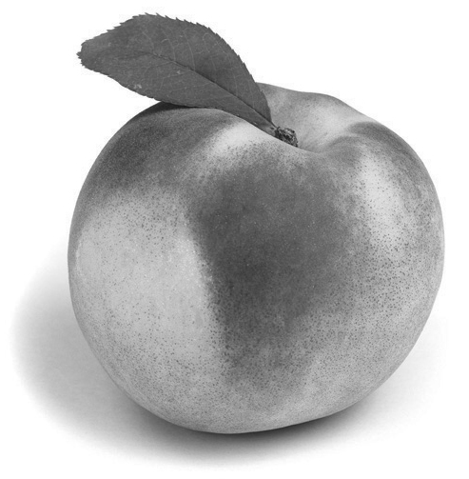
D  C  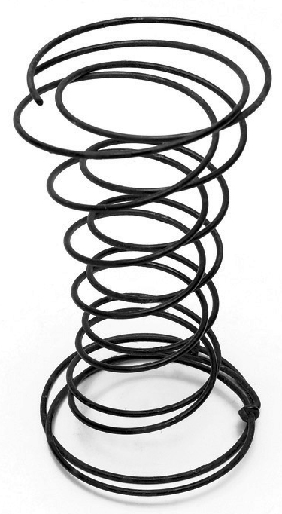 | 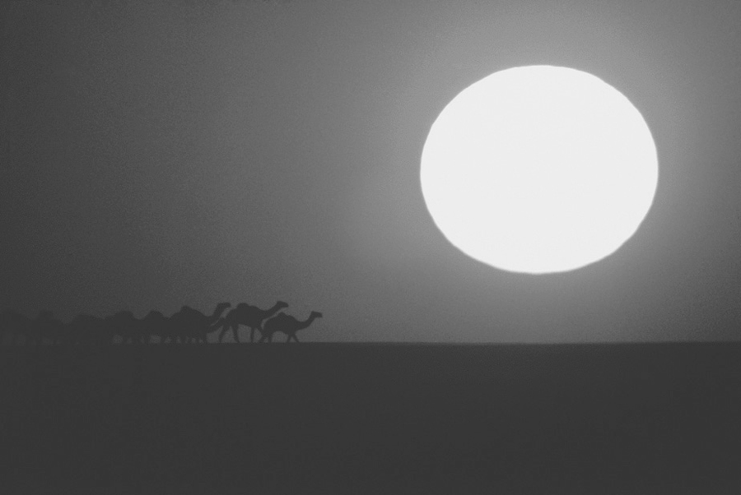
2. In each of the following examples, is energy used to do work or to cause a change?
a) a puddle of water evaporating in the sun
b) a burning log
c) a car moving along the road
d) a person climbing a staircase
3. Why is the amount of energy in the universe said to be constant?
4. Does each of the following situations describe a transfer or a transformation of energy,
or both?
a) Solar energy makes photosynthesis in plants possible.
b) Energy from a heating system warms the air in a home.
c) Power plants generate electricity that is then delivered to our homes.
d) Food provides the energy we need to go about our daily lives.
5. To perform work equal to 2 400 J, a machine consumes 12 000 J. What is the energy
efficiency of this machine?
6. Can a cup of boiling water contain more thermal energy than a bucket of water at 50°C?
Explain your answer.

⇒ Questions 7 to 12 are not intended for students in the ST program.
2 MOTION AND FORCES (pp. 79–91)
⇒ The questions in this section are not intended for students in the ST program.
3 forces in fluids (pp. 92–98)
⇒ The questions in this section are not intended for students in the ST program.
REVIEW QUESTIONS
⇒ Questions A to D are not intended for students in the ST program.
E. Prepare your own summary of Chapter 3 by building a concept map.
Follow-up
1. Why is it important to reduce energy consumption?
2. Whether we own or rent our homes, we can all take steps to reduce our energy consumption. Give three examples of such steps.

