Different forms of energy

Checkups and follow-ups
AST
Questions 1–6, 13–24, 30–36 and E
ChaptEr 3
Checkup
1 WHAT IS ENERGY? (pp. 70–78)
1. Name the form or forms of energy in each of the following energy sources.
A  B  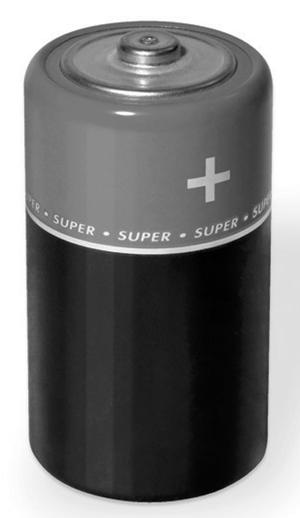 | 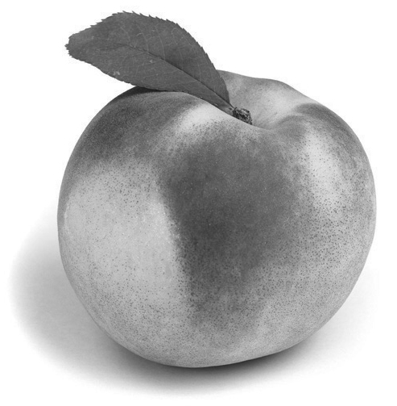
C  D  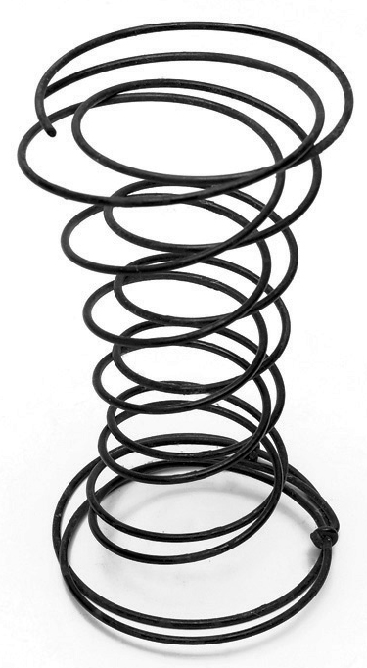 | 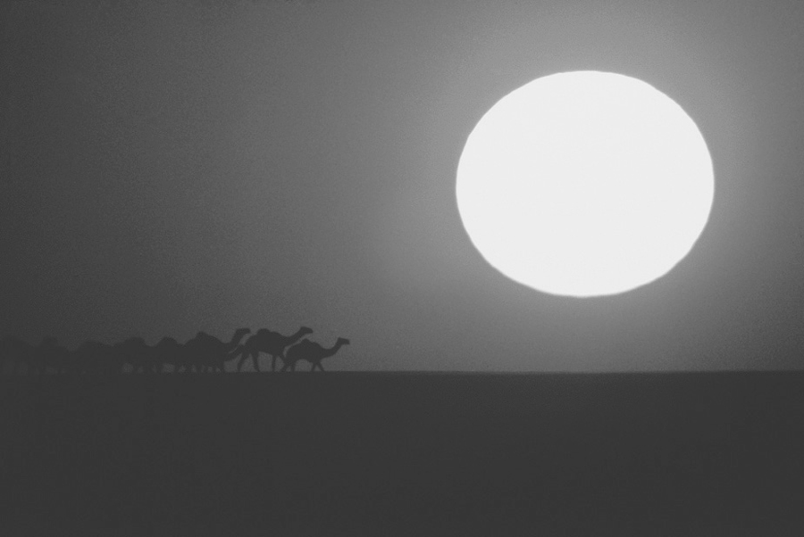
2. In each of the following examples, is energy used to do work or to cause a change?
a) a puddle of water evaporating in the sun
b) a burning log
c) a car moving along the road
d) a person climbing a staircase
3. Why is the amount of energy in the universe said to be constant?
4. Does each of the following situations describe a transfer or a transformation of energy, or both?
a) Solar energy makes photosynthesis in plants possible.
b) Energy from a heating system warms the air in a home.
c) Power plants generate electricity that is then delivered to our homes.
d) Food provides the energy we need to go about our daily lives.
5. To perform work equal to 2 400 J, a machine consumes 12 000 J. What is the energy efficiency of this machine?
6. Can a cup of boiling water contain more thermal energy than a bucket of water at 50°C?
Explain your answer.

⇒ Questions 7 to 12 are not intended for students in the AST program.
2 MOTION AND FORCES (pp. 79–91)
13. In each of the following situations, does the force involve pulling or pushing?
a) the force of a dog on its leash
b) the force of a person inserting a letter in an envelope
c) the force of a magnet on a paper clip
d) the force of a bowstring on an arrow
14. The illustration opposite represents the action of a force.
a) Is the force applied horizontally or vertically?
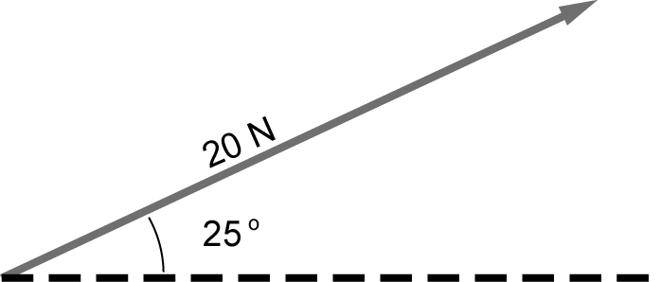
b) Which symbol indicates the direction of the force?
c) What is the magnitude of the force?
15. How does the intensity of the Earth’s gravitational field vary?
16. What distinguishes mass from weight?
17. Plasma or liquid crystal television sets are much lighter in weight than the old models with cathode ray screens. What is the weight of a television set that has a mass of 25 kg at the Earth’s surface?
Problem-solving steps | Application

18. On the surface of which planet of the solar system would you be heaviest? Explain your answer.
19. Look at the illustration opposite.
a) Will the mass of this explorer vehicle be the
same on Earth and Mars? Explain your
answer.
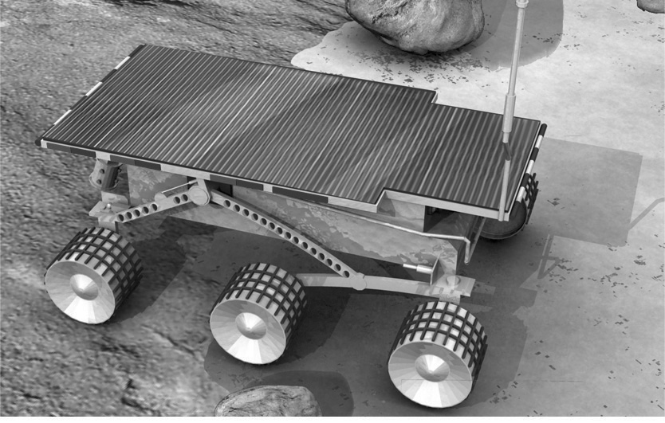
b) Will the weight of the explorer be the same on Earth and Mars? Explain your answer.
20. Name the type of force involved in each of the following examples.
a) pants that stick to our legs from static electricity
b) the force that holds together the particles in the nucleus of an atom
c) the friction between the gears of a watch
d) the string holding a helium-filled balloon
21. Find the resultant force in each of the following situations.
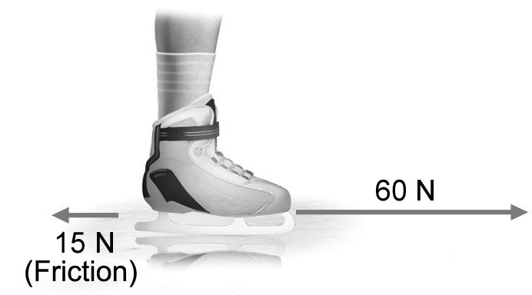
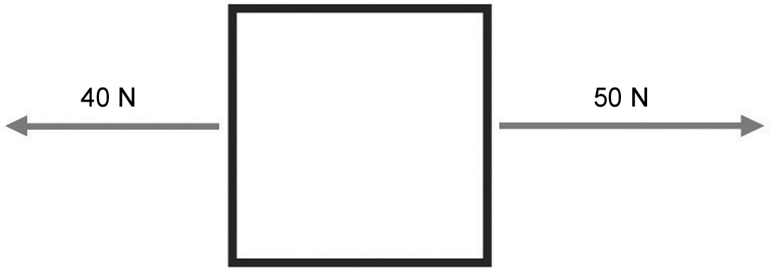
a) |  |  | b)
22. Which of the following situations will have the same effect as a force of 50 N? Explain your answer.
a) two forces of 25 N applied along the same line of action but in opposite directions
b) two forces of 25 N applied along the same line of action and in the same direction
c) two forces of 25 N applied along different lines of action but in the same direction
23. The motor of a boat has a propulsion force of 75 N, while the frictional force of the water against the hull is 10 N. What is the resultant force of this system?
24. If you walk at a constant pace (speed), what is the resultant force of your travel?

⇒ Questions 25 to 29 are not intended for students in the AST program.
3 forces IN FLUIDS (pp. 92–98)
30. a) What is a fluid?
b) Name four examples of fluids.
31. Look at the photo opposite.
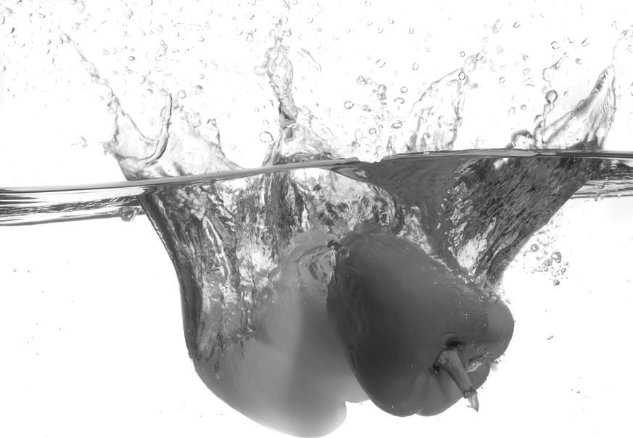
a) How does water pressure act on these objects?
b) Where is the pressure greatest?
Explain your answer.
c) If the water is replaced by a liquid of lower density, how will the pressure change?
32. Pressure is applied to the plunger of a syringe containing 30 mL of liquid. The plunger then exerts a pressure of 30 kPa on the liquid. If the initial pressure of the liquid was 2 kPa, what will be the pressure of the liquid expelled at the other end of the syringe? Explain your answer, specifying the principle of physics you used to determine the pressure.
33. What makes a boat float?
34. An object weighing 98 N is immersed in water.
a) What weight of water must be displaced so that the object can float? Explain your answer.
b) What is the volume of water displaced by the object, given that the density of water is
1 g/mL?
Problem-solving steps | Application
c) The same object is immersed in a solution with a density of 0.8 g/mL.
Given that the object displaces the same volume of liquid as in b), will it float or not?
Show your calculations.

Problem-solving steps | Application
35. When the wind blows hard, what happens to the air pressure? Explain your answer.
36. Name the principle that explains each of the following situations.
a) The hull of a submarine must be very thick, from top to bottom, to resist the pressure
of the water.
b) To float, a submarine must empty its ballast tanks.
c) Force can be amplified with a hydraulic press.
d) The action of the wind makes a flag fly.
e) Warming the air in a hot-air balloon makes it rise into the air.
f) Birds can fly partly because of the particular shape of their wings.
REVIEW QUESTIONS
⇒ Questions A to D are not intended for students in the AST program.
E. Prepare your own summary of Chapter 3 by building a concept map.
Follow-up
1. Why is it important to reduce energy consumption?
2. Whether we own or rent our homes, we can all take steps to reduce our energy consumption. Give three examples of such steps.

