Molecules and solutions

Checkups and follow-ups
ST
Questions 1–6, 17–23, 27–29, 31–33, A and C
ChaptEr 2
Checkup
1 what is a molecule? (pp. 40–50)
1. Are the following substances molecules? Explain your answer.
a) NaCl
b) O₂
c) Au
d) Co
e) CO
f) H₂SO₄
2. What is the natural tendency of each of the following elements with regard to gaining or losing electrons?
a) potassium
b) oxygen

c) aluminum
d) krypton
3. Metals give up electrons. Consequently, do they tend to form positive or negative ions?
4. Calculate the sum of the charges for each of the following electron transfers, and indicate the net charge of the resulting ion.
a) A calcium atom loses two electrons. | c) An iodine atom gains one electron.
b) A nitrogen atom gains three electrons. | d) An aluminum atom loses three electrons.
5. Do the models below represent atoms or ions? Explain your answers.
a) b)
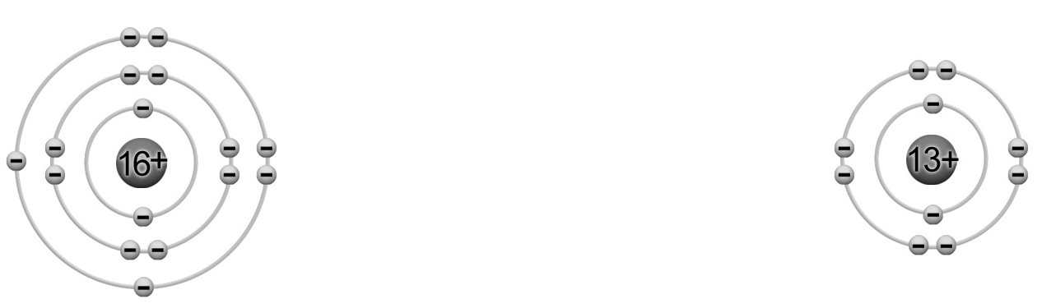
6. Iron has the ability to form one of two ions: Fe²⁺ or Fe³⁺. How many protons and electrons does each of these ions contain?

⇒ Questions 7 to 16 are not intended for students in the ST program.
2 PROPERTIES OF solutions (pp. 50–61)
17. Name the substances that act as solvents and solutes in each of the following solutions.
Solution | Solvent | Solute
a) Air is composed of approximately 80 percent nitrogen and 20 percent oxygen.
b) Steel is an alloy of iron with a small amount of carbon.
c) Seawater contains many mineral salts.
18. Fruit juices, body fluids and cleaning solutions for contact lenses are all examples of aqueous solutions. What is the solvent in these solutions?
19. Brine is a solution of sodium chloride (NaCl) at 18% m/V, which is used to preserve certain foods. To prepare 250 mL of brine, how much salt must be dissolved?
Problem-solving steps | Application
20. A technician prepares a solution, following the steps illustrated below. What is the concentration of this solution, in g/L?
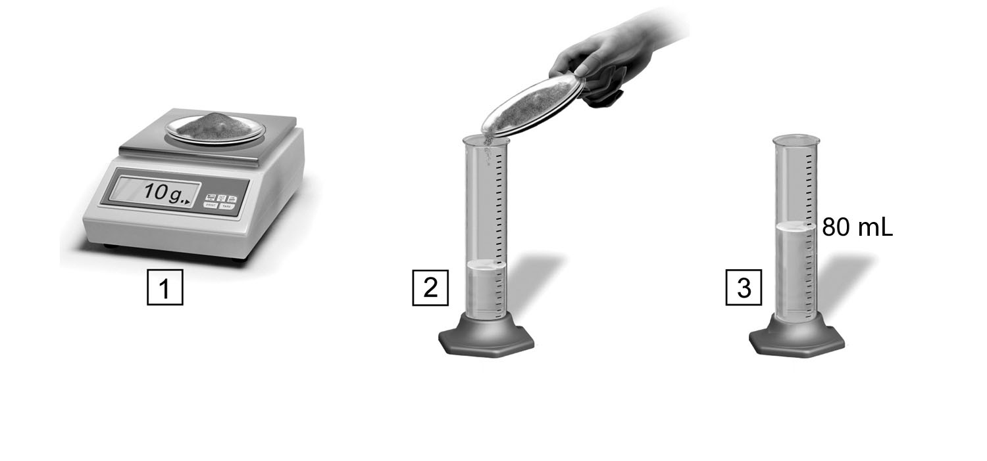
Problem-solving steps | Application
21. The label on a bottle of water says that the water contains 45 ppm of sodium.
a) What does this mean?

b) What is the concentration of sodium in g/L?
22. The water in a lake is contaminated. To determine the concentration of the contaminant, a technician takes a 50-mL sample of the water. After several tests, he concludes that the sample contains 3.75 mg of contaminant. Calculate the concentration of the contaminant, in ppm.
23. Certain minerals are essential to good health. For example, a person should take in approximately 350 mg of magnesium daily. Magnesium can be found in many foods, such as whole wheat bread, which contains about 850 ppm. Assuming that a slice of whole wheat bread has a mass of about 30 g, how many would a person have to eat to obtain the recommended daily dose of magnesium? Show your calculations.

⇒ Questions 24 to 26 are not intended for students in the ST program.

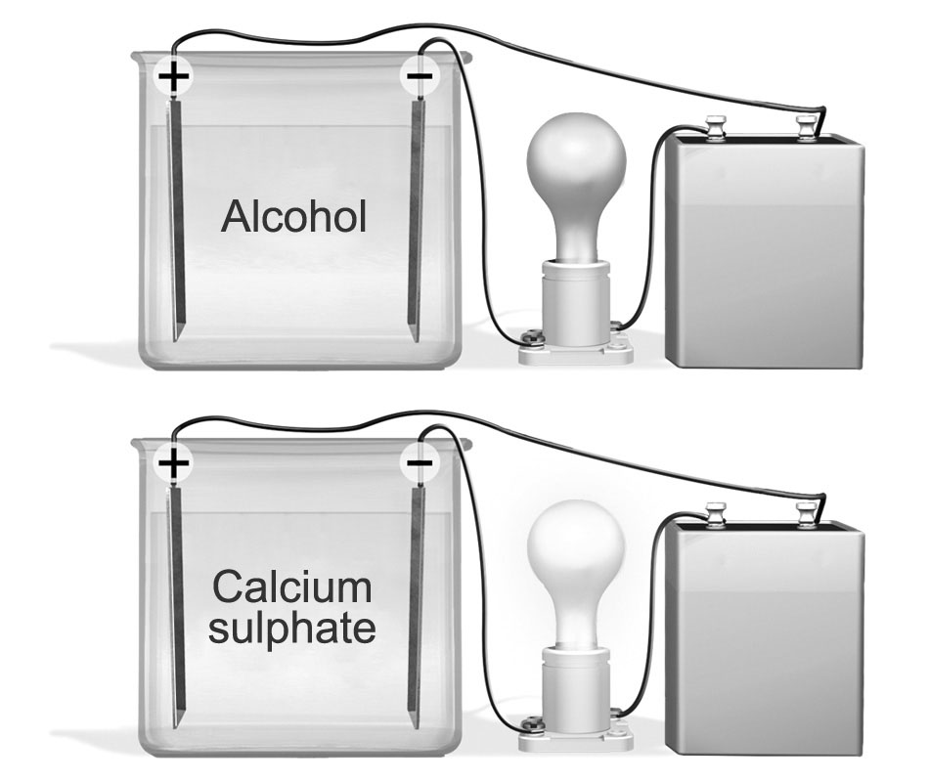
27. Which of the beakers below probably contains an electrolyte? Explain your answer.

28. How does a solution conduct electricity?
29. Are the following equations of electrolytic dissociation written correctly? Explain your answers.
a) MgO_{(s)} 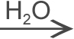 Mg²⁺_{(aq)} + O²⁻_{(aq)}
b) CaBr_{2(s)} Ca²⁺_{(aq)} + Br⁻ _{(aq)}
c) LiH_{(s)} Li⁺_{(aq)} + H⁺_{(aq)}
d) Al₂O_{3(s)} 2 Al³⁺_{(aq)} + 3 O²⁻_{(aq)}

⇒ Question 30 is not intended for students in the ST program.
31. Is each of the following substances an acid, a base or a salt?
a) HBr |  | d) ZnSO₄
b) KOH |  | e) H₃PO₄
c) BaF₂ |  | f) Cu(OH)₂
32. Look at the photo opposite.
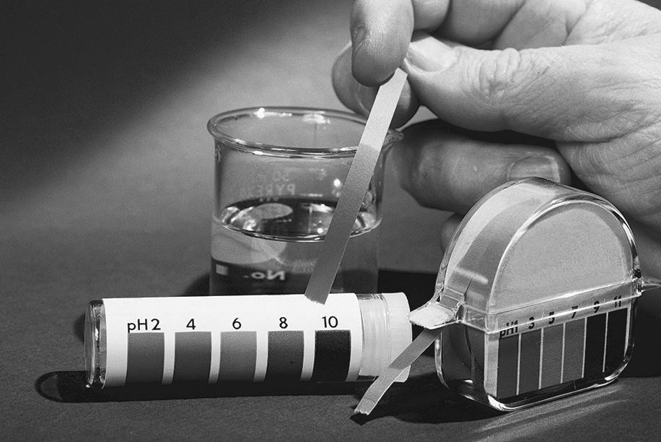
a) What is the pH of this solution?
- Is the solution acidic, basic or neutral?
Explain your answer.
33. Rain has a pH of about 5, while the pH of seawater is about 8. How many times more acidic is rainwater than seawater?
REVIEW QUESTIONS
⇒ Question B is not intended for students in the ST program.

A. A coalition was formed recently to protest the use of dihydrogen monoxide. According to the coalition, the widespread use of this substance has harmful effects on human health and the environment.
Dihydrogen monoxide is both colourless and odourless. It exists as a solid, liquid and gas, but it is usually sold in liquid form. Certain precautions must be taken during its use. Its vapour can cause burns, while prolonged exposure to the compound in its solid form can cause frostbite. Inhaling it in its liquid form has resulted in many deaths.
a) What is the chemical formula for dihydrogen monoxide?
b) Dihydrogen monoxide is the main component of acid rain. Is it the solute or the solvent? Explain your answer.

c) In its pure state, this substance does not conduct electricity, yet it is used to manufacture batteries. Explain how this is possible.
d) Soil erosion by this substance dissolves the minerals in the soil and carries them into lakes and rivers. How does this affect the concentration of minerals in the lakes and rivers?
e) If the total concentration of dissolved matter in a lake is 500 mg/L, what is its concentration in ppm?
f) Should the use of dihydrogen monoxide be banned? Explain your answer.
C. Prepare your own summary of Chapter 2 by building a concept map.
Follow-up
1. To fight air pollution, we must reduce our reliance on fossil fuel combustion. What can each person do to contribute to this reduction?
2. Describe some consequences of acid rain in your region.

