Atoms and elements

Checkups and follow-ups
EST
Questions 1–38 and A–C
Checkup
1 What is an atom? (pp. 6–17)
1. Why is it useful to represent an atom with a model?
ChaptEr 1
2. Look at the two photos below.
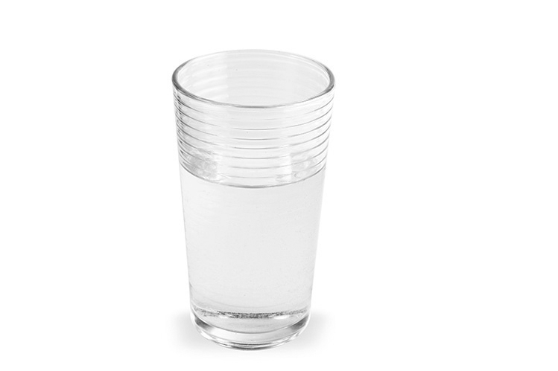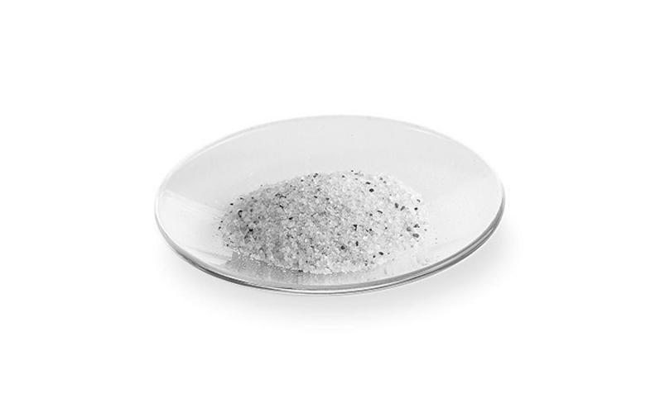
A
B
a) Which photo represents a model in which matter can be infinitely divided? Explain your answer.
b) Which photo represents a model in which matter cannot be infinitely divided? Explain your answer.
3. Here is a representation of a molecule of water (H₂O). Does it respect the principles behind Dalton’s atomic model? Explain your answer.
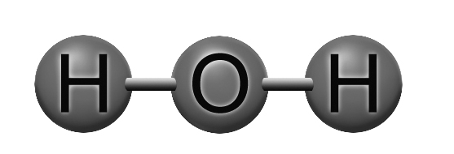
4. What conclusion did Thomson draw from each of the following observations?
a) The cathode rays cause a small propeller inside the tube to turn.
b) The rays are identical regardless of the metal used to make the cathode.
c) The cathode rays are attracted to the positive pole of an electrical field.
5. What type of radiation did Rutherford use for his research on atomic structure?
6. Look at the illustration below. Each letter corresponds to an observation made by Rutherford. Describe each observation and match it with one of Rutherford’s conclusions.
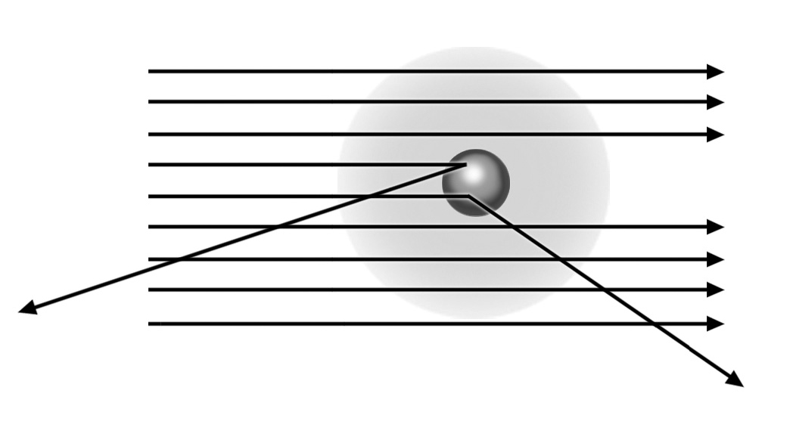
A
C
B
7. Which positively charged particle is found in the nucleus?
8. The bright colours of fireworks amaze and delight us. Each colour is the result of the combustion of a specific substance. For example, potassium chloride produces a purple flame, and sodium chloride, an orange-yellow flame. Which theory, proposed by Bohr, explains this phenomenon?
9. Match a characteristic of the Rutherford-Bohr atomic model with each of the following statements.
a) An atom contains as many protons as electrons.
b) Alpha particles pass easily through gold foil.
c) Alpha particles are strongly repelled by the nucleus.
d) A heated gas emits light waves of a specific length.
10. What is the neutron’s function in the atom?
11. Which particles of the atom account for most of its mass?
12. Which is the lightest particle of the atom?
2 THE PERIODIC CLASSIFICATION OF THE ELEMENTS (pp. 17–26)
13. Where are the nonmetals in the periodic table?
14. What do elements of the same group have in common?
15. Hydrogen is a nonmetal, but it is in the same column as the alkali metals. Explain your answer.
16. What are the elements in the second column of the periodic table called? What do they have in common?
17. In the atomic model of potassium below, which letter represents a valence electron? Explain your answer.
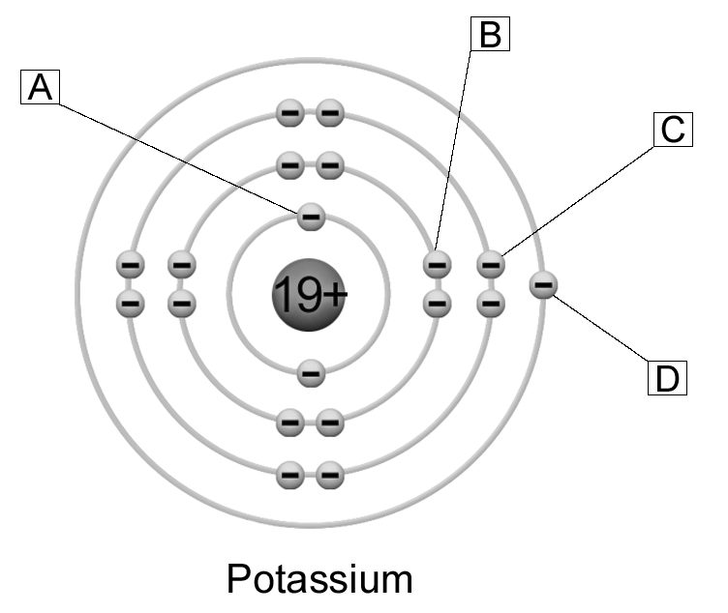
18. What do elements of the same period have in common?
19. The atomic radius is a periodic property of the elements. Explain how the atomic radius varies within a period.
20. How does the melting point vary within a period? Draw a graph showing the melting point as a function of the atomic number to explain your answer. Refer to the data in Appendix 1 and draw your graph on the sheet of graph paper at the end of this handout.
21. The table in Appendix 1 shows the first ionization energy of the elements of the periodic table.
a) How does this property vary within a period?
b) How does this property vary within a group?

22. What does the atomic number of an element represent?
23. What is the relative atomic mass of an element?
24. An atom of argon contains 18 protons, and its mass number is 40. How many neutrons does it contain?
25. An atom has 25 protons, 25 electrons and 27 neutrons. What is its mass in atomic mass units? Round your answer to the nearest whole number and explain your calculation.
26. Among the elements below, which are isotopes of the same element? Explain your answer.
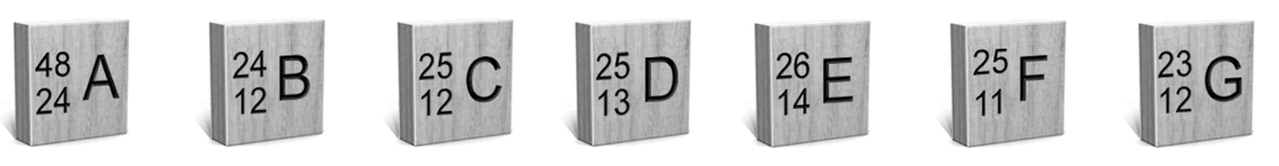
27. Which of these representations is impossible? Explain your answer.
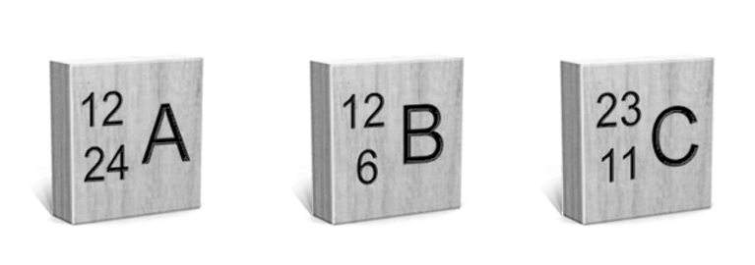
3 representing atoms (pp. 26–29)
28. How is Lewis notation useful?
29. Are the atomic representations below correct Lewis structures? If not, explain your answer.
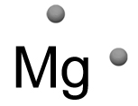
Magnesium
a)

b)
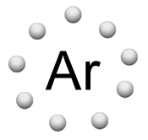
Argon
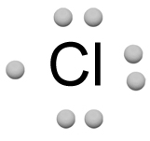
Chlorine
c)
30. Represent the following atoms in Lewis notation.
a) b) c)
Aluminum Iodine Barium
31. Are the atomic representations below correct according to the Rutherford-Bohr model? If not, explain your answer.

Calcium
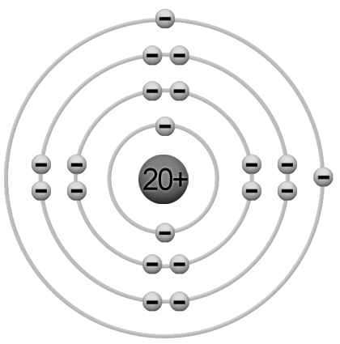
a)

Neon
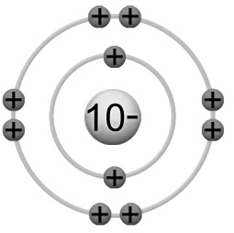
b)

Chlorine
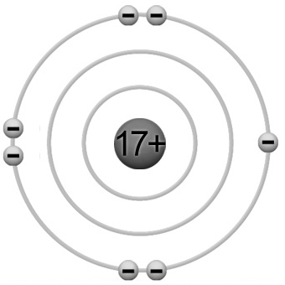
c)

Lithium
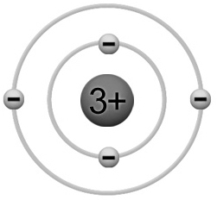
d)
32. Are the following representations correct according to the simplified atomic model? If not, explain explain your answer.
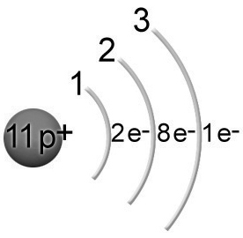
Sodium
a)
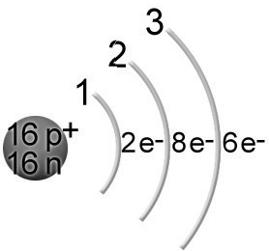
Sulphur
b)
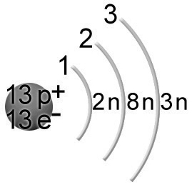
Aluminum
c)
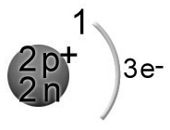
Helium
d)
33. Draw an atom of fluorine according to the simplified atomic model.
4 THE CONCEPT OF MOLE (pp. 30–31)
34. How many moles are there in each of the following samples of matter?
a) 12 g of carbon |  | c) 80 g of argon
b) 20 g of calcium |  | d) 10 g of sodium
35. What is the molar mass of each of the following molecules?
a) LiBr
b) CO₂
c) H₂SO₄
d) Mg(NO₃)₂
36. A 0.25-mol sample of a certain substance has a mass of 10 g.
a) What is the molar mass of this substance?
b) Which element has the same molar mass?
37. What is the mass, in grams, of 6.02  10²³ atoms of gold?
38. How many particles are there in a sample of matter that contains three moles of particles?
REVIEW QUESTIONS

A. The chemical reactivity of elements depends on their ability to give up their valence electrons. The most reactive metal in the periodic table is francium. Explain why, using the Rutherford-Bohr atomic model.
B. Different models of the atom have been proposed over time.
The changes from one model to the next reflect recent
experimental findings. In certain contexts, however,
an older model may still apply. From this point of view,
which model—Dalton’s model, Thomson’s model,
the Rutherford-Bohr model or the simplified atomic
model—is the most relevant to an explanation of each
of the following phenomena?

a) Cathode ray screens depend on the emission of
rays from the cathode of a gas discharge tube.
b) When magnesium burns, it emits a bright light.
For this reason, it was previously used in camera flashes.
c) In a nuclear reaction, neutrons are frequently emitted.
d) If you rub a balloon on your head, it gives off electrons
(onto your hair), creating static electricity.
e) Iron combines with oxygen in a ratio of 2:3 to form
rust (Fe₂O₃).
f) Atoms are mostly empty space.

g) The atomic mass of helium is 4 u.
C. Prepare your own summary of Chapter 1 by building a concept map.
Follow-up
1. The Amazon is not the only place affected by mercury contamination. Relatively high concentrations can also be found in Québec landfills. Name three commonplace objects that you use that might contain mercury. Explain your answers.
2. Mercury is a heavy metal. Using atomic models and the periodic table of the elements, explain why it belongs to this category of elements.

