Atoms and elements

Checkups and follow-ups
ST
Questions 1–9, 13–18, 28–31, A and C
ChaptEr 1
Checkup
1 What is an atom? (pp. 6–17)
1. Why is it useful to represent an atom with a model?
2. Look at the two photos below.

A
B
a) Which photo represents a model in which matter can be infinitely divided? Explain your answer.
b) Which photo represents a model in which matter cannot be infinitely divided? Explain your answer.
3. Here is a representation of a molecule of water (H₂O). Does it respect the principles behind Dalton’s atomic model? Explain your answer.
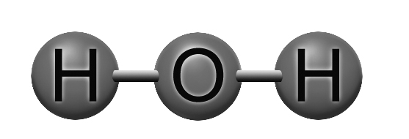
4. What conclusion did Thomson draw from each of the following observations?
a) The cathode rays cause a small propeller inside the tube to turn.
b) The rays are identical regardless of the metal used to make the cathode.
c) The cathode rays are attracted to the positive pole of an electrical field.
5. What type of radiation did Rutherford use for his research on atomic structure?
6. Look at the illustration below. Each letter corresponds to an observation made by Rutherford. Describe each observation and match it with one of Rutherford’s conclusions.
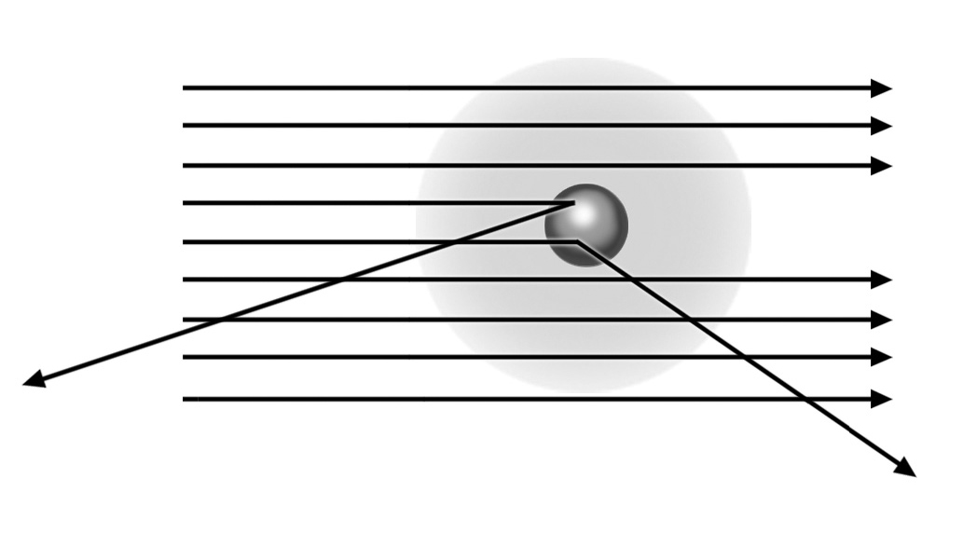
A
C
B
7. Which positively charged particle is found in the nucleus?
8. The bright colours of fireworks amaze and delight us. Each colour is the result of the combustion of a specific substance. For example, potassium chloride produces a purple flame, and sodium chloride, an orange-yellow flame. Which theory, proposed by Bohr, explains this phenomenon?

9. Match a characteristic of the Rutherford-Bohr atomic model with each of the following statements.
a) An atom contains as many protons as electrons.
b) Alpha particles pass easily through gold foil.
c) Alpha particles are strongly repelled by the nucleus.
d) A heated gas emits light waves of a specific length.

⇒ Questions 10 to 12 are not intended for students in the ST program.
2 THE PERIODIC CLASSIFICATION OF THE ELEMENTS (pp. 17–26)
13. Where are the nonmetals in the periodic table?
14. What do elements of the same group have in common?
15. Hydrogen is a nonmetal, but it is in the same column as the alkali metals. Explain your answer.
16. What are the elements in the second column of the periodic table called? What do they have in common?
17. In the atomic model of potassium below, which letter represents a valence electron? Explain your answer.
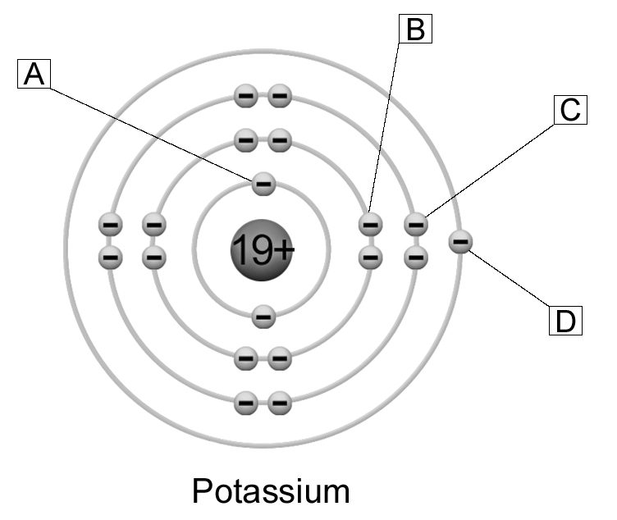
18. What do elements of the same period have in common?

⇒ Questions 19 to 27 are not intended for students in the ST program.
3 representing atoms (pp. 26–29)
28. How is Lewis notation useful?
29. Are the atomic representations below correct Lewis structures? If not, explain your answer.
Magnesium
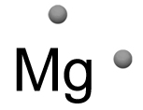
a)

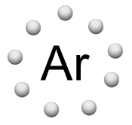
b)
Argon

c)
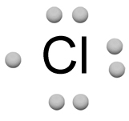
Chlorine
30. Represent the following atoms in Lewis notation.
a) b) c)
Aluminum Iodine Barium
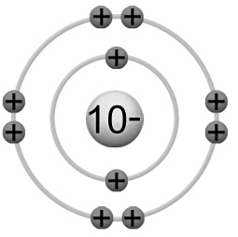
31. Are the atomic representations below correct according to the Rutherford-Bohr model? If not, explain your answer.
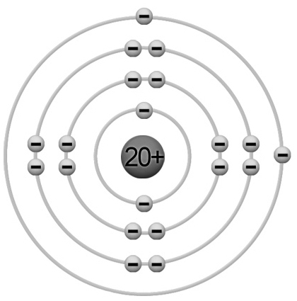
Calcium
a)

Neon
b)

Chlorine
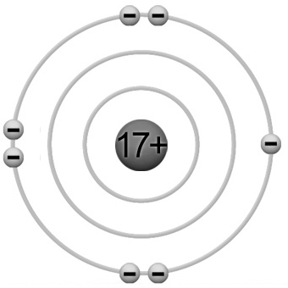
c)

Lithium
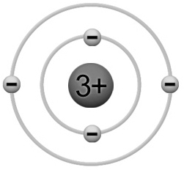
d)

⇒ Questions 32 and 33 are not intended for students in the ST program.
4 THE CONCEPT OF MOLE (pp. 30–31)
⇒ The questions in this section are not intended for students in the ST program.
REVIEW QUESTIONS
⇒ Question B is not intended for students in the ST program.

A. The chemical reactivity of elements depends on their ability to give up their valence electrons. The most reactive metal in the periodic table is francium. Explain why, using the Rutherford-Bohr atomic model.
C. Prepare your own summary of Chapter 1 by building a concept map.
Follow-up
1. The Amazon is not the only place affected by mercury contamination. Relatively high concentrations can also be found in Québec landfills. Name three commonplace objects that you use that might contain mercury. Explain your answers.
2. Mercury is a heavy metal. Using atomic models and the periodic table of the elements, explain why it belongs to this category of elements.

