Electrical engineering

Checkups and follow-ups
EST
Questions 1–18, A and C
ChaptEr 14
Checkup
1 WHAT IS ELECTRICAL ENGINEERING? (pp. 458–462)
1. List five technical objects that you use every day and that could have been designed by an electrical engineer. Explain your choices.
2. What are the main differences between electrical components and electronic components?
3. How do electrical engineers represent circuits and related information?
4. Batteries are a source of direct current. Power plants generate alternating current. Explain the difference between these two types of current.
5. Explain why the following statements are false.
a) Electrons flow from the positive terminal of a battery to the negative terminal.

b) An electrical circuit contains only components designed to conduct current.
2 POWER SUPPLY (pp. 462–463)
6. An electrical engineer must choose a power supply for various electrical material.
What is the most suitable power source for each of the following projects?
a) a communications tower to be built in the Far North of Québec, beyond access to the power grid
b) a digital camera
c) a photocopier
7. Name one advantage and one disadvantage for each of the power supplies mentioned in question 6.
3 CONDUCTION, INSULATION AND PROTECTION (pp. 464–468)
8. Which of the following is acting as a conductor in an electrical circuit?
Explain your answer.
a) the plastic casing of an electrical wire
b) a metal screw wrapped with electrical wire, inside a switch
c) the ceramic housing for an electrical outlet
d) wiring connected to a battery
9. What kind of circuit is used to save space inside a computer?
10. Electrical wires are usually covered in plastic.
a) Explain your answer.
b) Which electrical function is performed by the plastic casing?
11. Fuses and breakers perform the same function in electrical circuits.
a) What is this function called?
b) Which of the two components—fuses or breakers—is the better option? Explain your answer.
12. Look at the electrical resistor opposite.
(See the colour illustration in the student book, p. 479.)
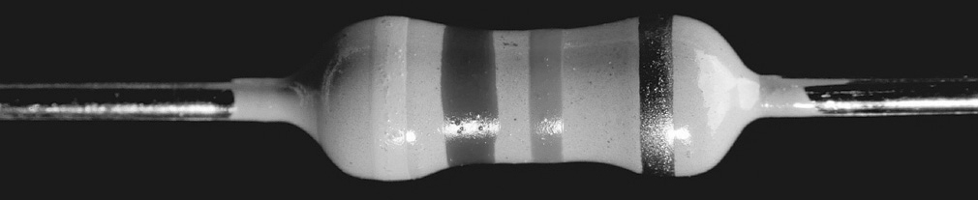
a) What is its resistance value?
b) What are the minimum and maxium values determined by the tolerance?
c) Which unit of measurement is used to express resistance?
d) Describe one advantage of using a resistor in an electrical circuit.
4 CONTROL (pp. 469–471)
13. When a lamp is switched off, is the electrical circuit to the light bulb open or closed? Explain your answer.
14. Choose the appropriate type of switch for the following functions.
a) opening or closing two contacts at once
b) opening one or the other of two circuits
5 THE TRANSFORMATION OF ENERGY (pp. 471–472)
15. In each of the appliances below, electrical energy is converted into another form of energy. What is the resulting form of energy?
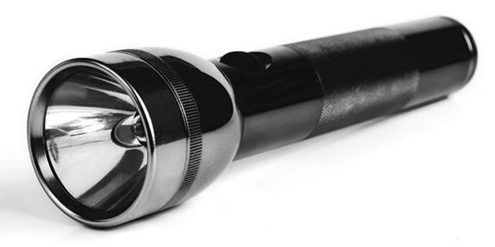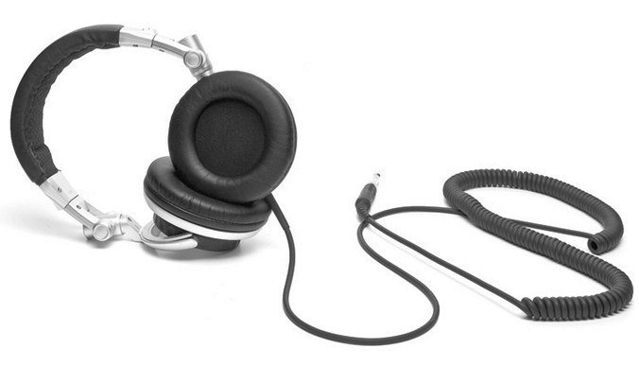
A
B
C
6 COMPONENTS WITH OTHER FUNCTIONS (pp. 473–478)
16. Anna designs an electrical circuit for a laptop computer. The parts for the circuit are fragile, so she wants to make sure that the current flow will remain stable even when the computer is plugged into an outlet where the power supply fluctuates slightly. Which electrical component should she place at the beginning of the circuit? Explain briefly how this component works.
17. Which unit of measurement is used to express capacitance?

18. Name three functions of diodes in electrical circuits.

⇒ Questions 19 to 21 are not intended for students in the EST program.
REVIEW QUESTIONS
⇒ Question B is not intended for students in the EST program.
A. When you go to a friend’s house and ring the doorbell, an electrical circuit is activated, and the doorbell rings.
a) When you press the button for the doorbell, you close an electrical circuit. Which function does the push button perform in the circuit?
b) The doorbell is covered in plastic. Why? Which function does this small round plastic cover perform?
c) When electrons start to flow in the circuit, they pass through a coil of electrical wire wrapped around a small iron bar. What is this device called?
d) What form of energy results from this transformation?
e) The iron core inside the wire coil is attracted to a metal bar (a tone bar). When they meet, the tone bar vibrates. What is the final form of energy produced by this device?
f) Back at your friend’s house a week later, you have to knock on the door because the doorbell is not working. Your friend tells you that it has not been working since the night before, when he tried to plug in a string of lights to decorate his house. The lights came on for less than a second and then went out. What do you advise him to do?
C. Prepare your own summary of Chapter 14 by building a concept map.
Follow-up
1. What do you think makes electronic equipment difficult to recycle?
2. What can you do in your own daily life to reduce the impact of electronic waste on the environment?

