Mechanical engineering

Checkups and follow-ups
AST
Questions 1–17 and A–E
ChaptEr 13
Checkup
1 what is mechanical engineering? (p. 426)
1. Name the branch of science and technology that focuses specifically on the study of technical objects with moving parts.
.
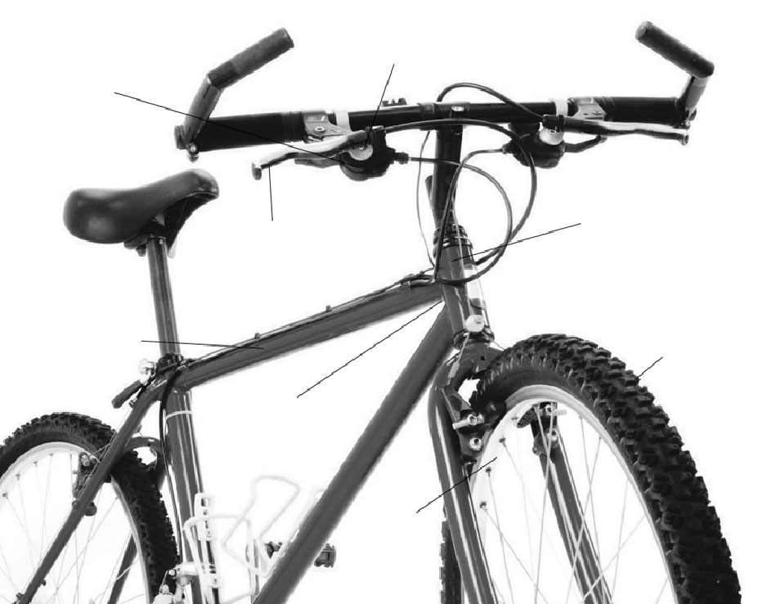
2 LINking in technical objects (pp. 427–430)
Brake
housing
Bolt
Brake lever
Head
tube
Tire
Wheel
Welding
Crossbar
2. Look at the bicycle opposite.
a) Name the four characteristics of the link
between the tires and their respective wheels.
Explain each characteristic.
b) Name the four characteristics of the link between the brake housing and lever.
Explain each characteristic.

c) Name the characteristics of the link between the crossbar and the head tube. Explain each characteristic.
3. How many degrees of freedom does the front wheel of the bicycle in question 2 have?
Explain your answer.
3 guiDING CoNTROLS (pp. 431–435)
4. Look at the three objects below.
1
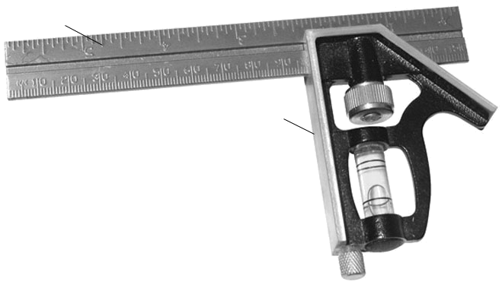
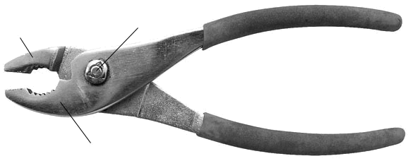
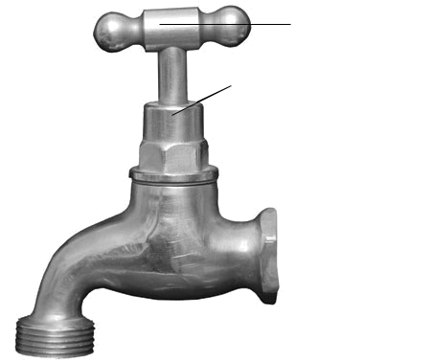
Square head
Ruler
Rivet
Lever 2
Lever 1
Handle
Nut
2
3
a) For each of the three objects, name the type of guiding involved.
b) Identify the guiding component in each object.

5. In each of the following statements, what factor causes the strength of the adhesion between two surfaces to vary?
a) Nonslip stair treads are installed in a staircase to prevent accidents.
b) Cross-country skis usually glide better in colder weather.
c) To avoid injury, it is best not to wear leather-soled shoes when playing sports in a gym.
d) Each spring, Yuri oils his bicycle chain to protect it from premature wear.
6. In gymnastics competitions—for example, in the high bar event—athletes cover their hands with powder.
a) What is the mechanical function of the powder?
b) How is the powder useful during this event?
4 MOTION TRANSMISSION SYSTEMS (pp. 435–445)
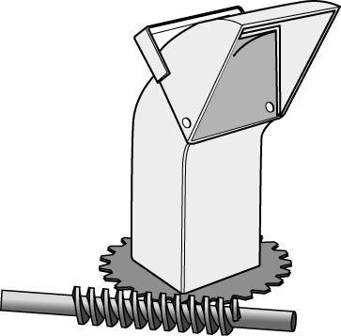
7. The motion transmission system opposite is used to direct
the chute of a snow blower.
a) What is this type of motion transmission system called?
b) Name the driver component in this system. What colour
is it in the illustration? (See the colour illustration in the student book, p. 451.)

c) Name the driven component in this system. What colour is it in the illustration?
(See the colour illustration in the student book, p. 451.)
d) Does the system contain an intermediate component? If so, what is it called?
e) If the snow blower user decides to turn the chute manually, the motion transmission system could be damaged. Explain your answer.
8. Antonia is asked to build a gear train using two of the gears illustrated below.

A
B
C
a) Which gears should she choose for her system?
b) Which characteristic of the gears would motivate her choice?
9. Among the motion transmission systems below, identify those whose rotational motions are correctly illustrated.
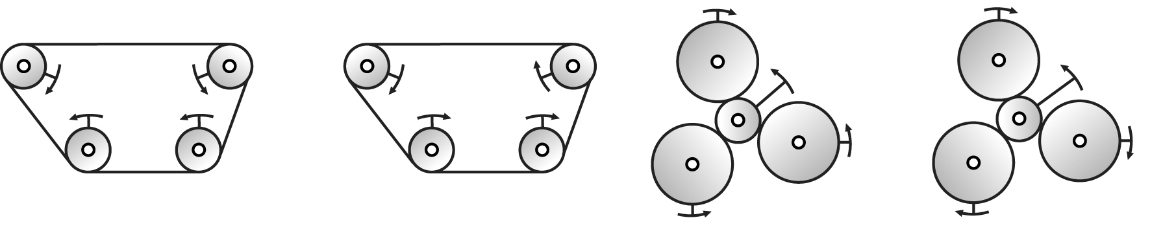
a)
b)
c)
d)

10. Look at the mechanism opposite.
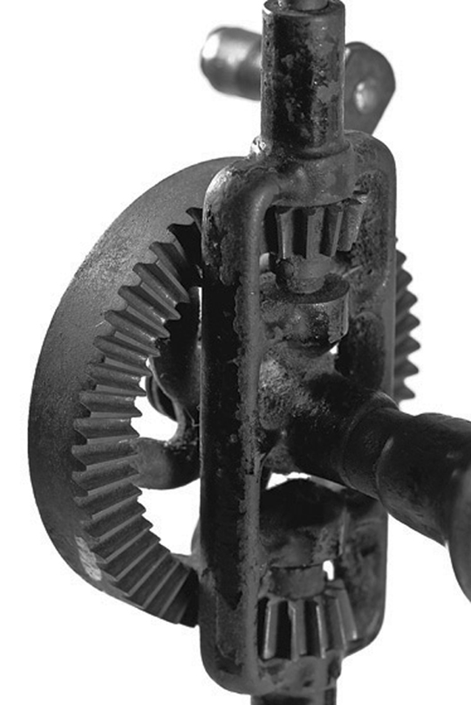
a) Which type of motion transmission system is used in this
technical object?
b) Which type of gear is used in this system?
11. Based on the information provided, calculate the ratio of the gear speeds
for each of the motion transmission systems below.
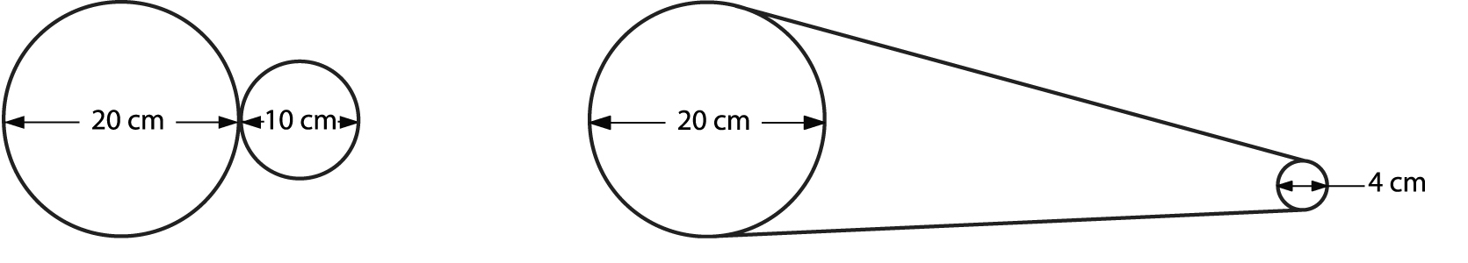
a)
b)
12. Look at the two worm and worm gear systems opposite.
In which system will the rotational speed be more greatly
reduced? Explain your answer.
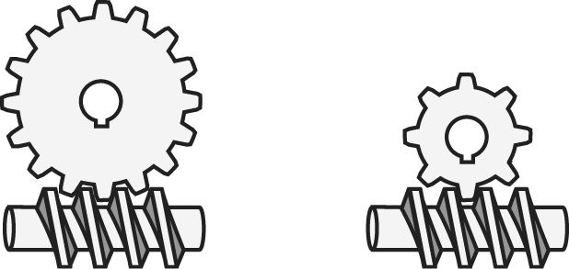
a)
b)
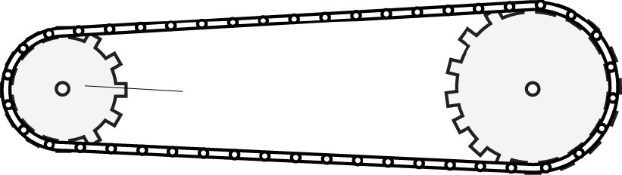
13. In the chain and sprocket system opposite,
the rotational speed of the driver sprocket is
60 revolutions per minute. Based on the information provided by the illustration, calculate the rotational speed of the other sprocket. Express your answer in revolutions per minute.
Driver sprocket

14. The object opposite is a hand drill. By turning the crank, a person can use the drill to bore holes.
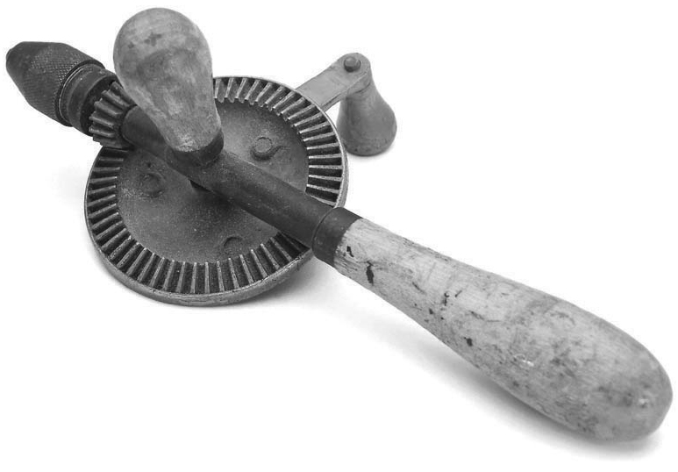
a) What colour is the gear that receives the engine torque when the drill is used?
(See the colour illustration in the student book, p. 452.)
b) Given that steel is harder than spruce wood, will
the resisting torque be stronger when drilling a
hole in a piece of steel or in a piece of spruce?
Explain your answer.
5 MOTION TRANSFORMATION SYSTEMS (pp. 445–449)
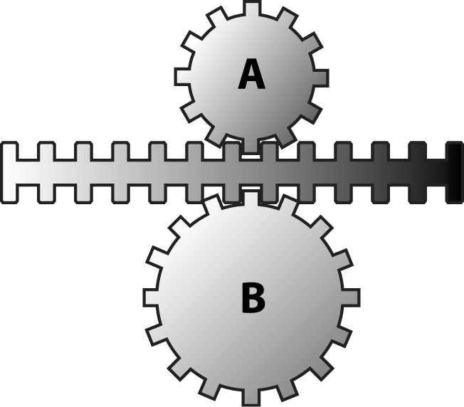
15. Look at the motion transformation system opposite.
a) What is this type of motion transformation system
called?
b) Which of the two gears will turn faster? Explain
your answer.

16. A tensioner is used to tighten the wire or rope
of a clothesline, as in the illustration opposite.
Which type of motion transformation system is
at work here?
17. Look at the motion transformation systems below.
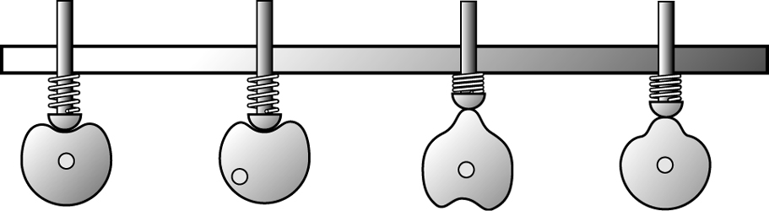
A
B
C
D

a) What are these motion transformation systems called?
b) Which of the four systems involves an eccentric? Explain your answer.
c) What does the spring do in these systems?
d) In which of the four systems will the rod rise the highest?
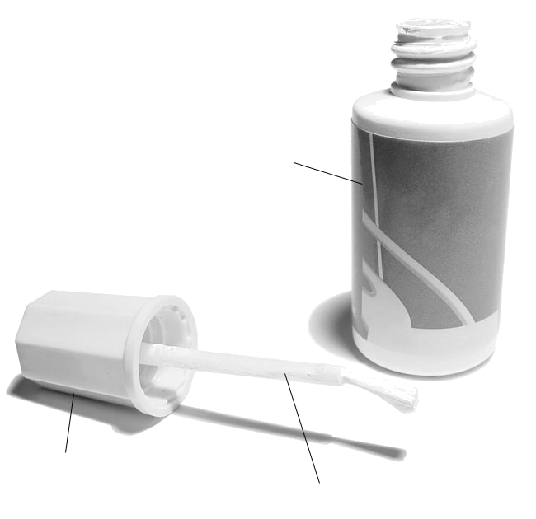
REVIEW QUESTIONS
Brush stem
Cap
Bottle
A. Look at the bottle of correction fluid opposite.
a) Name the characteristics of the link between the cap
and the brush stem.
b) Name the characteristics of the link between the cap
and the bottle.
c) Which part acts as a guiding control in this object?
d) Which type of guiding is involved?
e) What characteristic of the guiding component controls the guiding?
B. Referring to the correction fluid bottle in question A, how many degrees of freedom do the following parts have?
a) the cap when screwed on the bottle
b) the brush stem when attached to the cap

C. Glue sticks are among the most popular types of glue. In the
tube, the glue stick is attached to a nut. Twisting the screw at
the base of the tube will make the glue stick move up or down.
a) What is the usual mechanical function of glue in technical objects?
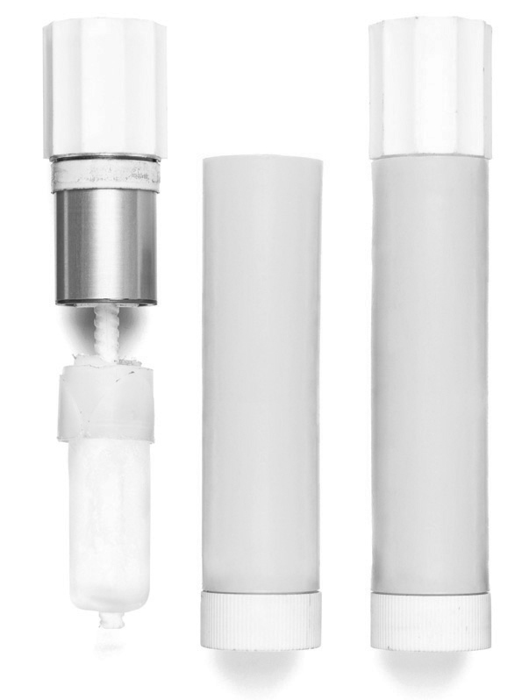
b) Which part guides the glue stick motion, and which type
of guiding is involved?
c) Is the system for raising or lowering the glue stick a motion transmission system or a motion transformation system? Identify the type of system at work.
d) Name the four characteristics of the link between the cap and the tube.
D. Referring to the glue stick in question C, answer the following questions.
a) How many degrees of freedom does the nut in the tube have? Describe them.
b) How many degrees of freedom does the cap have when it is placed on the tube? Describe them.
c) Explain why it is important for there to be adhesion between glue and parts to be glued.
E. Prepare your own summary of Chapter 13 by building a concept map.

Follow-up
1. Why is the mechanical energy from an electric motor considered “greener” than energy from a combustion engine? Give at least two reasons.
2. How can you counteract the harmful effects of combustion engines when you choose a means of transportation? Give several examples.

