Manufacturing technical objects

Checkups and follow-ups
ST
Questions 1–5, A and D
ChaptEr 12
Checkup
1 MATERIALS (pp. 386–390)
1. Depending on how they are used, technical objects are likely to be subjected to stress. Name the constraint at work in the part of the object indicated in the photos below.
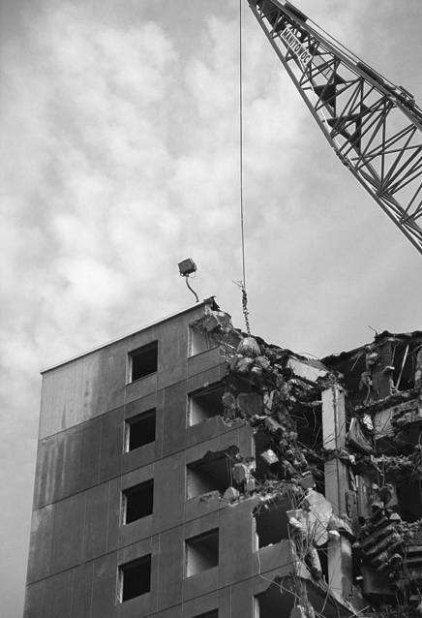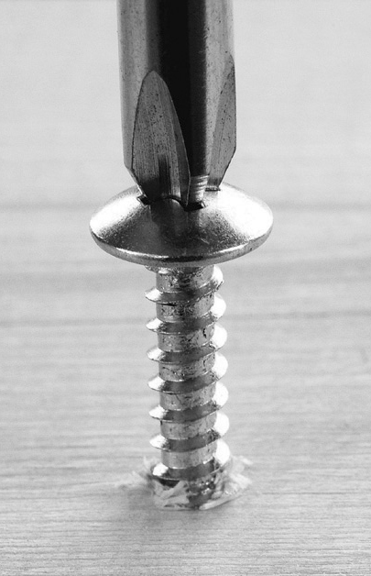
A
B
C
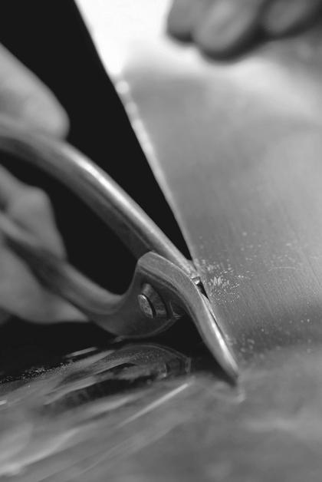
D
E
2. When manufacturing a technical object, it is often necessary to define the mechanical properties of different materials in order to make the most suitable choice. Which mechanical property is sought in each of the following examples?
ChaptEr 12

a) a plastic that keeps its shape even when twisted
b) wooden flooring that resists indentation by pointed objects, such as shoe heels
c) a metal that stretches well to make wire
d) a boat hull that resists shocks caused by running into shoals
e) a material that bends easily, without breaking, to make eavestroughing
2 CATEGORIES OF MATERIALS AND THEIR PROPERTIES (pp. 390–401)
3. Identify the category of material used to make the following objects. Choose from the following categories (each category may be used only once):
– wood and modified wood – metals and alloys
– plastics – ceramics
– composites
a) coins
b) a sheet of plywood
c) a pane of glass
d) a soft-drink bottle
e) a bulletproof vest
4. Which category of material would you suggest to meet the following needs? Choose from the same categories as in question 3 (each category may be used only once).
a) a shiny material that conducts electricity well
b) a light, durable and inexpensive material
c) a material that combines the properties of several categories of materials
d) a natural-looking material, with variations in colour and shade, that can be shaped and assembled easily
e) a durable material with low electrical conductivity and high degrees of heat resistance and hardness
5. During an experiment, a student puts two iron nails in a beaker containing an aqueous solution. One of the two nails was previously coated in grease. Which of the two nails will take longer to rust? Explain your answer.

⇒ Question 6 is not intended for students in the ST program.
3 Technical Drafting (pp. 401–410)
⇒ The questions in this section are not intended for students in the ST program.
4 MANUFACTURING: TOOLS AND TECHNIQUES (pp. 410–417)
⇒ The questions in this section are not intended for students in the ST program.
REVIEW QUESTIONS
⇒ Questions B and C are not intended for students in the ST program.
A. The photo opposite shows a handsaw, a tool often used to saw wood. The cutting part of this tool is made out of steel, while the handle is made of acrylonitrile butadiene styrene (ABS).
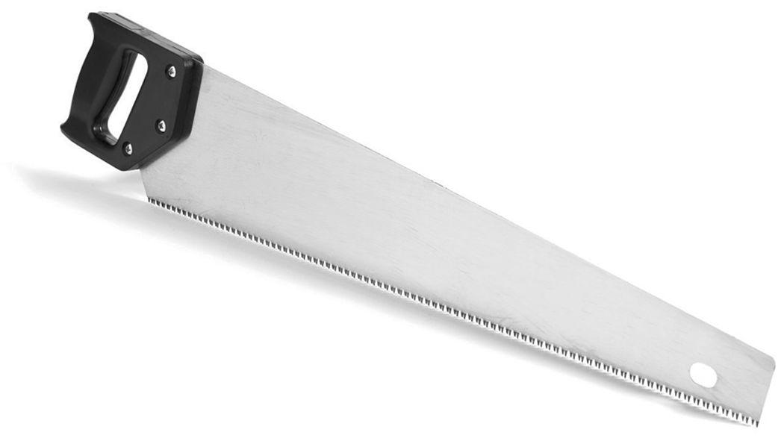
a) Which category of material does the cutting part belong to?
b) Since ABS can be remoulded when heated, which subcategory of plastics does this material belong to?
c) When the saw is used, the blade sometimes bends and then returns to its original shape. Which constraint is this part being subjected to and which mechanical property allows it to return to its original shape?
d) One of the important features of the handle is that it is difficult to deform permanently. Which mechanical property does the handle exhibit?
D. Prepare your own summary of Chapter 12 by building a concept map.
Follow-up
1. If you were planning to buy some wooden boards, how could you make sure that the lumber you choose was harvested according to sustainable development practices?
2. Paper is one of the main products derived from logging. Suggest several ways in which we could limit our paper consumption.

