Manufacturing technical objects

Checkups and follow-ups
AST
Questions 1–14 and A–D
ChaptEr 12
Checkup
1 MATERIALS (pp. 386–390)
1. Depending on how they are used, technical objects are likely to be subjected to stress. Name the constraint at work in the part of the object indicated in the photos below.
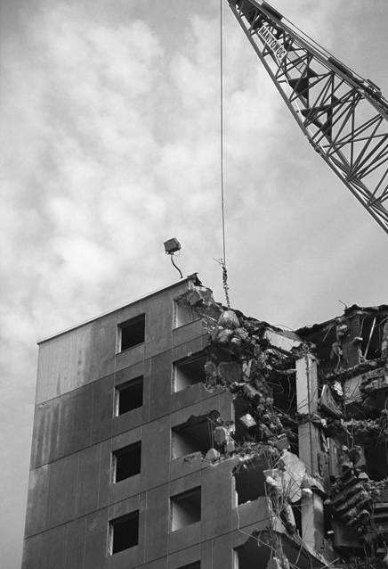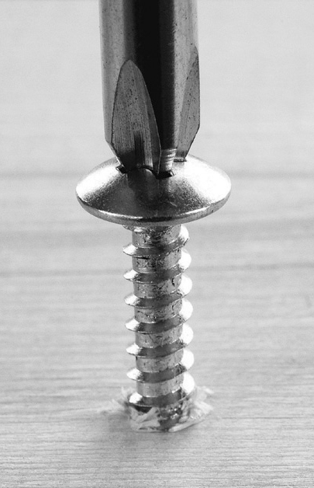
A
B
C
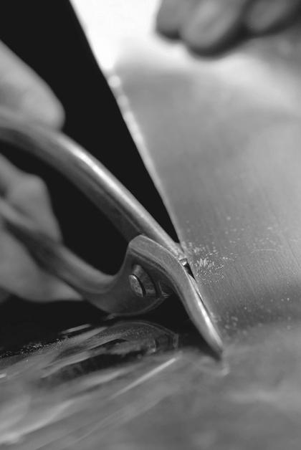
D
E
2. When manufacturing a technical object, it is often necessary to define the mechanical properties of different materials in order to make the most suitable choice. Which mechanical property is sought in each of the following examples?

a) a plastic that keeps its shape even when twisted
b) wooden flooring that resists indentation by pointed objects, such as shoe heels
c) a metal that stretches well to make wire
d) a boat hull that resists shocks caused by running into shoals
e) a material that bends easily, without breaking, to make eavestroughing
2 CATEGORIES OF MATERIALS AND THEIR PROPERTIES (pp. 390–401)
3. Identify the category of material used to make the following objects. Choose from the following categories (each category may be used only once):
– wood and modified wood – metals and alloys
– plastics – ceramics
– composites
a) coins
b) a sheet of plywood
c) a pane of glass
d) a soft-drink bottle
e) a bulletproof vest
4. Which category of material would you suggest to meet the following needs? Choose from the same categories as in question 3 (each category may be used only once).
a) a shiny material that conducts electricity well
b) a light, durable and inexpensive material
c) a material that combines the properties of several categories of materials
d) a natural-looking material, with variations in colour and shade, that can be shaped and assembled easily
e) a durable material with low electrical conductivity and high degrees of heat resistance and hardness
5. During an experiment, a student puts two iron nails in a beaker containing an aqueous solution. One of the two nails was previously coated in grease. Which of the two nails will take longer to rust? Explain your answer.
6. In the Middle Ages, when knights had swords forged, the steel blades were heated then dipped in water.
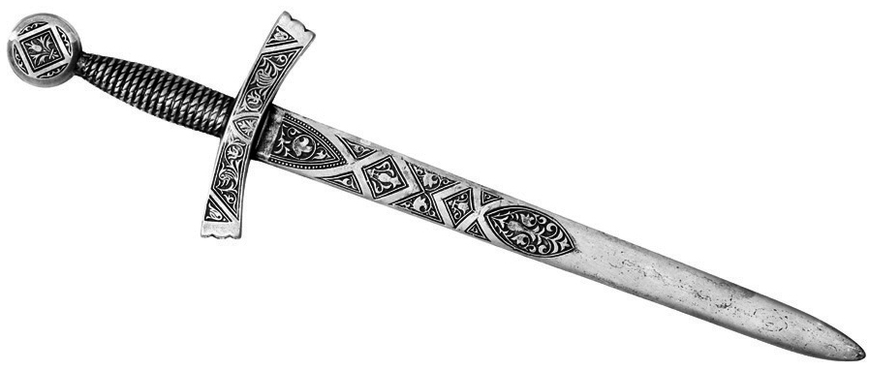
Name the thermal treatment just described and identify the main advantage of the treatment for the eventual properties of the blade.
3 Technical Drafting (pp. 401–410)
7. Look at the two drawings below of a compact disk storage tower.
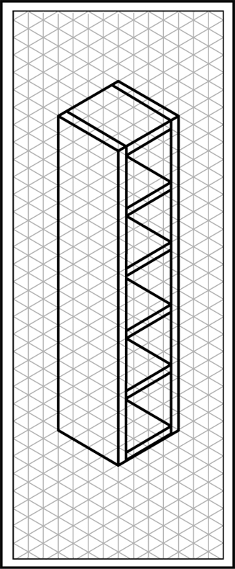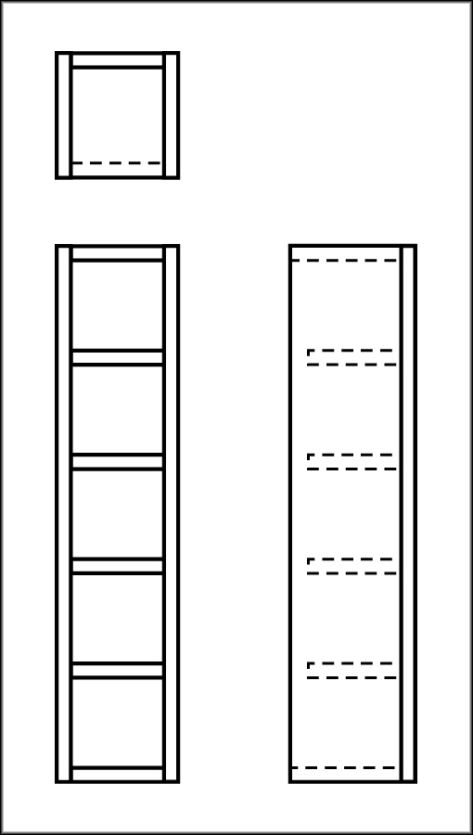
a) Name the type of projection used in each drawing.
B
A
b) Could these two drawings be called general arrangements? Explain your answer.

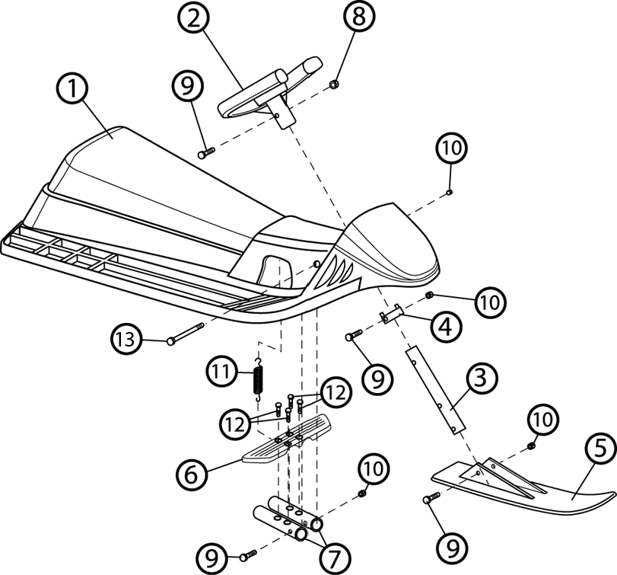
8. Look at the drawing opposite, which represents a three-ski sled.
a) What type of drawing is it?
b) The number 12 parts are metal screws. Determine how many of these screws are needed to assemble this technical object.
c) If we wished to represent all the parts with detail drawings, what is the minimum number of drawings we would have to make? Explain your answer.
d) Part number 3 can be machined by bending. How can we represent, in a detail drawing, the surface area required to manufacture this part?
9. To manufacture a part, a student relies on the drawing opposite.
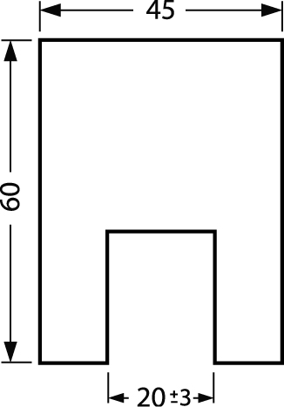
a) When the actual part dimensions are checked, the width of the indentation is found to measure 22 mm. Does this part comply with the drawing? Explain your answer.
b) What is the minimum width the indentation could have?
10. Match each solid below with the correct development.
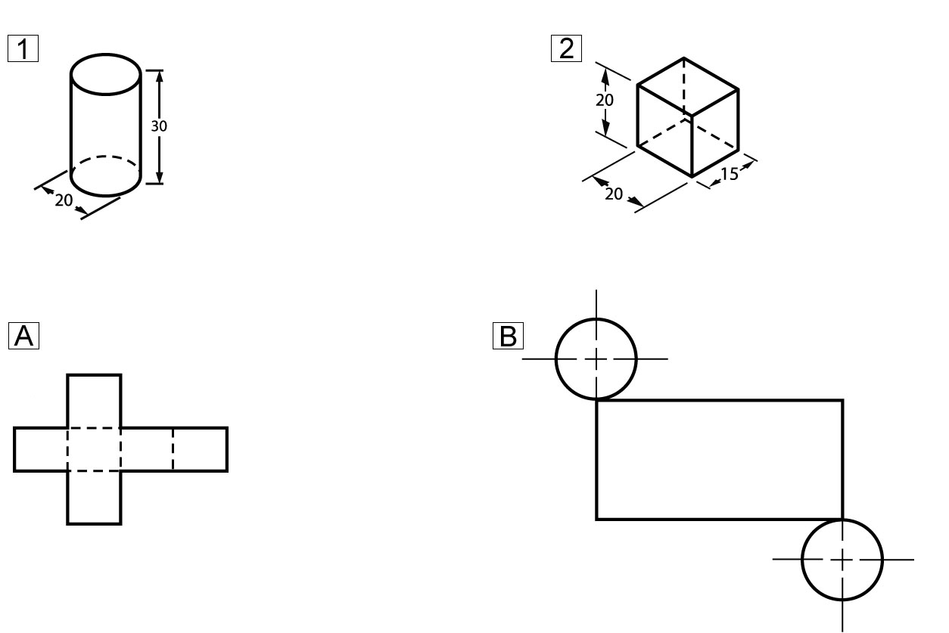
Solids
Developments
4 MANUFACTURING: TOOLS AND TECHNIQUES (pp. 410–417)
11. Drilling is one of the most frequently used techniques in the manufacture of technical objects.
a) What is the purpose of drilling?
b) What are the two main factors to consider when choosing a drill bit?
c) Must the two factors in question b) also be considered when determining the speed of rotation of the drill bit? If not, what should be considered instead?
12. The roof of the birdhouse opposite has been covered in aluminum, obtained from a single sheet of metal. Which machining technique was used to shape the sheet of aluminum? Explain your answer.

13. Name three ways to inspect parts for a technical object.
14. For which assembly technique is each of the following tools most often used?
a) a hammer
b) carpenter’s glue
c) a soldering iron
d) a screw
REVIEW QUESTIONS
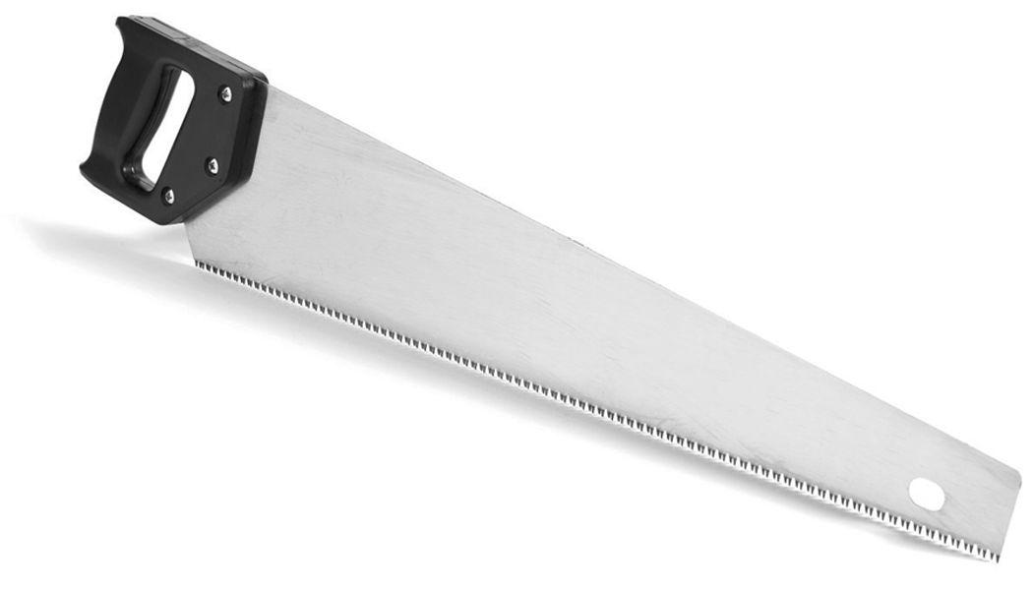
A. The photo opposite shows a handsaw, a tool often used to saw wood. The cutting part of this tool is made out of steel, while the handle is made of acrylonitrile butadiene styrene (ABS).
a) Which category of material does the cutting part belong to?
b) Since ABS can be remoulded when heated, which subcategory of plastics does this material belong to?
c) When the saw is used, the blade sometimes bends and then returns to its original shape. Which constraint is this part being subjected to and which mechanical property allows it to return to its original shape?
d) One of the important features of the handle is that it is difficult to deform permanently. Which mechanical property does the handle exhibit?
B. The steel used to manufacture the blade of the saw in question A has been quenched. What was the purpose of this treatment?
C. Look at the drawing below.
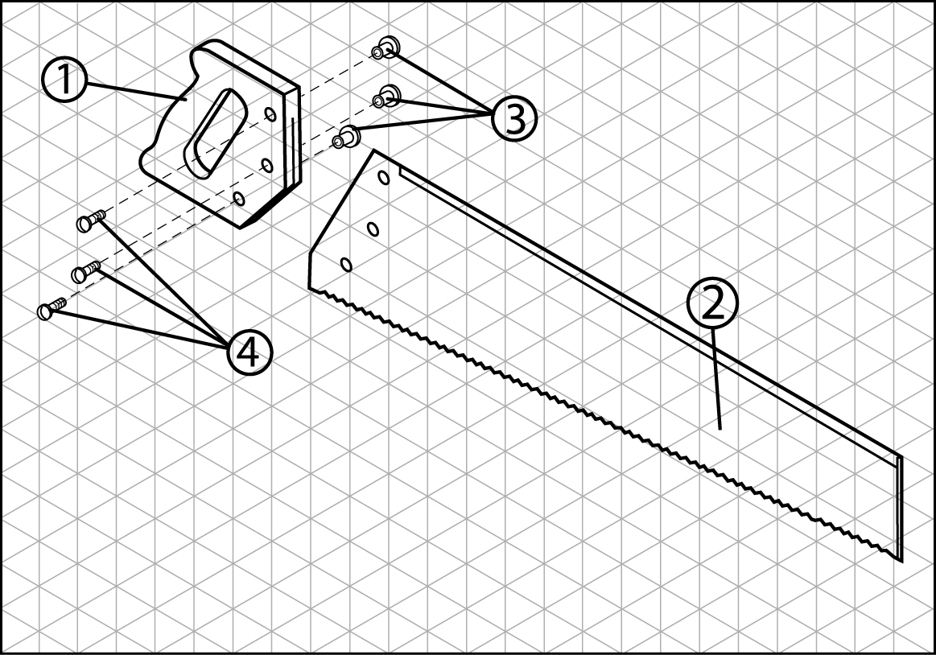
a) What type of drawing is it?
b) Make a technical diagram for the handsaw.
c) Can the handsaw be considered a machine tool? Explain your answer.
d) At which stage of the manufacturing process is this tool mainly used?
D. Prepare your own summary of Chapter 12 by building a concept map.
Follow-up
1. If you were planning to buy some wooden boards, how could you make sure that the lumber you choose was harvested according to sustainable development practices?
2. Paper is one of the main products derived from logging. Suggest several ways in which we could limit our paper consumption.

