Genetics

Checkups and follow-ups
EST
Questions 1–17, A and B
ChaptEr 11
Checkup
1 FACTORS RESPONSIBLE FOR CHARACTER TRAITS AMONG LIVING ORGANISMS (pp. 350–358)
1. Look at the two cells opposite.
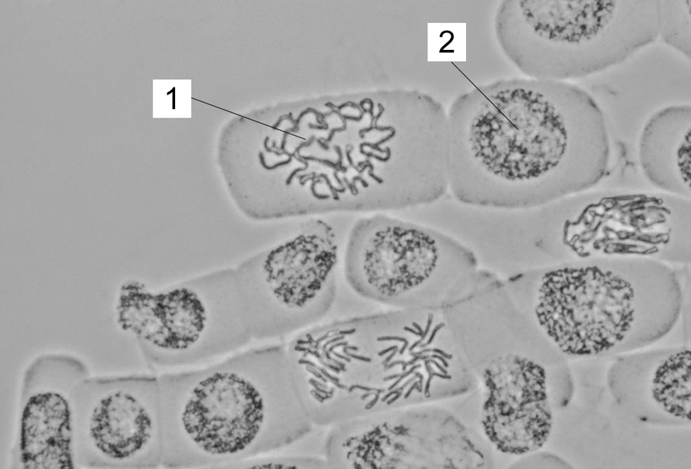
a) What is the form of the DNA in cell 1?
b) What is the form of the DNA in cell 2?
2. All members of the same species have an identical number of chromosomes in their
cells.
a) In total, how many chromosomes do humans have in most of their cells?
b) What is the name of a representation of chromosomes in ordered pairs?
c) What is the name of the DNA segment that forms chromosomes and contains information for making proteins?
d) Give three examples of character traits that are expressed because of the proteins our bodies manufacture.

3. Look at the illustration opposite representing DNA in a simplified form.
Use the information in the illustration to answer the following questions.
(See the colour illustration in the student book, p. 374.)
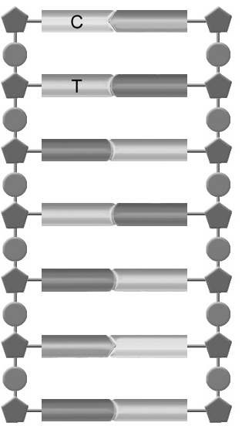
a) Name the nitrogenous base represented by the following shape:
(Write its full name.)
b) Name the nitrogenous base represented by the following shape:
(Write its full name.)
c) Name the nitrogenous base represented by the following shape:
(Write its full name.)
d) Name the nitrogenous base represented by the following shape:
(Write its full name.)
e) If  represents a phosphate group, what does  represent?
4. We know that letters are the building blocks for forming words.
a) What are the building blocks for making proteins called?
b) The alphabet contains 26 letters. How many different building blocks can be used to make proteins?
c) True or false? The building blocks for forming proteins in bacteria and fungi are different from those we use to make our own proteins. Explain your answer.
5. The growth hormone stimulates growth and metabolism, among other things. This molecule is a sequence of 191 amino acids.
a) Why can this hormone be identified as a protein?
b) The growth hormone controls functions and carries messages in our bodies. Name four other roles proteins can play in the human body.
6. Protein synthesis occurs as a result of certain processes in a cell. Place the following steps in the correct order.
A. An mRNA is formed.
B. tRNA bond with the mRNA. Amino acids are joined together.
C. The synthesized protein detaches itself from the ribosome and folds into its final shape.
D. The two strands of DNA separate.
E. An mRNA attaches itself to a ribosome.
7. Does each of the following statements refer to DNA or RNA?
a) My full name is ribonucleic acid.
b) The sugar I contain is deoxyribose.
c) I do not contain any thymine.
d) Most of the time, I am a molecule made up of two complementary strands.
e) One of my nitrogenous bases is uracil.
f) I act as a messenger during protein synthesis.
2 principLes OF HEREDITY (pp. 358–369)
8. Fruit flies are often used for experiments in genetics. To reproduce, sperm from the male flies fertilize the ova of the female flies, which then lay eggs. Why can fruit flies be said to reproduce by crossbreeding?
9. Among the character traits studied in fruit flies is the length of their wings. Two shapes are possible for this character trait: normal wings and miniature wings.
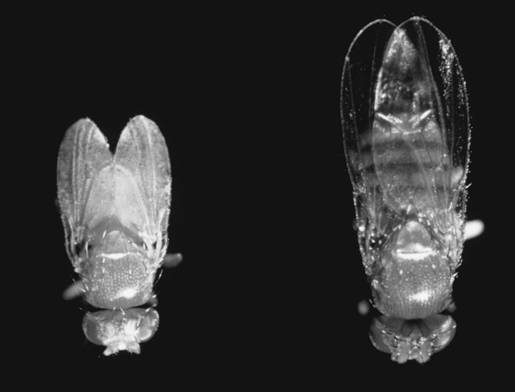
If two pure-line individuals with normal wings are crossbred, what proportion of the offspring will also have normal wings? Explain your answer.
1
2
1. Fruit fly with miniature wings
2. Fruit fly with normal wings

10. When a fruit fly has an allele for normal wings and an allele for miniature wings, its phenotype for this character trait is “normal-winged.”
a) Is this individual homozygous or heterozygous for the character trait? Explain your answer.
b) Which of the two alleles is dominant?
c) Which of the two alleles is recessive?
d) What would be the possible genotype or genotypes for a fruit fly with normal wings?
e) What would be the possible genotype or genotypes for a fruit fly with miniature wings?
11. Is each of the following character traits hereditary or not?
a) the tendency to tan in the sun
b) eye colour
c) hair length
d) the presence of a scar
e) hand size
f) occurrence of cystic fibrosis
g) infection with the flu
12. In guinea pigs, the allele for black-coloured fur (B) is dominant over the allele that produces white fur (b). A pure-line individual with black fur is crossbred with an individual with white fur. What is the probability that a black-haired offspring from this cross will be heterozygous for the character trait? Support your answer with a Punnett square.

Parents
Genotype

Possible
gametes
Punnett square

13. In rabbits, the allele for black hair (B) is dominant over the allele for tan-coloured hair (b). Second, the allele for short hair (S) is dominant over the allele for long hair (s). A long-haired male rabbit that is heterozygous for hair colour is crossbred with a black short-haired female that is homozygous for both character traits. Using a Punnett square:
a) Specify the possible genotype or genotypes of the offspring from this crossbreeding.
b) Specify the possible phenotype or phenotypes of the offspring from this crossbreeding.

Parents
Genotype
Possible
gametes

Punnett square

14. In tomatoes, the allele for purple stems (P) is dominant over the allele for green stems (p). Second, the allele for red fruit (R) is dominant over the allele for yellow fruit (r). Two tomato plants that are heterozygous for the two character traits are crossbred. Supposing that 160 new plants are obtained, use a Punnett square to show how many of them, in theory, will have:
a) a purple stem and yellow fruit
b) a purple stem and red fruit
c) a green stem and yellow fruit
d) a green stem and red fruit

Parents
Genotype

Possible
gametes
Punnett square

3 clonING (pp. 369–373)
15. Why can identical twins be described as clones of each other?
16. Distinguish between natural cloning and artificial cloning. Give an example of each.
17. Look at the figures below.
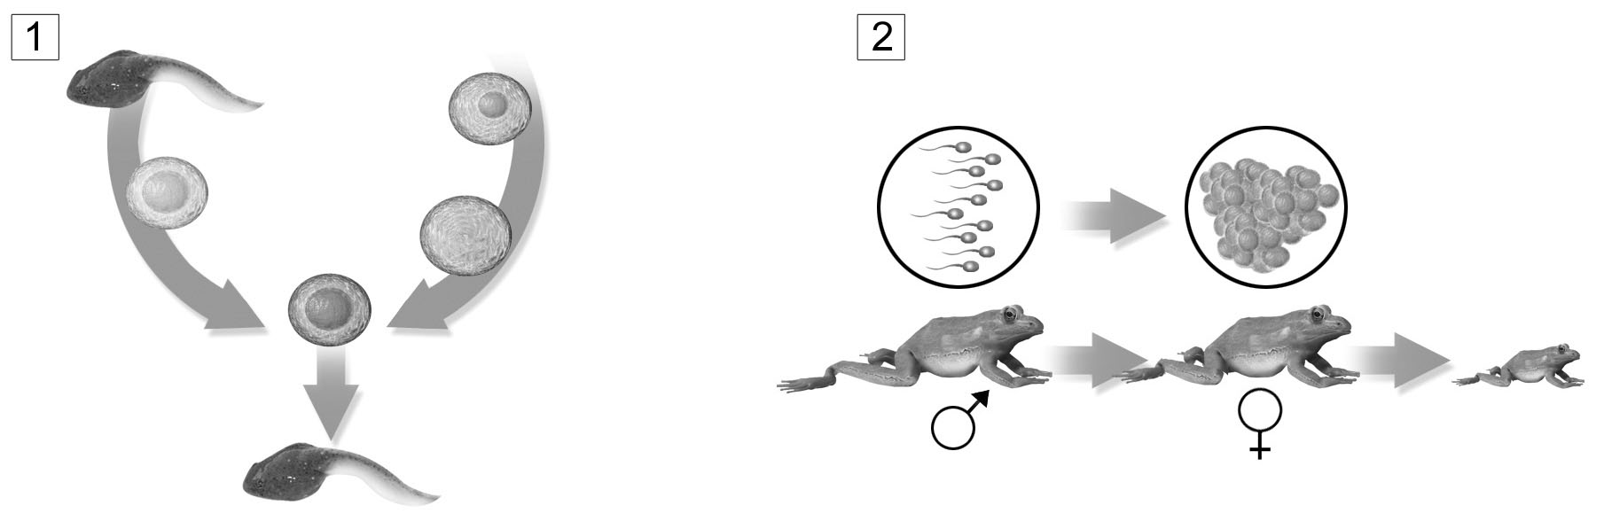
Tadpole
Frog spawn
Fertilization
a) Which of the two figures illustrates cloning? Explain why.
b) Is this natural or artificial cloning? Explain your answer.
REVIEW QUESTIONS
A. Read the following text and then answer the questions below.
In Canada, one in 10 000 people suffers from Huntington’s chorea, which causes neurons in the brain to decay. Patients typically have difficulty controlling their movements; eventually they become completely immobile and die.
On our fourth pair of chromosomes, we all have a gene called the Huntington gene. It
contains instructions for synthesizing a protein called huntingtin, whose exact function in
our neurons remains unexplained. It is known, however, that a particular amino acid is
repeated in its structure. If this amino acid is repeated fewer than 35 times in a row, the
carrier does not normally suffer from Huntington’s chorea. When there is a sequence with
more than 35 repetitions, the person has the disease.
Unfortunately, people who carry the allele causing Huntington’s chorea in their DNA are inevitably afflicted with the disease. The first symptoms of this hereditary disease usually appear between the ages of 30 and 45 years, so affected adults may already be parents before realizing that they are sick.
a) Which mRNA has the longer nucleotide sequence: the one copied from the mutant allele associated with Huntington’s chorea or the one copied from the normal allele? Explain your answer.
b) Which of the two alleles is dominant: the one that causes the disease or the one that does not? Explain your answer.
c) What are the possible genotypes for a person with this disease?
d) If the father of a child is heterozygous for this character trait and the mother does not have Huntington’s chorea, what is the probability that the child will have the disease? You can use a Punnett square to answer this question.

Parents
Genotype
Possible
gametes
Punnett square

B. Prepare your own summary of Chapter 11 by building a concept map.
Follow-up
1. Why were researchers interested in the nucleotide sequence of the gene responsible for taxol synthesis?
2. In Québec, phytotherapy, which is the treatment of diseases with plants, is becoming increasingly popular. Explain why protecting genetic diversity is important for this industry.

