Ecosystems

Checkups and follow-ups
AST
Questions 1–15, A and C
ChaptEr 10
Checkup
1 WHAT IS AN ECOSYSTEM? (pp. 318–326)
1. Which level of ecological organization do the following examples illustrate?
a) a pack of wolves
b) wolves hunting a caribou herd
c) a lone wolf
d) a pack of wolves drinking from a lake
2. What is the difference between a community and an ecosystem?
3. What is the name of the feeding relationships between the living organisms of an ecosystem?
4. A carnivore cannot be a primary consumer in a food chain. Explain your answer.
5. Which trophic level do detritivores belong to? Explain your answer.
6. What is transferred from one organism to another within each ecosystem?

7. Explain the role of decomposers in the material flow of an ecosystem.
8. What is the main source of energy in an ecosystem?
9. Approximately 10 percent of the energy absorbed by one consumer is available to the next consumer in a food chain. What happens to the energy that is lost at each level of a food chain? Give two explanations.
10. All the living organisms in an ecosystem need organic matter to survive.
a) Which organisms are responsible for producing new organic matter (biomass)?
b) What indicator is obtained by measuring the amount of new biomass produced by these organisms over a certain length of time?
c) Name four factors that can affect the production of new biomass.
• |  |  | •
• |  |  | •
11. Build a food chain based on the photos below.
a) Draw the food chain.
b) Specify the trophic level for each of the living organisms in your food chain.
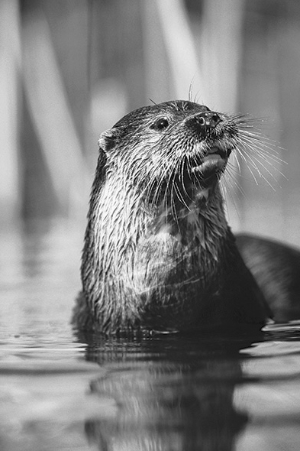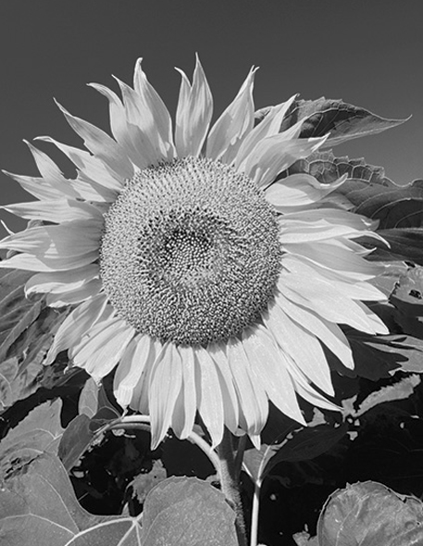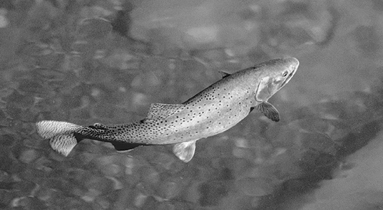
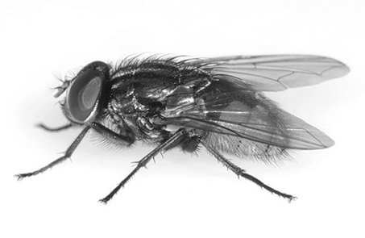
1
2
3
4
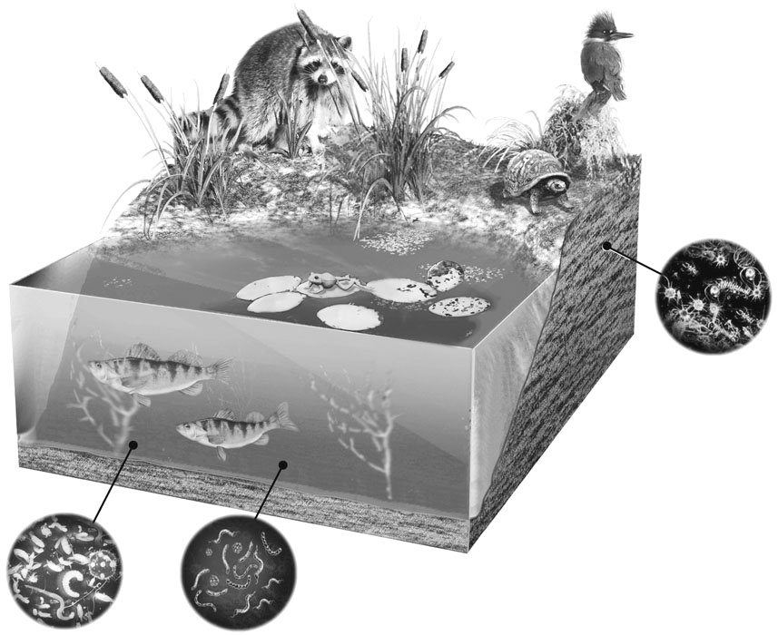
12. Look at the illustration opposite.
Raccoon
Water lily
Kingfisher
Detritivorous insects
Turtle
Bacteria
Phytoplankton
Algae
Cattails
Perch
Frog
a) Among the organisms in the
illustration, name those that are:
– producers
– consumers
– decomposers
b) Draw a possible food chain containing the organisms in the illustration.
13. If you tried to establish the feeding relationships between all the organisms of the lake ecosystem illustrated in question 12, would you be drawing a food chain or a trophic network? Explain your answer.
2 DISTURBANCES (pp. 327–331)
14. True or false? Explain your answers.
a) The freezing of a lake can be considered a natural disturbance.
b) Excessive hunting and fishing are human disturbances of ecosystems.
c) All types of natural disturbance can occur in Québec.
d) Ecological succession occurs only after a natural disturbance.

e) Transforming forests into farmland constitutes a natural disturbance.
f) A flood following heavy rain is a natural disturbance.
15. What is ecological succession?

⇒ Questions 16 and 17 are not intended for students in the AST program.
3 EcotoxicologY (pp. 331–336)
⇒ The questions in this section are not intended for students in the AST program.
4 biotechnologY TO THE RESCUE (pp. 337–341)
⇒ The questions in this section are not intended for students in the AST program.
REVIEW QUESTIONS
⇒ Question B is not intended for students in the AST program.
A. Look at the following three food chains.
Chain 1
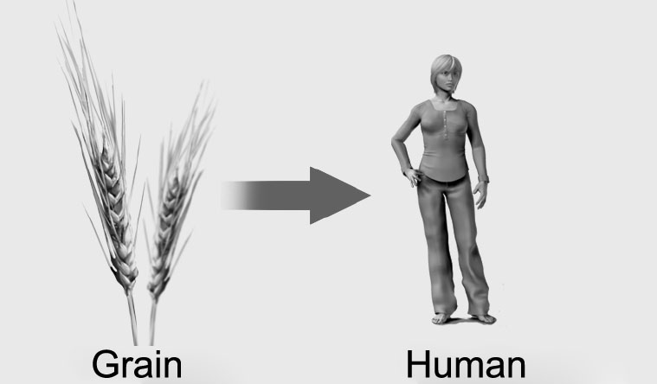
Chain 2
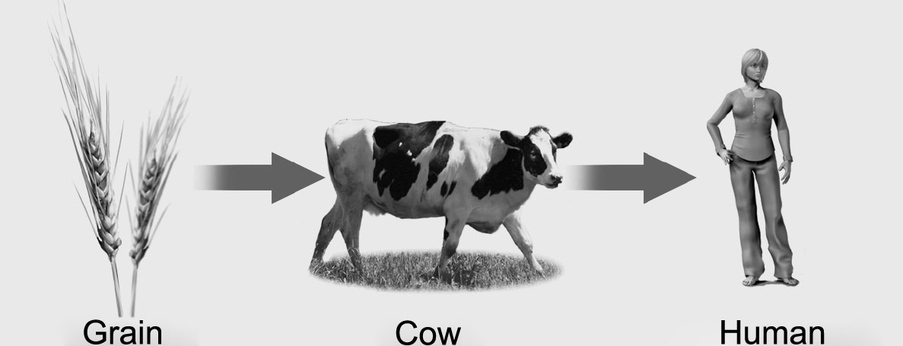
Chain 3
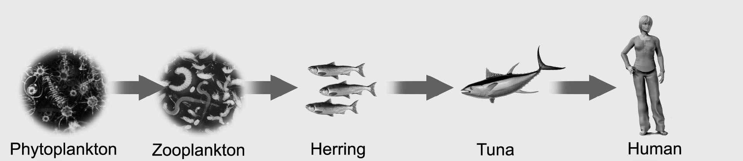

a) For each of the food chains, name the trophic level of the human.
b) Why is it correct to identify the phytoplankton in Chain 3 as producers?
c) Suppose that 10 percent of the available energy is converted into biomass at each change of trophic level. For each of the three food chains, calculate the percentage of the energy from the producers that the humans eventually convert into biomass.
Chain 1:
Chain 2:
Chain 3:
C. Prepare your own summary of Chapter 10 by building a concept map.
Follow-up
1. Tests conducted by Health Canada show that it is now possible to swim at several beaches along the St. Lawrence River (Fleuve Saint-Laurent). However, swimming on days after a heavy rainfall is not recommended. Explain your answer.
2. What precautions must be taken by riverside residents in areas where local wastewater is discharged into septic tanks rather than to a treatment plant?

