Genetics and reproduction

Support activities – Concept review
LW2
Concept review: asexual and sexual reproduction,
cell cultures, DNA, genetic diversity, genetic transformation (GMOs), meiosis and sexual development, mitosis, plant and animal cells
1. Complete the sentences, using the words in the box below. You may not need some words, and you may use others more than once.
• asexual  • cell membrane  • cell wall  • chloroplasts  • culture  • cytoplasm | • cytosine  • division  • DNA  • female  • gametes  • genes | • genome  • helix  • male  • nuclear membrane  • nucleus  • parent | • production  • repair  • sexual  • vacuole  • variations  • zygote
a) Animal and plant cells have four main parts:
– the , which regulates exchanges between the cell and its environment
– the , a jelly-like fluid containing several small organs called
organelles
– the , which regulates cell activities and contains hereditary information
– the , which regulates exchanges between the nucleus
and the organelles
. . . and sometimes
– the , which is a pocket in the cytoplasm. In animals, fats are stored in it; in plants, it holds starch and waste.
Plant cells have the following specific characteristics:
– the , which surrounds the cell membrane and contains a large amount of cellulose (the substance that gives plants their rigidity)
– , which capture sunlight to produce food
b) Genetic diversity refers to the of all the
within a single species.
c) Asexual reproduction involves a single that produces
one or more “copies” of itself. Sexual reproduction involves the fusion of two cells:
one cell and one cell.
d) DNA is a molecule shaped like a double and found in the cell
. The genetic information in DNA is encoded in the sequence of nitrogenous base pairs (adenine, , guanine and thymine).
e) Mitosis is the process of cell by which cells multiply, ensuring
the growth and of various tissues.
f) Meiosis is the process of cell that produces male and female
gametes, making reproduction possible. Fertilization is the fusion of two : an ovum and a sperm. It produces a zygote, a complete cell with genetic material from both the father and the mother.
g) Cell is a process by which cells are grown outside their original environment or their originating organism.
h) A genetic transformation is a modification of a (the complete set of genetic information for any individual of a species) by removing or altering one or more of its genes or by inserting genes from another species.
2. Name the two types of cells illustrated and identify their parts.
a)
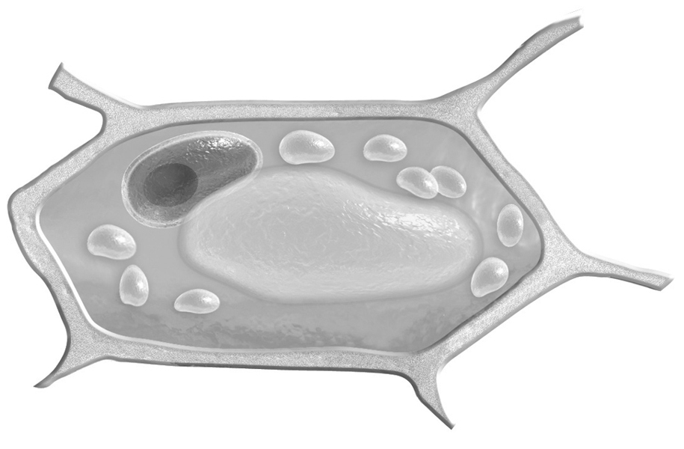
A.
E.
B.
F.

C.
D.
G.
b)
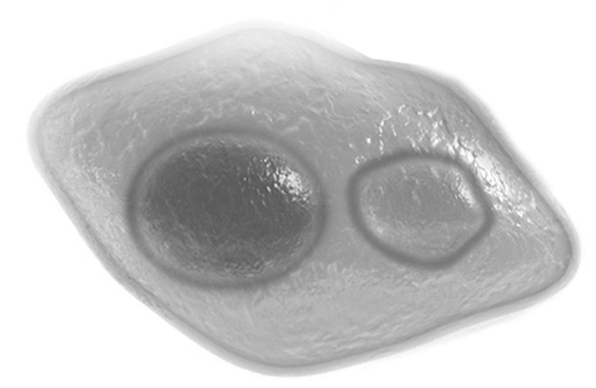
A.
B.
C.
D.

E.

3. What part of the cell contains hereditary information?
4. What type of reproduction produces offspring that are not identical to their parents?
5. True or false?
a) DNA is divided into segments called genes.
b) Asexual reproduction is a significant source of genetic diversity.
c) A chromosome is a rod-shaped structure made of DNA filaments.
d) An ovum has 23 pairs of chromosomes.
e) A living organism whose DNA has been modified is a GMO.
6. When do two people have exactly the same genetic information?
7. What does mitosis produce? Use the expressions daughter cells and mother cell in your answer.
8. Complete the sentences, using the words in the box below. You will need all the words, and you may use some more than once.
• chromosomes  • daughter cells | • division  • half | • meiosis  • mother cell | • reduces
Meiosis I is an initial that the number of chromosomes by . Meiosis II divides the in two.
creates four that each contain
of the genetic material of the .
9. Describe the stages of a cell culture, using the pictures below.
A. C.
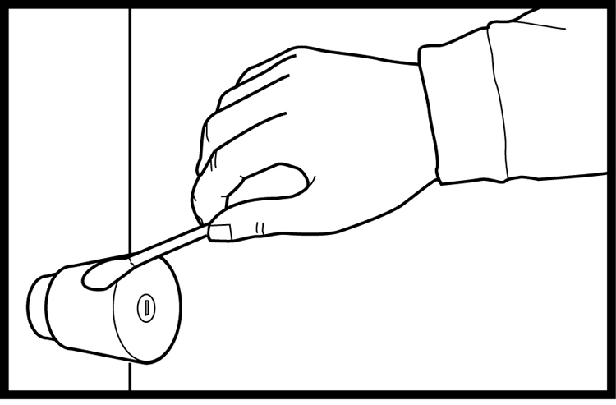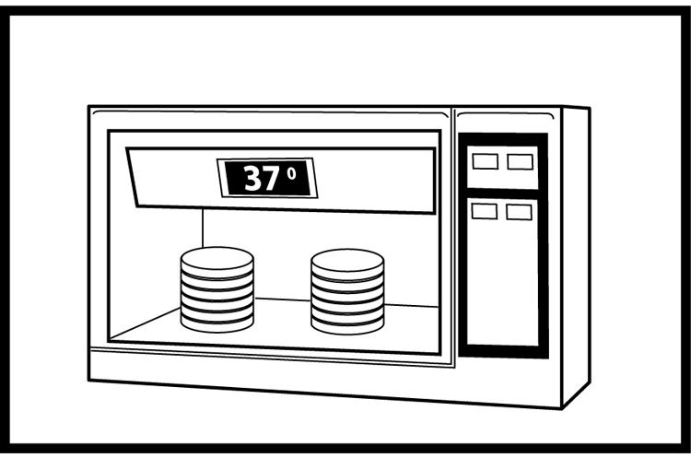
B. D.
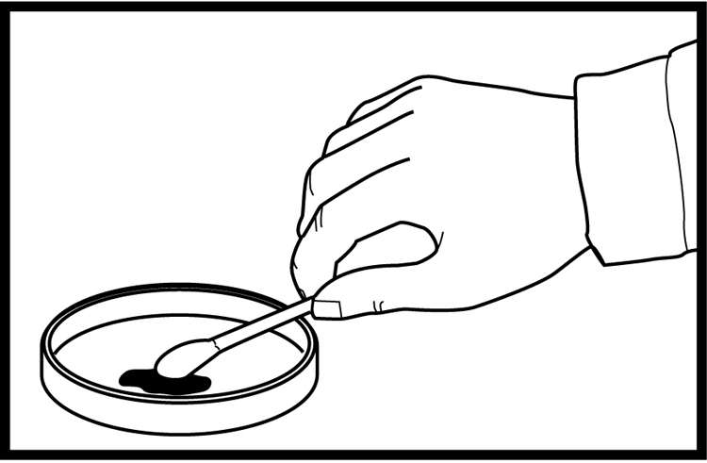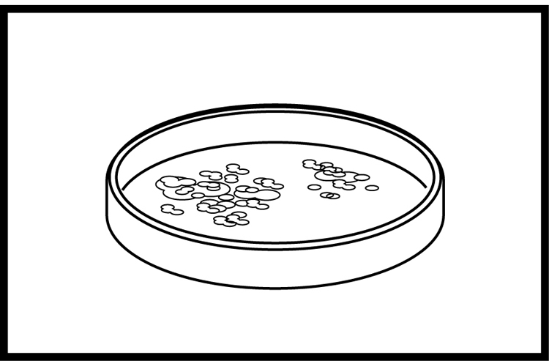
10. What is the purpose of genetic transformation? Give several examples.

