The lithosphere

Support activities – Concept review
Concept review: erosion, internal structure of the Earth, lithosphere, relief, tectonic plate, types of rocks (basic minerals), types of soil, universal gravitation, volcano
1. Complete the sentences, using the words in the box below. You may not need some words, and you may use others more than once.
E&S3
• coldest  • core  • greater  • hottest | • liquid  • lithosphere  • mantle  • map | • minerals  • molten  • rocks  • sediment | • smaller  • soil  • solid  • tectonic plates
a) The internal structure of the Earth consists of three parts: the Earth’s crust, the
mantle and the core. The crust is the outer shell of the Earth; it contains the
that form the continents and the ocean floor. The mantle
is the layer that makes up the greatest part of the Earth’s volume. The part of the
mantle near the crust is , while the lower mantle is partially
. The core, at the centre of the Earth, is the
and densest part. The inner core is .
b) The lithosphere is the shell of the Earth. It consists of the Earth’s crust and the upper mantle. It includes all landforms: mountains, plains, plateaux, volcanoes, etc. According to plate tectonics, the lithosphere is divided into more than a dozen large sections called . They float on the partially
portion of the mantle.
c) Relief refers to all the landforms on the surface of the
(elevations, depressions, slopes).
d) A volcano is formed when the magma from the rises through the Earth’s crust to the surface.
e) Erosion is the wearing away and transformation of or soil by glaciers, surface runoff and atmospheric phenomena (rain, wind, frost).
f) Universal gravitation is the force of attraction that one mass exerts on another. The force of gravity is subject to two laws: The the mass of an object, the greater the effect of gravity. The the distance between objects, the weaker the effect of gravity.
g) Rock is material made up of the in the Earth’s crust.
Rocks are divided into three main categories: igneous rocks, sedimentary rocks
and metamorphic rocks.
h) is the loose upper layer of the Earth’s crust. It can be divided into four types: clay, loam, sand and humus.
2. Give three examples of the consequences of erosion.
3. On each line of the table below, check the situation where the force of gravity is greater.
 | Situation A |  | Situation B
a) | Between the Sun and Mercury |  | Between the Sun and Pluto
b) | On the surface of the Moon |  | On the Earth’s surface
c) | A large rock thrown from a building |  | A ball thrown from a building
4. What type of rock fits each of the following descriptions?
a) rocks formed by the gradual accumulation of sediment
b) rocks that have been transformed by heat or pressure in the Earth’s crust
c) rocks formed when magma cools
5. Match each description with the correct number from the illustration below.
Description  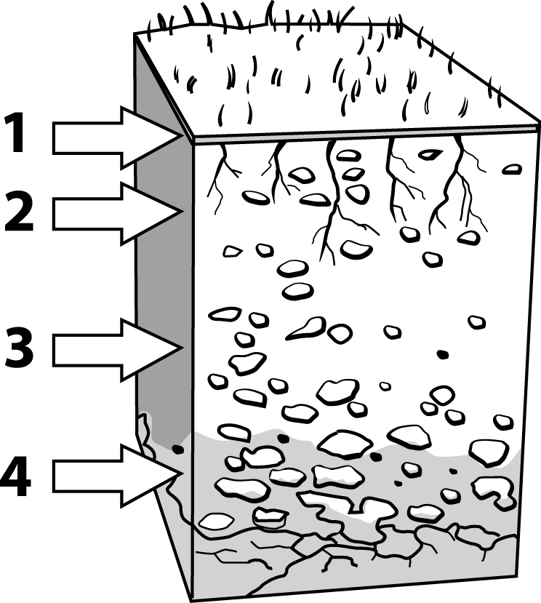 |  | No.
a) | Humus made up of partly decomposed organic matter
b) | Organic matter from decomposing living organisms
c) | Parent rock
d) | Fragments of disintegrated parent rock
6. Give an example of the effect of the Moon’s gravitational pull on the Earth.

