Control and the transformation of energy

Support activities – Second Year of Secondary Cycle Two

ACTIVITY 62
EST
Student BOOK: Chapter 14, pages 469–472
RELATED HANDOUT: Concept review 62

1. Complete the following sentences, using the words or groups of words in the box below. You may use some words more than once.
• closed  • contact(s)  • control  • double-pole switch  • double-throw switch  • electrical | • electrical circuit  • electrons  • luminous  • magnetic  • open | • push-button  • rocker  • single-pole switch  • single-throw switch  • sound | • switch  • thermal  • toggle  • transformation

a) In a ________________________ circuit, electric current flows in a loop. The ________________________ can then travel throughout the ________________________. In an ________________________ circuit, electric current cannot flow in a loop. With a ________________________ component, we can open and close a circuit as we wish. This function depends on a ________________________.

b) A ________________________ can open or close one ________________________ at a time, while a ________________________ can open or close two ________________________ at once. With a ________________________, the electrons can follow only one path, while with a ________________________, the electrons may follow one of two distinct paths. The position of a double-throw switch determines the path that the ________________________ will take. There are several types of switches: ________________________, ________________________, ________________________ and ________________________ contact.
EST

c) The ________________________ of energy is performed by any component that can convert ________________________ energy into another form of energy. For example, an incandescent light bulb transforms electrical energy into ________________________ energy. A heating element transforms electrical energy into ________________________ energy. A piezoelectric crystal transforms electrical energy into mechanical energy or
________________________ energy (vibrations). An electromagnet transforms electrical energy into ________________________ energy.
2. Look at the electrical circuit below.
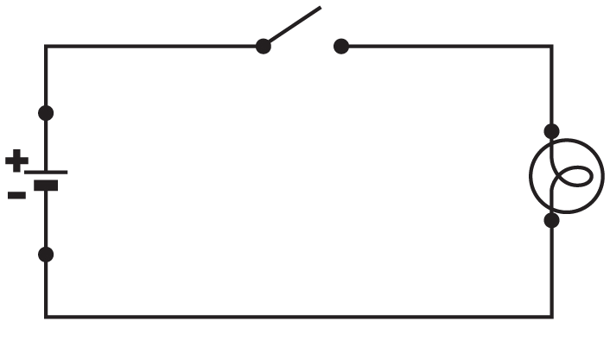
a) Is the circuit open or closed?
b) Is the light bulb on?
3. Which type of switch would you use in the following situations?
EST
- You want to turn on a light in an entranceway or hall.
b) You want to turn on the living room and dining room lights at the same time.
c) You want to turn on an appliance.
d) You want to turn on the living room and dining room lights or the entranceway and hall lights.
4. What component in the following objects transforms electrical energy? What form of energy is obtained?
a) a kettle
b) a quartz watch
c) a flashlight
d) a tape recorder

5. Which type of switch do these symbols represent?
EST
 | Symbol | Switch
a) | 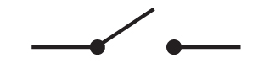
b) | 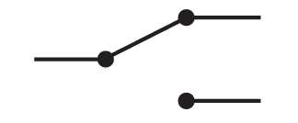
c) | 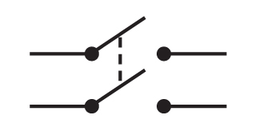
d) | 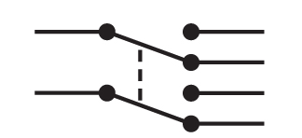
6. Which type of switch is often used to detect the opening of emergency doors?
EST

