Control and the transformation of energy

Support activities – Second Year of Secondary Cycle Two

ACTIVITY 62
ST
student BOOK: Chapter 14, pages 469–472
RELATED HANDOUT: Concept review 62

1. Complete the following sentences, using the words or groups of words in the box below. You may not need some words, and you may use others more than once.
• closed  • contact(s)  • control  • double-pole switch  • double-throw switch  • electrical | • electrical circuit  • electrons  • luminous  • magnetic  • open | • push-button  • rocker  • single-pole switch  • single-throw switch  • sound | • switch  • thermal  • toggle  • transformation

a) In a ________________________ circuit, electric current flows in a loop. The ________________________ can then travel throughout the ________________________. In an ________________________ circuit, electric current cannot flow in a loop. With a ________________________ component, we can open and close a circuit as we wish. This function depends on a ________________________.

b) The ________________________ of energy is performed by any component that can convert ________________________ energy into another form of energy. For example, an incandescent light bulb transforms electrical energy into ________________________ energy. A heating element transforms electrical energy into ________________________ energy. A piezoelectric crystal transforms electrical energy into mechanical energy or
________________________ energy (vibrations). An electromagnet transforms electrical energy into ________________________ energy.
2. Look at the electrical circuit below.
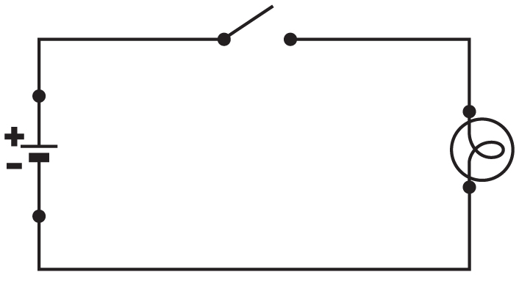
a) Is the circuit open or closed?
b) Is the light bulb on?
3. What component in the following objects transforms electrical energy? What form of energy is obtained?
a) a kettle
b) a quartz watch
c) a flashlight
d) a tape recorder

