Electricity, electronics and electrical circuits

Support activities – Second Year of Secondary Cycle Two

ACTIVITY 60
ST
student BOOK: Chapter 14, pages 458–461
RELATED HANDOUT: Concept review 60

1. Complete the following sentences, using the words or groups of words in the box below. You may use some words more than once.
• alternating  • battery  • components  • conductive  • conductors  • conventional | • diagram  • direct  • electrical circuits  • electrical engineering  • electric current | • electricity  • electronic components  • electronics  • low-intensity  • negative | • positive  • powerful  • power plants  • semiconductor

a) __________________________ deals with the design and development of electrical
objects and systems. It covers two areas: __________________________ and ________________________. All electrical devices depend on __________________________.

b) Electronic components are made of a __________________________ material, while in electricity, a __________________________ material is used. Electrical components operate on more __________________________ circuits than electronic components, which are miniaturized and draw __________________________ current. Finally, electrical conduction can be more finely controlled in __________________________.

c) An electrical circuit is a simple or complex set of __________________________ and __________________________ carrying an __________________________. The _________________________ current direction flows from a ________________________ terminal to a _______________________ terminal. A circuit _________________________ is a symbolic representation of the different components of a circuit.

d) In __________________________ current, the electrons always move in the same direction. A __________________________ is a source of __________________________ current. In __________________________ current, the electrons change direction many times per second. __________________________ generate __________________________ current.
2. True or false? If a statement is false, correct the error or errors.
a) Electronic components follow the general laws of electricity.
b) In alternating current, protons flow continuously in the same direction.
c) Copper is a semiconductor.
d) The conventional current direction is the opposite of the actual direction of electron movement.
e) Silicon is a semiconductor.
3. Are the following objects representative of the field of electricity or the field of electronics?
a) a vacuum cleaner
b) a computer
c) a flashlight
d) a stereo
e) a cellphone
4. Identify the symbols for circuit components in the table below.
Symbol | Meaning





5. Draw an arrow to show the conventional current direction in the circuit diagram.
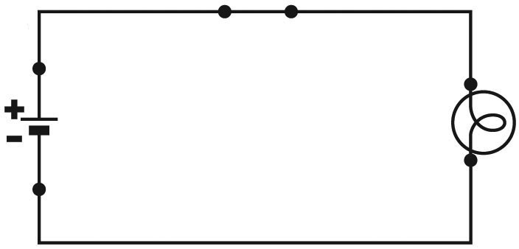
6. Name two advantages of electronics over electricity.

