Motion transformation systems

Support activities – Second Year of Secondary Cycle Two

ACTIVITY 59
AST
student BOOK: Chapter 13, pages 445–449
RELATED HANDOUT: Concept review 59

1. Complete the following sentences, using the words or groups of words in the box below. You may use some words more than once.
• altering  • cam and follower systems  • centred  • driver | • eccentrics  • motion transformation  • motion transformation  systems  • nut | • off-centre  • rack and pinion systems  • rotational axis | • screw gear systems  • slider-crank mechanisms  • translational

a) In a technical object, when components relay a motion while ______________________________________ the nature of the motion, they perform the mechanical function of ______________________________________. Usually, more than one component is required for ______________________________________. Together, they form ______________________________________.

b) Among the most common ______________________________________ used in technical objects, ______________________________________ and ______________________________________ are said to be reversible. ______________________________________ and _______________________________________ are not reversible. ______________________________________ are reversible when they can be used to convert rotational motion into ______________________________________ motion, and vice versa.

c) There are two types of ______________________________________. In the first type, the screw is the ______________________________________, and its rotational motion is transformed into the ______________________________________ motion of the ______________________________________. In the second type, the __________________________________ is the __________________________________; its rotational motion is transformed into the ______________________________________ motion of the screw.

d) In _______________________________, special cams called “_______________________________” are sometimes used. The main difference between cams and _______________________________ lies in the location of the _______________________________. In cams, it is _______________________________, while in _______________________________, it is _______________________________.

2. Identify the type of motion transformation system described by the following statements. In the case of screw gear systems, specify the type.
a) These systems usually require a device such as a return spring.
b) To turn the wheels of a car with the help of a crankshaft, we use this type of motion transformation system.
c) This type of system is often found in jacks for lifting cars.
d) This type of system is often found in automobile steering systems, such as the one illustrated below.
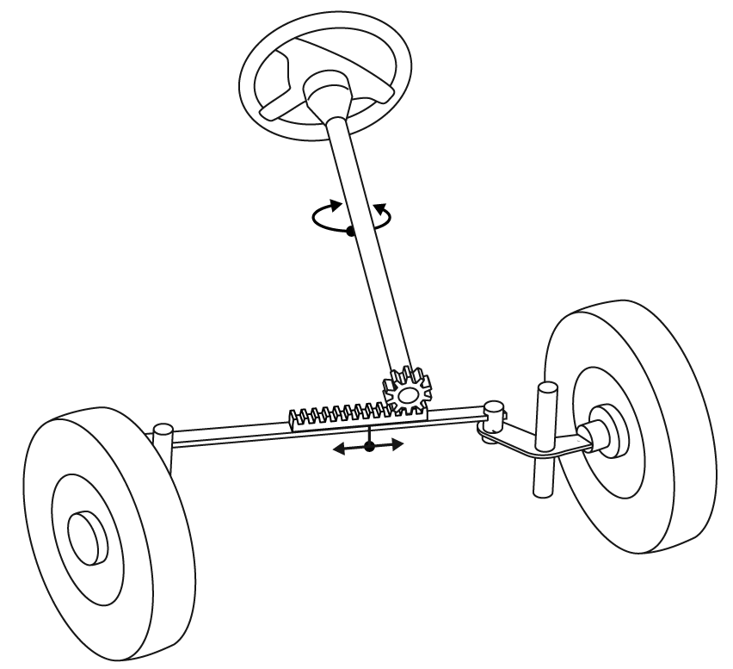
3. True or false?
a) In screw gear systems, types 1 and 2, a rotational motion is transformed into a translational motion. The opposite is not true.
b) In cam and follower systems, the follower must be guided in its rotational motion.
c) In screw gear systems, the threads of the screws and nuts must match for the system to work properly.
d) In cam and follower systems, the follower is the driver.
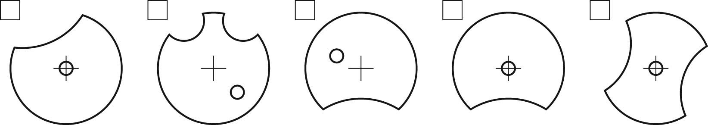
4. Look at the illustrations below and check the outlines that represent an eccentric.

