Speed changes in motion transmission systems

Support activities – Second Year of Secondary Cycle Two

ACTIVITY 58
EST
student BOOK: Chapter 13, pages 442–444
RELATED HANDOUT: Concept review 58

1. Complete the following sentences, using the words or groups of words in the box below. You may use some words more than once.
• diameters  • driven components | • driver component  • greater | • number of teeth  • speed change

a) In motion transmission systems, a ___________________________ occurs when the ___________________________ does not turn at the same speed as the ___________________________. In a worm and worm gear system, the ___________________________ the ___________________________ on the gear, the greater the decrease in speed. In friction gear systems and belt and pulley systems, a ___________________________ occurs when gear ___________________________ are different. In gear trains and chain and sprocket systems, a __________________________ occurs when the ___________________________ on the gears varies.
2. What am I?

a) I am the motion transmission system of choice for dramatically reducing the speed of a rotational motion during transmission.

b) I am the number of teeth on a gear that turns twice as fast as a gear with eight teeth in a motion transmission system.

c) I am the diameter of a pulley that turns four times more slowly than a five-centimetre pulley in a motion transmission system.

3. For each of the following statements, determine whether there is an increase, decrease or no change in speed during motion transmission.
a) Motion is transmitted from a friction gear two centimetres in diameter to a friction gear three centimetres in diameter.
b) In a gear train, the motion of a gear with eight teeth is transmitted to a gear with six teeth.
c) In a gear train, the motion of a gear five centimetres in diameter is transmitted to a gear four centimetres in diameter.
4. Look at the three motion transmission systems below.
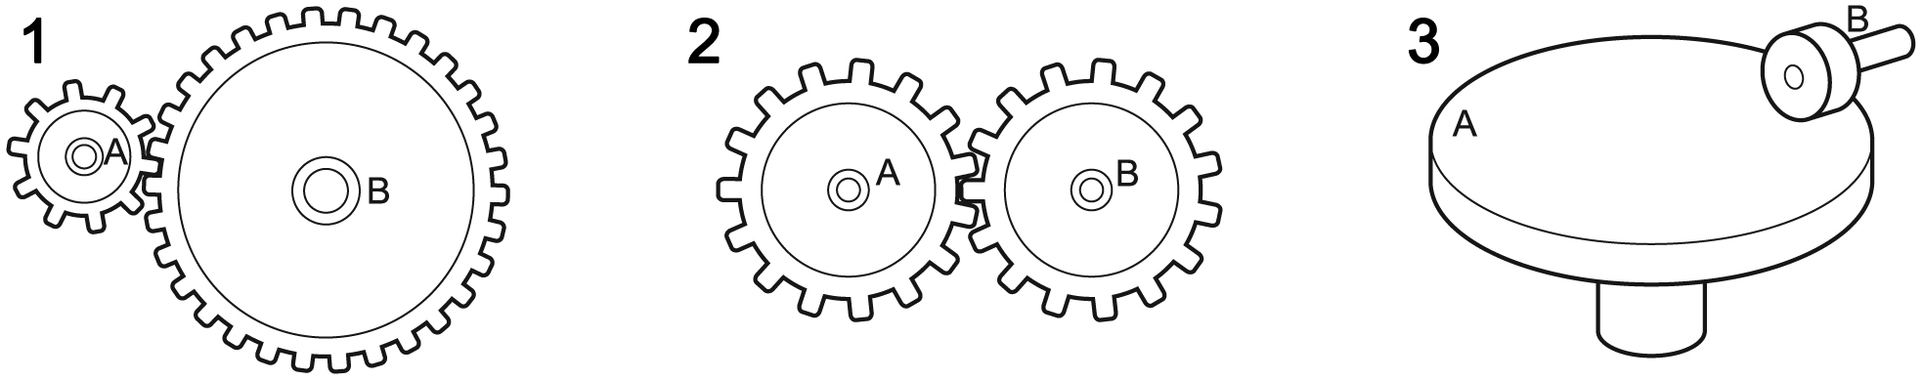
a) In which of these three systems will there be an increase in speed when motion is transmitted from component A to component B? Explain your answer.
b) In which of these three systems will there be a decrease in speed when motion is transmitted from component A to component B? Explain your answer.

5. Look at the three motion transmission systems below.
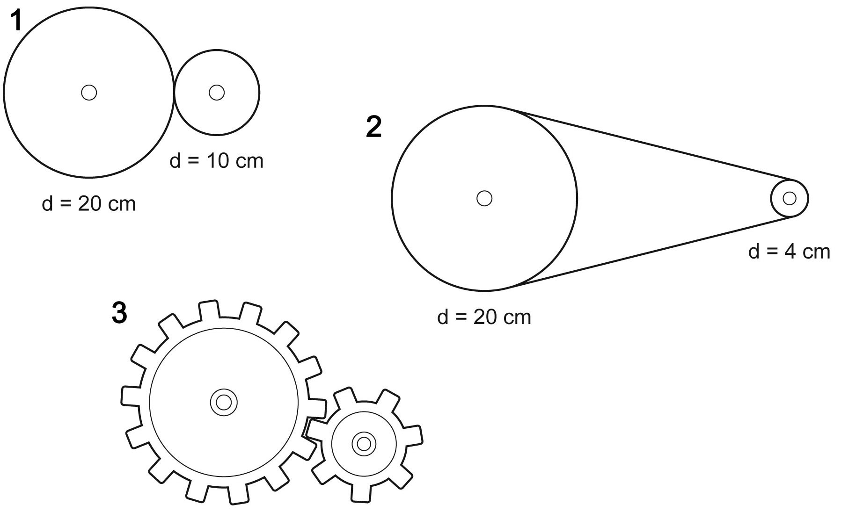
14 teeth 7 teeth
In which of these three systems does the biggest speed change occur? Explain your answer.

