Motion transmission systems

Support activities – Second Year of Secondary Cycle Two

ACTIVITY 57
EST
student BOOK: Chapter 13, pages 435–441
RELATED HANDOUT: Concept review 57

1. Complete the following sentences, using the words or groups of words in the box below. You may use some words more than once.
• altering  • chain and sprocket systems  • driven component(s)  • driver component(s) | • friction gear systems  • gear trains  • intermediate components | • motion transmission  • motion transmission system(s) | • reversible  • worm and worm gear systems

a) In a technical object, when components transfer a motion from one part to another without ___________________________________ the nature of the motion, they perform the mechanical function of ___________________________________. Usually, more than one component is required for ___________________________________. Together, they form a ___________________________________.

b) A mechanical system contains three types of component. The parts that receive the force required to activate the system are called “___________________________________.” Those that receive the motion and transfer it to another part are called “___________________________________.” Sometimes, one or more components can be found between the ___________________________________ and the ___________________________________; they are ___________________________________. In mechanical engineering, when a ___________________________________ can become a ___________________________________, and vice versa, the system is said to be ___________________________________.

c) Among the most common ___________________________________ are ___________________________________, ___________________________________, ___________________________________, ___________________________________ and belt and pulley systems.
2. Who am I, or who are we?
a) We are the two directions of rotational motion.
b) We are motion transmission systems with at least one gear.
c) I am a motion transmission system that cannot be reversible.
d) I am a system for which the gear teeth, the gear type and the number of teeth in each gear must be considered when I am being built.
e) I am a system in which some of my components must contain a smooth groove.
3. In the pairs of motion transmission systems below, circle the system that is usually used to transfer motion between distant parts.
a) gear train and chain and sprocket system
b) belt and pulley system and friction gear system
4. Look at the illustrations below.
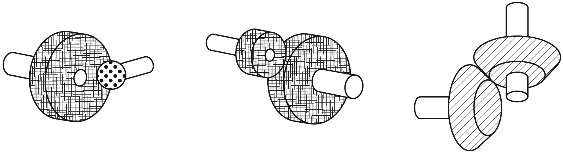
a) Complete the legend below to identify the bevel gears, the straight gears and the spherical gears.
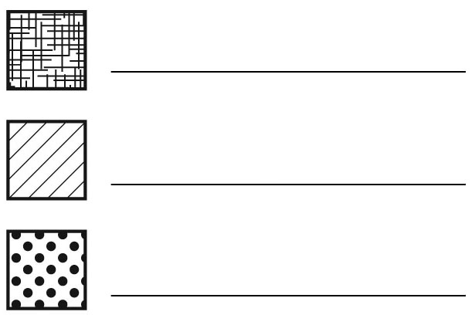
Legend:

b) Which type of motion transmission system is illustrated?
5. Complete each figure below, indicating:
i) the directions in which the driver and driven components of the system rotate.
ii) the name of the motion transmission system illustrated.
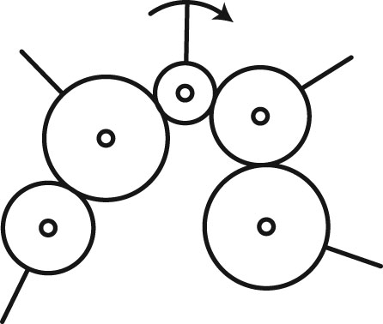
a)

b)
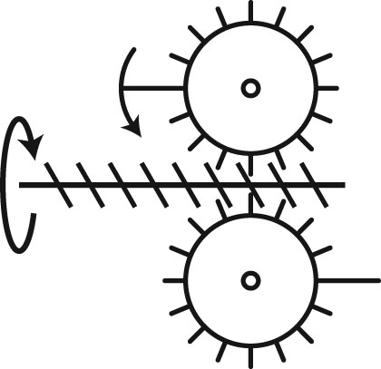
c)
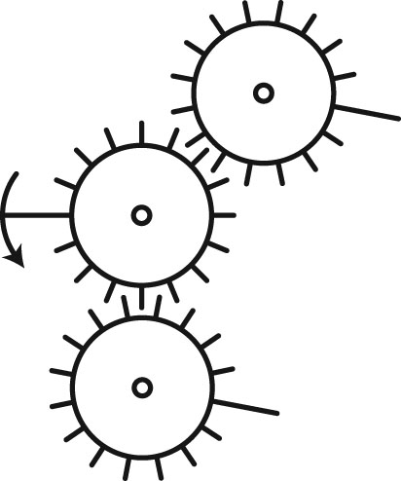
d)
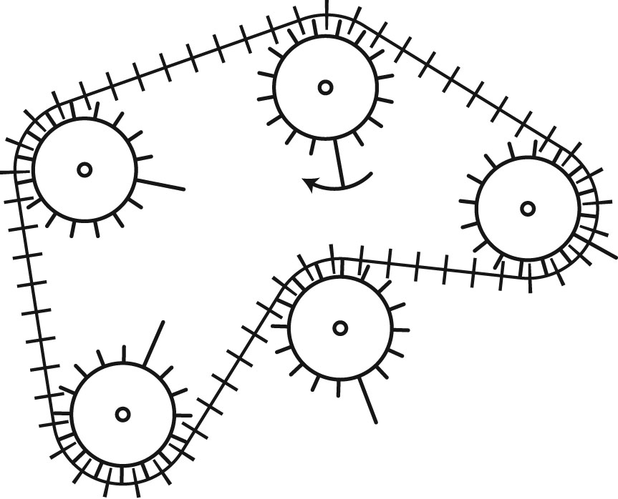
e)
