Linking in technical objects

Support activities – Second Year of Secondary Cycle Two

ACTIVITY 55
ST
student BOOK: Chapter 13, pages 427–430
RELATED HANDOUT: Concept review 55

1. Complete the following sentences, using the words or groups of words in the box below. You may not need some words, and you may use others more than once.
• characteristics  • complementary  • complete  • degrees of freedom | • independent motion  • indirect  • linking | • linking components  • links  • non-removable | • partial  • rigid  • six

a) In a technical object, we say there are ___________________________ between the parts when they are held together. ___________________________ is a mechanical function performed by any component that connects different parts of a technical object. ___________________________ can be performed by parts like nails and screws. These parts are called “___________________________.” ___________________________ can also occur because the connected parts have ___________________________ shapes.

b) A link always has four ___________________________—one of each of the following four pairs: direct or ___________________________, ___________________________ or flexible, removable or ___________________________, and ___________________________ or ___________________________.

2. Identify the characteristic of the links described in the statements below.
a) characteristic of a link when the linking component or the surfaces of the linked parts are rigid
b) characteristic of a link when at least one part can move independently of the other parts

c) characteristic of a link in which the separation of the linked parts damages their surfaces or the linking component
d) characteristic of a link that requires a linking component
3. Consider the link below between the doorknob and the door.
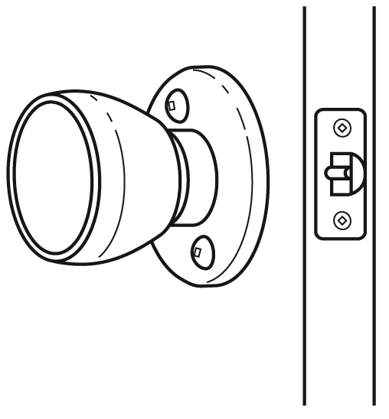
a) Identify the characteristics of this link by checking the correct boxes.
direct □ | indirect □
rigid □ | flexible □
removable □ | non-removable □
complete □ | partial □
b) On the figure, draw an arrow that points to a linking component, if there are any.
4. Consider the link between the eraser below and the plastic-coated paper covering it.
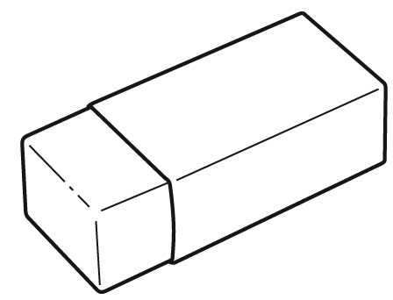
a) Identify the characteristics of this link by checking the correct boxes.
direct □ | indirect □
rigid □ | flexible □
removable □ | non-removable □
complete □ | partial □
b) On the figure, draw an arrow that points to a linking component, if there are any.
5. True or false?
a) Glue usually plays the role of a linking component in a technical object.
b) A link can be both partial and flexible.

