Linking in technical objects

Support activities – Second Year of Secondary Cycle Two

ACTIVITY 55
AST
student BOOK: Chapter 13, pages 427–430
RELATED HANDOUT: Concept review 55

1. Complete the following sentences, using the words or groups of words in the box below. You may use some words more than once.
• characteristics  • complementary  • complete  • degrees of freedom | • independent motion  • indirect  • linking | • linking components  • links  • non-removable | • partial  • rigid  • six

a) In a technical object, we say there are ___________________________ between the parts when they are held together. ___________________________ is a mechanical function performed by any component that connects different parts of a technical object. ___________________________ can be performed by parts like nails and screws. These parts are called “___________________________.” ___________________________ can also occur because the connected parts have ___________________________ shapes.

b) A link always has four ___________________________—one of each of the following four pairs: direct or ___________________________, ___________________________ or flexible, removable or ___________________________, and ___________________________ or ___________________________.

c) In a technical object, linking limits the possibility of ___________________________ of one part in relation to another. There are ___________________________ possibilities of ___________________________. The possibilities of ___________________________ of a linked part are its ___________________________.
2. Identify the characteristic of the links described in the statements below.
a) characteristic of a link when the linking component or the surfaces of the linked parts are rigid
b) characteristic of a link when at least one part can move independently of the other parts

c) characteristic of a link in which the separation of the linked parts damages their surfaces or the linking component
d) characteristic of a link that requires a linking component
3. Consider the link below between the doorknob and the door.
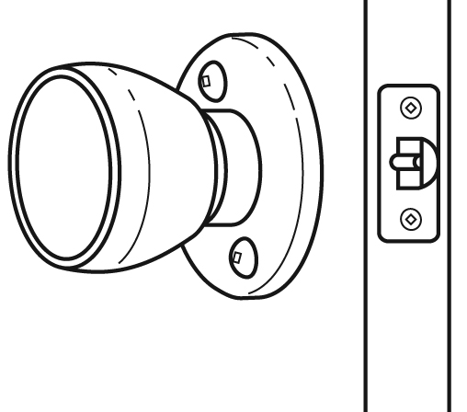
a) Identify the characteristics of this link by checking the correct boxes.
direct □ | indirect □
rigid □ | flexible □
removable □ | non-removable □
complete □ | partial □
b) On the figure, draw an arrow that points to a linking component, if there are any.
c) If the doorknob has any degrees of freedom in relation to the door, how many does it have?
4. Consider the link between the eraser below and the plastic-coated paper covering it.
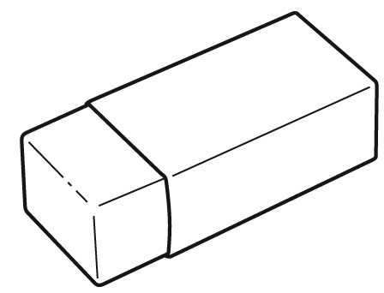
a) Identify the characteristics of this link by checking the correct boxes.
direct □ | indirect □
rigid □ | flexible □
removable □ | non-removable □
complete □ | partial □
b) On the figure, draw an arrow that points to a linking component, if there are any.
c) If the plastic-coated paper has any degrees of freedom in relation to the eraser, how many does it have?
5. True or false?
a) Glue usually plays the role of a linking component in a technical object.
b) A link can be both partial and flexible.
c) In a complete link, one of the parts has at least one degree of freedom.
d) For any part, there are six possibilities of independent motion: four translational motions and two rotational motions.

