Diagrams

Support activities – Second Year of Secondary Cycle Two

ACTIVITY 53
AST
student BOOK: Chapter 12, pages 408-–410
RELATED HANDOUT: Concept review 53

1. Complete the following sentences, using the words or groups of words in the box below. You may use some words more than once.
• circuit  • circuit diagram  • components  • design plan  • diagram  • dimensions | • electrical circuit  • forces  • guiding controls  • layout  • materials  • movement | • names  • principles  • selected manufacturing process  • shapes | • simplified  • symbols  • technical diagram

a) In technical drawing, drafters can make a _______________________________ representation of an object, a part of an object or a system. This type of drawing is called a “______________________________.” There are several types of diagrams, the most common being the ______________________________, the ______________________________ and the ______________________________. To convey information as simply as possible in a ______________________________ and to provide the right information to anyone analyzing the drawing, standardized ______________________________ are used.

b) A ______________________________ provides information on one or more of the operating ______________________________ of an object. Consequently, it usually represents the ______________________________ of the parts, the ______________________________ of the parts and the operational ______________________________ involved.

c) A ______________________________ provides information on the ______________________________ of an operational object. Along with the ______________________________ of the parts, this type of diagram usually indicates the important ______________________________ and ______________________________ to be considered in their manufacture, the ______________________________ to be used and the linking ______________________________ and types of ______________________________ required, if applicable.
d) Finally, a ______________________________ provides information on the ______________________________of the various components of an ______________________________. The diagram contains the ______________________________ for the various ______________________________ components.
2. Do the following statements refer to a design plan, a technical diagram or a circuit diagram? Check the correct box. Some statements refer to more than one type of diagram.
 | Design plan | Technical diagram | Circuit diagram
a) It usually contains a legend of materials. | □ | □ | □
b) It contains symbols representing the motion of moving parts. | □ | □ | □
c) Standardized symbols are used in this type of drawing. | □ | □ | □
d) It usually contains the symbol for an electrical wire. | □ | □ | □
e) It shows the forces that must be applied for the object to work. | □ | □ | □
f) It is a simplified representation. | □ | □ | □
3. Identify the following symbols and the type of diagram in which they are usually found.
Symbol | Meaning | Type of diagram


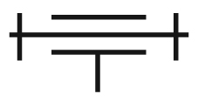


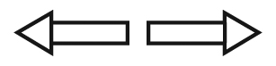

4. Look at the electrical circuit below.
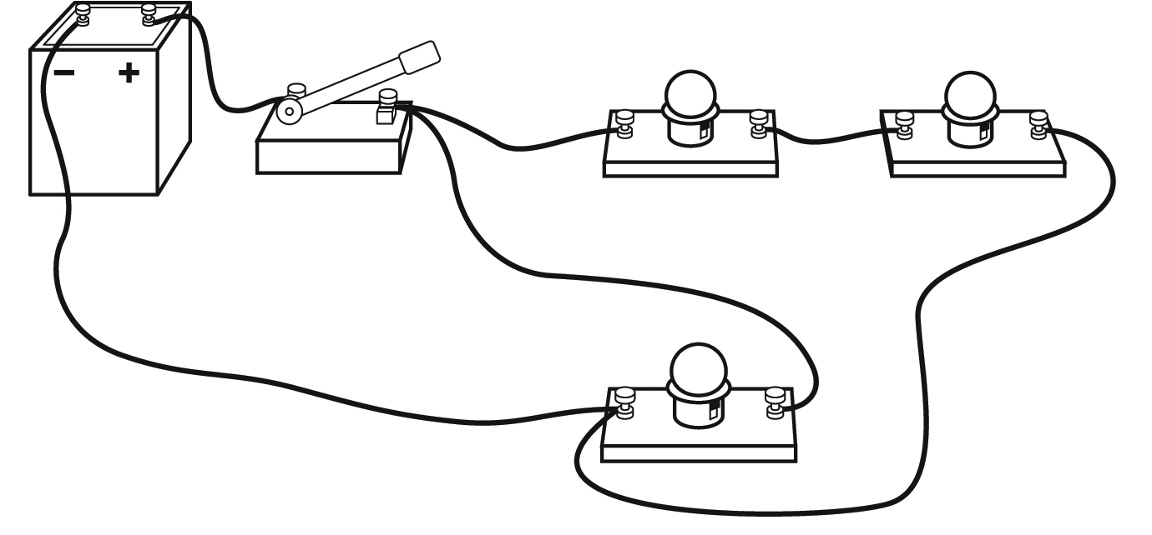
Which of the following diagrams represents this electrical circuit? Check the correct diagram.
