Projections and engineering drawings

Support activities – Second Year of Secondary Cycle Two

ACTIVITY 52
EST
student BOOK: Chapter 12, pages 401–407
RELATED HANDOUT: Concept review 52

1. Complete the following sentences, using the words or groups of words in the box below. You may use some words more than once.
• 120º angles  • basic lines  • detail drawing  • details  • different views  • dimensional tolerances | • dimensions  • exploded view  • front  • general arrangement  • isometric projection(s) | • manufacturing  • maximum acceptable differences  • multiview projection(s)  • projections | • right-side  • separated  • shapes  • sides of the cube  • single view  • top

a) ______________________________ are used to represent a three-dimensional object on a two-dimensional surface. Among those most commonly used in drafting are ______________________________ and ______________________________. To draw an ______________________________ of an object, the lines representing its length, height and depth must form ______________________________ on the paper.

b) To draw a ______________________________ of an object, the drafter must visualize the object in the middle of a transparent cube. Using ______________________________, the drafter then draws the ______________________________ of the object as they would appear on the ______________________________. The three views that are usually illustrated in a ______________________________ are the ______________________________, ______________________________ and ______________________________views.

c) A ______________________________ is a technical drawing showing the overall appearance of an object. ______________________________ are suitable for this type of drawing, because they contain many ______________________________ of the object. However, a representation in an ______________________________ is often added because it offers the advantage of showing the general shape of the object in a ______________________________.
d) To manufacture an object, it is often useful to represent it with its parts ______________________________ from one another. This type of drawing
is called an “______________________________” and is usually drawn as an ______________________________.
e) To specify all the relevant information for ______________________________ a part of an object, a ______________________________ is the appropriate type of drawing. It shows one or more views of a ______________________________. It provides information on the ______________________________ and ______________________________ of the part. When useful, indicators of the ______________________________ between the specified measurements on the drawing and the actual measurements of the finished object can be included in the ______________________________. These indicators are called “______________________________.”
2. As a member of the organizing committee for his school’s first cross-country competition, Sam must build a podium for the medals ceremony. He is given the drawing below.
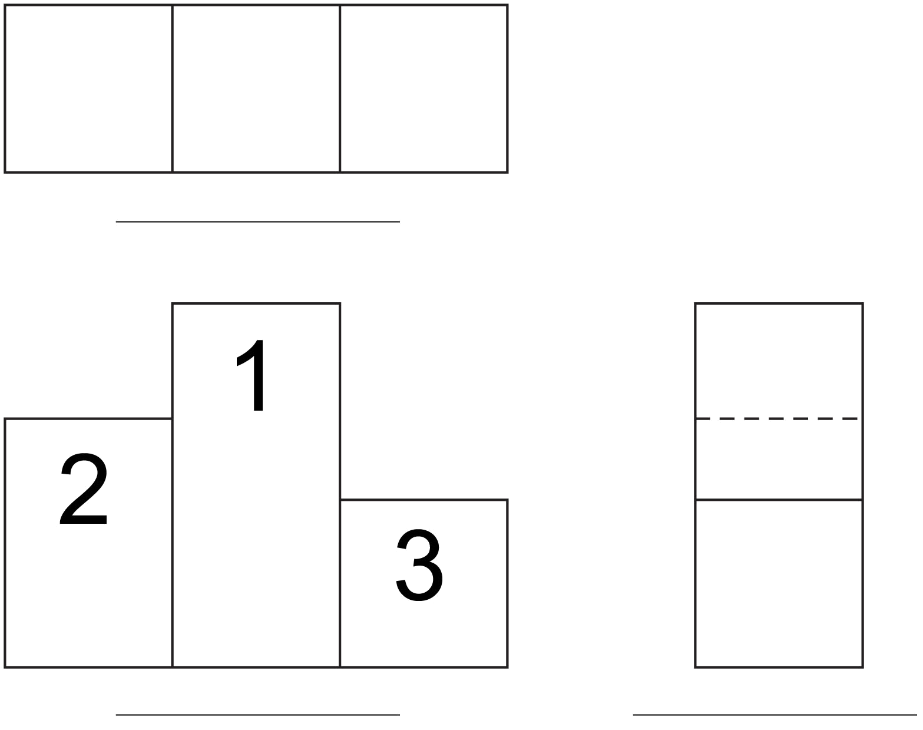

a) What type of drawing is it?
b) What type of projection was used to make this drawing?
c) Write the name of the view on the line under each one.
d) What type of drawing will Sam need, to know the shapes and exact dimensions of each of the podium parts?
3. Look at the drawing below of the motor unit of a motorized toy.
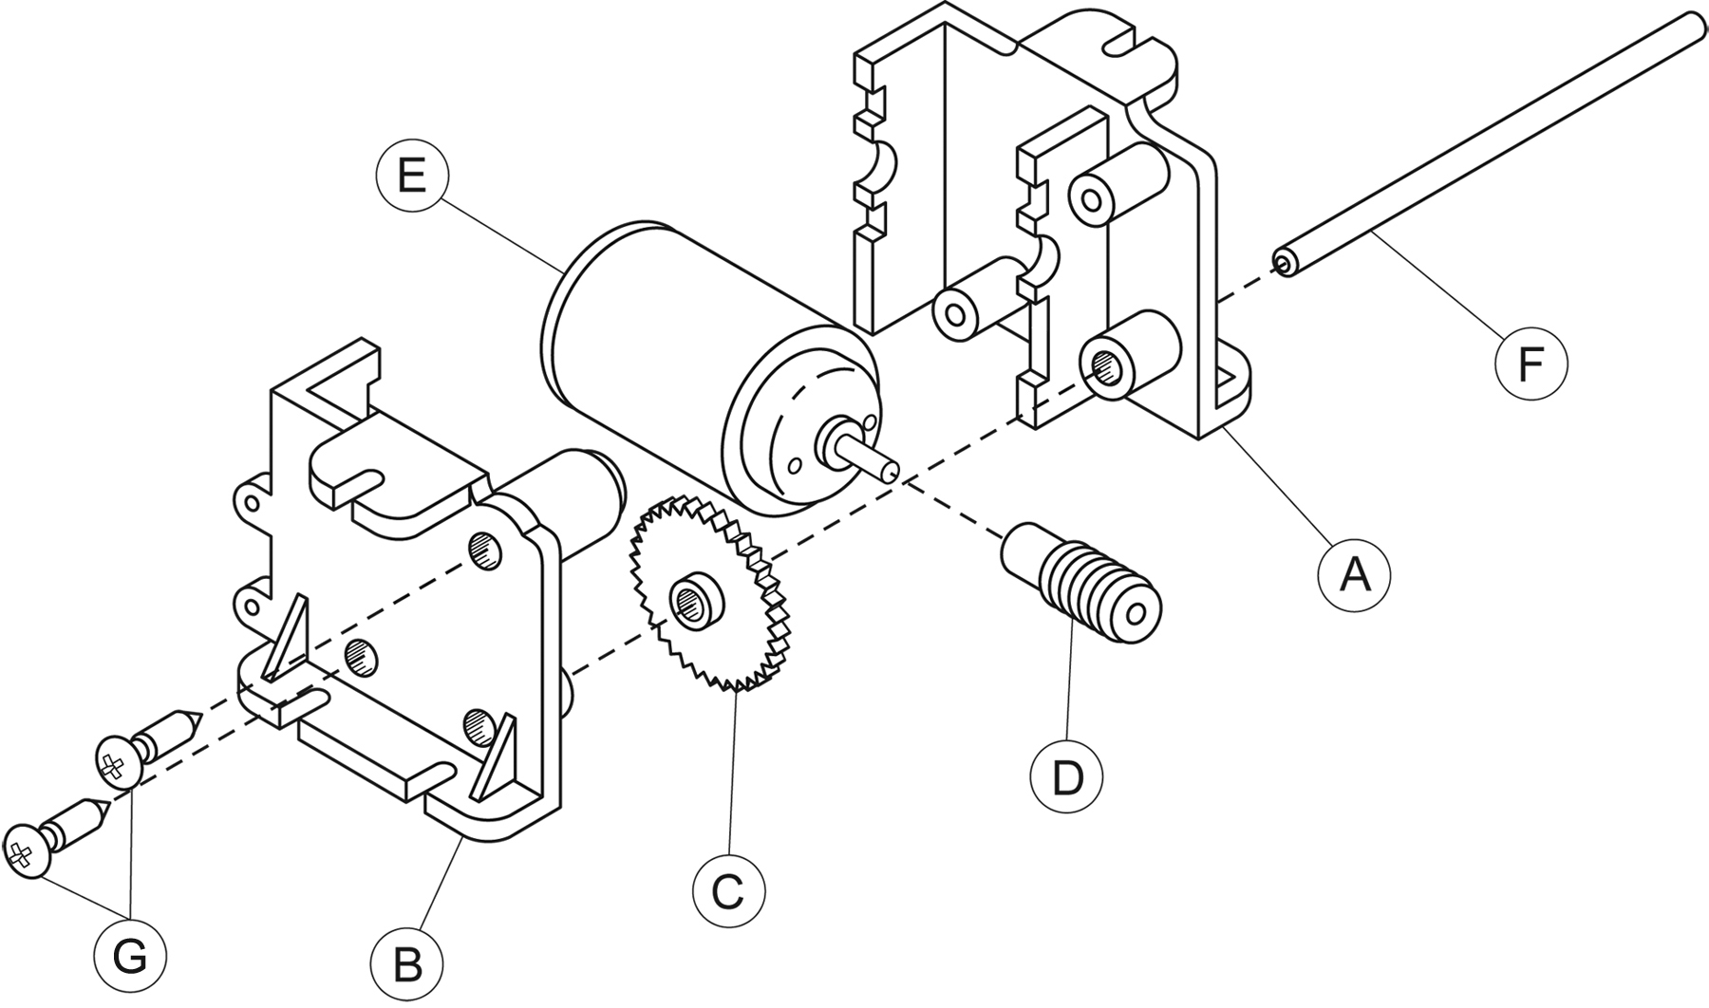
a) What type of drawing is it?
b) What type of projection was used to make this drawing?
c) How many different parts does the motor unit contain?
4. True or false?
a) In a general arrangement, it is possible to find all the relevant information for manufacturing the parts of the object represented.
b) A single object cannot be represented with more than one projection.

