The atmosphere: atmospheric circulation

Support activities – Second Year of Secondary Cycle Two
ACTIVITY 30
EST
student BOOK: Chapter 7, pages 226–232
Related Handout: Concept review 30

1. Complete the following sentences, using the words or groups of words in the box below. You may use some words more than once.

• atmospheric  • capital letter H  • capital letter L  • change  • cold  • combine  • Coriolis effect  • cumulus  • denser  • depressions  • descend  • Ferrel cell | • flooding  • Hadley cell  • high pressure  • horizontally  • hot  • hurricanes  • jet streams  • line  • low pressure  • low-pressure  • motion  • nimbostratus | • parallel  • polar  • Polar cell  • polar easterlies  • pressure  • prevailing  • regular  • rise  • rotation  • same direction  • spiral  • subtropical | • temperature  • three  • trade winds  • triangles  • troposphere  • warm  • warm air  • warm front  • warms up  • weather conditions  • westerlies  • winds

a) The air surrounding the Earth is in constant ________________________. It is important to remember that hot air tends to ________________________, and cold air tends to fall. A phenomenon of convection occurs between ________________________ regions and cold regions. The hot, humid air from equatorial regions (________________________ zones) heads toward the poles and then descends over cold, dry regions (high-pressure zones). In the same way, the cold, dry air from the poles descends toward the warm regions of the equator and ________________________. ________________________ circulation is the global-scale movement of the layer of air surrounding the Earth.

b) Because of the ________________________ of the Earth, air near the surface circulates at right angles to the north-south axis. The ________________________ causes winds to deviate to the right in the Northern Hemisphere, and to the left in the Southern Hemisphere. This affects the trajectory of air masses in the ________________________.
c) Atmospheric circulation consists of several circulation cells, and the movement
inside the cells is very ________________________. Each hemisphere contains ________________________ circulation cells: the ________________________,
from the equator to the 30th parallel; the Ferrel cell, from the 30th to the 60th ______________________; and the ________________________, located over the pole. The circulation of air in the Northern Hemisphere is comparable to circulation in the Southern Hemisphere.
EST
d) In the Northern Hemisphere, the warm air from the Hadley cell over the equator rises in the atmosphere and moves toward the 30th ________________________. It cools and runs into the winds from the Ferrel cell, which force it to ________________________ and return to the equator.
EST
e) The air in the ________________________ rises in the atmosphere and heads toward the 60th parallel. It cools and runs into the winds from the Polar cell, which force it to rise and return toward the 30th parallel.
EST
f) The air from the Polar cell, which originally lies above the pole, sinks toward the Earth and turns toward the 60th ________________________. It meets the air from the Ferrel cell, which forces it to rise and return to the pole.
EST
g) Near the surface, atmospheric circulation cells create ________________________ winds that blow in the ________________________ all around the Earth. The direction
is determined by the ________________________. Between the equator and the
30th parallel, the prevailing winds are ________________________ coming from the east. Between the 30th and 60th parallels, the prevailing winds are _______________________. Between the 60th parallel and the pole, the prevailing winds are _____________________.
EST
h) In Québec, the prevailing winds are ________________________. On the regional level, winds are affected by local systems of high and low ________________________. At very high altitudes, there are powerful winds called “________________________.”
EST
i) Each hemisphere has two jet streams: a ________________________ jet stream, and a polar jet stream. Airplane pilots travelling east take advantage of these winds that can carry their aircraft, thus saving fuel.
EST
j) An air mass is formed when a large expanse of the atmosphere acquires the ________________________ and humidity of the region it is crossing. Air masses are pushed by ______________________ and are closely watched by meteorologists because they bring changes in ________________________. The climate in Québec is subject to the effect of air masses from tropical regions and ________________________ regions.
k) When air masses meet, they do not ________________________. Cold air, which is ________________________, slides under the lighter warm air. The ________________________ where the two masses meet is called a “front.” In this zone, winds, humidity and temperature ________________________ rapidly. There are two types of fronts: cold fronts and ________________________ fronts.
l) A ________________________ front occurs when a mass of cold air meets a mass of warm air. The warm air rises rapidly and cools. This leads to the formation of large ________________________ clouds, which are often a sign of coming bad weather: rain and strong winds. A warm front occurs when a mass of ________________________ moves toward a mass of cold air. The warm air rises gently above the cold air, creating light clouds called “________________________.” Warm fronts usually bring cloudy weather and showers.
m) Most air masses move ________________________, but some vertical movement also occurs, such as in the formation of anticyclones or ________________________, which depends on local pressure.
n) An anticyclone is an area of atmospheric circulation surrounding a centre of ________________________. A depression is an area of atmospheric circulation surrounding a centre of ________________________.
o) On weather maps, a cold front is designated by a blue line with a row of blue ________________________, while a ________________________ is designated by a red line with a row of red triangles. The ________________________ is used as a symbol for anticyclones, and the ________________________ is used for depressions.
p) Air masses also meet above the warm waters of tropical oceans and sometimes create strong ________________________. A huge ________________________ of powerful winds is then formed. Depending on the area, these storms are called “cyclones,” “________________________” or “typhoons.” The violent winds whirl around areas of ________________________. They can have disastrous consequences, such as ________________________ and landslides.
2. Find the term that fits each of the following definitions.
a) clouds that accompany the formation of a warm front
b) the direction of the wind in an anticyclone in Québec
3. Complete the illustration below of global atmospheric circulation, and the accompanying legend.
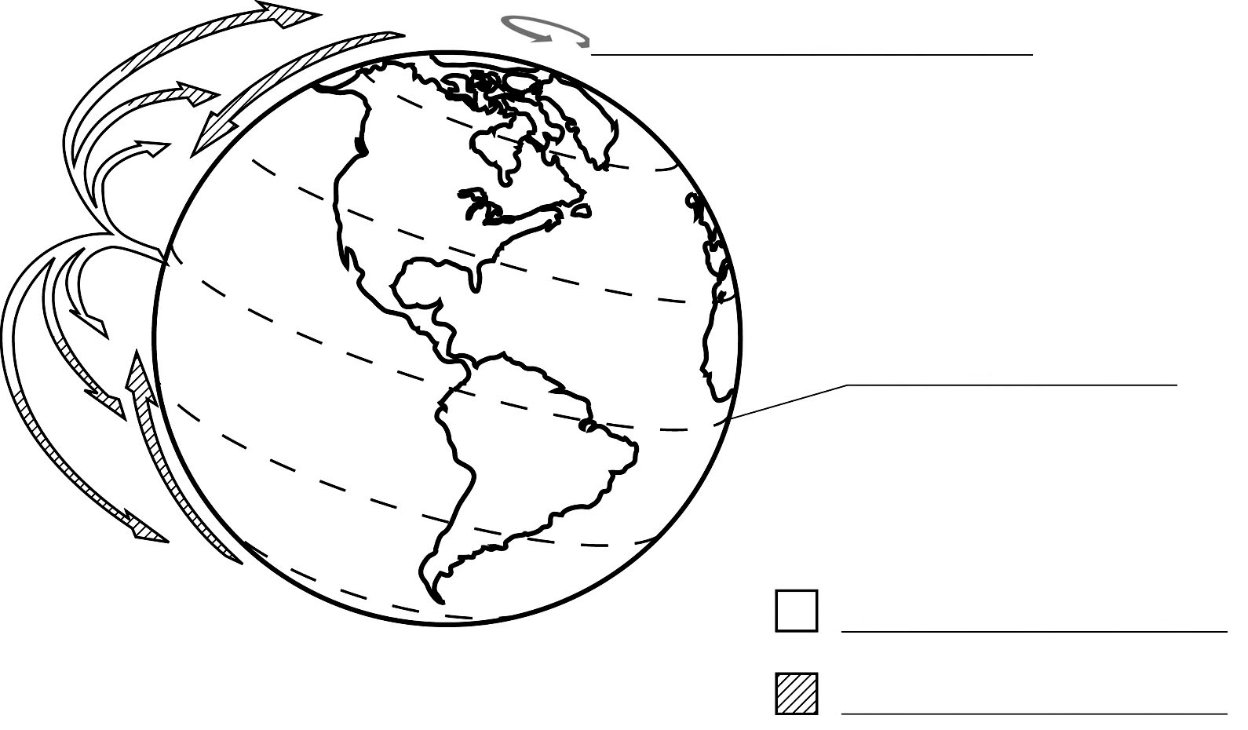
Legend

