The atmosphere: atmospheric circulation

Support activities – Second Year of Secondary Cycle Two
ACTIVITY 30
AST
student BOOK: Chapter 7, pages 226–232
Related Handout: Concept review 30

1. Complete the following sentences, using the words or groups of words in the box below. You may not need some words, and you may use others more than once.

• atmospheric  • capital letter H  • capital letter L  • change  • cold  • combine  • Coriolis effect  • cumulus  • denser  • depressions  • descend  • Ferrel cell | • flooding  • Hadley cell  • high pressure  • horizontally  • hot  • hurricanes  • jet streams  • line  • low pressure  • low-pressure  • motion  • nimbostratus | • parallel  • polar  • Polar cell  • polar easterlies  • pressure  • prevailing  • regular  • rise  • rotation  • same direction  • spiral  • subtropical | • temperature  • three  • trade winds  • triangles  • troposphere  • warm  • warm air  • warm front  • warms up  • weather conditions  • westerlies  • winds

a) The air surrounding the Earth is in constant ________________________. It is important to remember that hot air tends to ________________________, and cold air tends to fall. A phenomenon of convection occurs between ________________________ regions and cold regions. The hot, humid air from equatorial regions (________________________ zones) heads toward the poles and then descends over cold, dry regions (high-pressure zones). In the same way, the cold, dry air from the poles descends toward the warm regions of the equator and ________________________. ________________________ circulation is the global-scale movement of the layer of air surrounding the Earth.

b) Because of the ________________________ of the Earth, air near the surface circulates at right angles to the north-south axis. The ________________________ causes winds to deviate to the right in the Northern Hemisphere, and to the left in the Southern Hemisphere. This affects the trajectory of air masses in the ________________________.
c) An air mass is formed when a large expanse of the atmosphere acquires the ________________________ and humidity of the region it is crossing. Air masses are pushed by ______________________ and are closely watched by meteorologists because they bring changes in ________________________. The climate in Québec is subject to the effect of air masses from tropical regions and ________________________ regions.
d) When air masses meet, they do not ________________________. Cold air, which is ________________________, slides under the lighter warm air. The ________________________ where the two masses meet is called a “front.” In this zone, winds, humidity and temperature ________________________ rapidly. There are two types of fronts: cold fronts and ________________________ fronts.
e) A ________________________ front occurs when a mass of cold air meets a mass of warm air. The warm air rises rapidly and cools. This leads to the formation of large ________________________ clouds, which are often a sign of coming bad weather: rain and strong winds. A warm front occurs when a mass of ________________________ moves toward a mass of cold air. The warm air rises gently above the cold air, creating light clouds called “________________________.” Warm fronts usually bring cloudy weather and showers.
f) Most air masses move ________________________, but some vertical movement also occurs, such as in the formation of anticyclones or ________________________, which depends on local pressure.
g) An anticyclone is an area of atmospheric circulation surrounding a centre of ________________________. A depression is an area of atmospheric circulation surrounding a centre of ________________________.
h) On weather maps, a cold front is designated by a blue line with a row of blue ________________________, while a ________________________ is designated by a red line with a row of red triangles. The ________________________ is used as a symbol for anticyclones, and the ________________________ is used for depressions.
i) Air masses also meet above the warm waters of tropical oceans and sometimes create strong ________________________. A huge ________________________ of powerful winds is then formed. Depending on the area, these storms are called “cyclones,” “________________________” or “typhoons.” The violent winds whirl around areas of ________________________. They can have disastrous consequences, such as ________________________ and landslides.
2. Find the term that fits each of the following definitions.
a) clouds that accompany the formation of a warm front
b) the direction of the wind in an anticyclone in Québec
3. Complete the illustration below of global atmospheric circulation, and the accompanying legend.
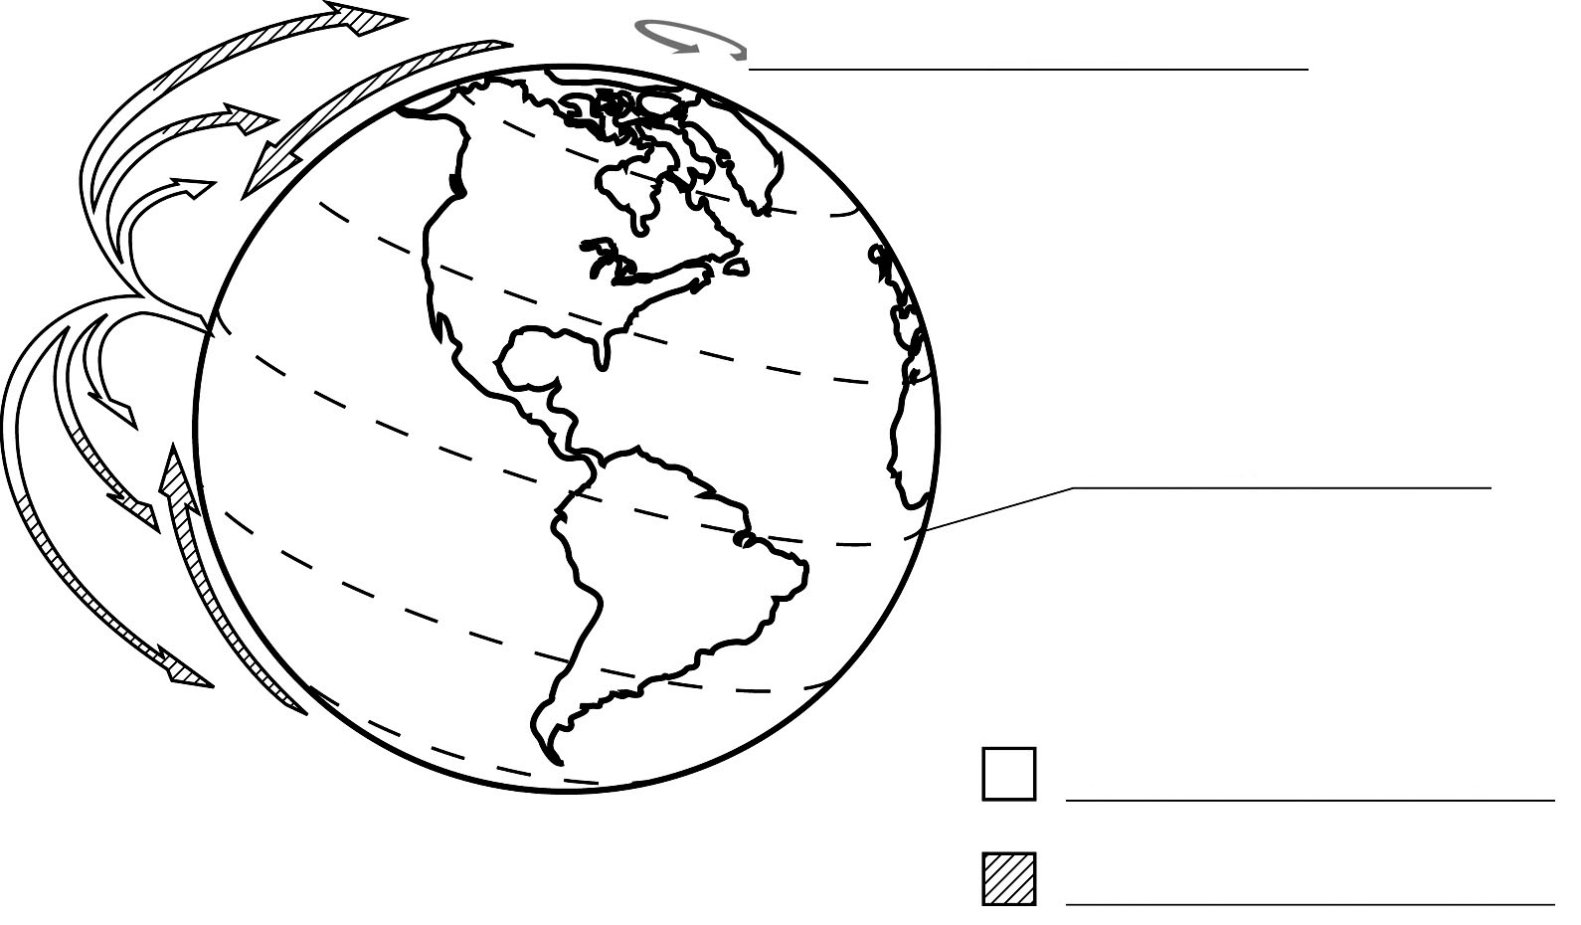
Legend

