Magnetism and electromagnetism

Support activities – Second Year of Secondary Cycle Two
ACTIVITY 23
ST
student BOOK: Chapter 5, pages 163–168
Related Handout: Concept review 23

1. Complete the following sentences, using the words or groups of words in the box below. You may not need some words, and you may use others more than once.
• adding  • aligned  • artificial  • attract each other  • attraction  • circular  • cobalt  • coming out of  • conserve  • direction  • distance  • domains | • dynamic  • electromagnet(s)  • electromagnetism  • entering into  • ferromagnetic  • ferromagnetic core  • fingers  • geographic  North Pole  • increasing  • like  • magnetic field | • magnetic field  lines  • magnetism  • magnetized  • mechanical  • more powerful  • motion  • natural  • nickel  • not aligned  • opposite  • ore | • permanent  • powerful  • right-hand rule  • rolled  • sharp blow  • solenoid  • south-seeking  • steel  • stopping  • temporary  • thumb

a) ________________________ describes all the phenomena caused by magnets. Magnets are objects that can attract other objects containing iron, ________________________ or cobalt. Around 600 bce, the Greeks discovered an ________________________ called magnetite, which is a ________________________ magnet with this property.

b) Certain metals have magnetic properties, which can be explained by their composition: they contain a set of regions called “________________________,” and each of these regions acts like a tiny magnet. The directions of these domains are ________________________ if the metal is not magnetized. If the metal is ________________________, its domains will be well ________________________. The greater the number of aligned domains, the ________________________ the magnet.
c) Each magnet has a north-seeking and a ________________________ pole. By convention, the north pole of a magnet corresponds to the end that naturally turns toward the magnetic pole that is located close to the Earth’s ________________________.

d) Magnets interact with one another through forces of ________________________ and repulsion. In other words, opposite magnetic poles ________________________, and ________________________ magnetic poles repel each other. These forces can act across a ________________________. In a diagram of a magnetic field, they are represented by ________________________. By convention, the lines are drawn ________________________ the north pole and ________________________ the south pole of a magnet.
e) Electricity can be used to make magnets. The interaction between magnetism and electricity is called “________________________.” An electric current can generate a magnetic field, and the ________________________ is also true. Only ________________________ electricity can generate a magnetic field because the electrical charges must be in ________________________.
f) Using the ________________________, we can determine the direction of the magnetic field lines of a live wire. The ________________________ points in the direction of the current, from the positive terminal toward the negative terminal. The ________________________ wrapped around the wire show the direction of the magnetic field lines. These lines are ________________________.

2. The figure below represents the Earth, which is a large magnet. Complete the figure with the following terms.
– geographic North Pole
– North Magnetic Pole
– geographic South Pole
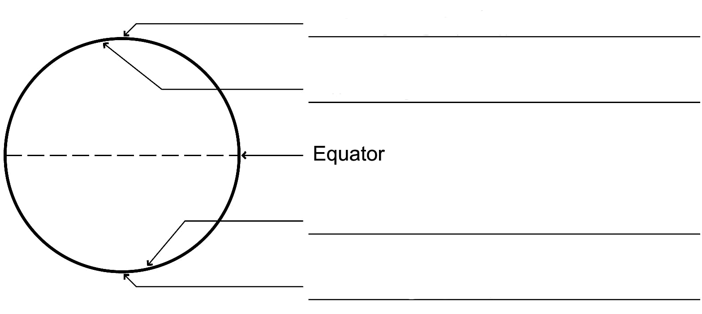
– South Magnetic Pole
3. The circles below represent compasses. In each situation, draw the needles of the compasses, using an arrow to show the direction they point.
a) 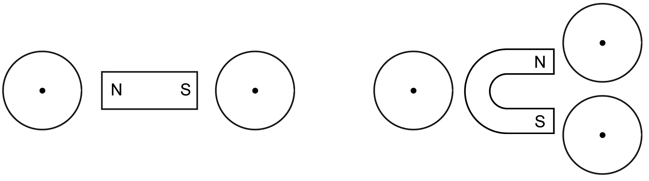
b)
4. Draw the magnetic field of each of the magnets below.
b)
a) 